Weeds Detection Using Mask-RCNN

Weeds Detection using Mask-RCNN is a project that helps detect weeds and uses Mask RCNN for detecting purposes. The objective is to perform using opencv and implement using opencv modules. I did segmentation and object detection using the bounding box. I detected Mint leaf and Foxtail. I did so with confidence score and adjusted the confidence scores.

I used Mask RCNN neural network. I installed all the required packages in the requirements.txt file.
I did random vertical flip and random horizontal flip on the images. I performed transformations on the images. I created tensorflow environment and installed tensorflow library and all the required packages in it. I used visual studio code to execute the whole project.

epochs: 50
batch_size: 2 # small on purpose - only 40 images total in the dataset
lr: 0.005
momentum: 0.9
weight_decay: 0.0005
lr_step_size: 15
lr_gamma: 0.1
num_workers: 2

train_images: dataset/train
train_ann: dataset/train/_annotations.coco.json
val_images: dataset/valid
val_ann: dataset/valid/_annotations.coco.json

Weed Detection using Mask R-CNN Technical Report/Project Guide for all your documents (data.yaml, detect_weeds.py, training logs, and project description).

Abstract
The system uses the Mask R-CNN (ResNet-50 + FPN) network architecture to perform instance segmentation for the identification and classification of crops and weeds in agricultural imagery via PyTorch. The network generates output in the form of bounding box detections along with per-pixel masks with associated confidence scores. The training was done for 50 epochs using a small dataset in Roboflow COCO format (total images = ~40) along with random horizontal and vertical flip augmentation and geometric augmentations.

Objective

• Recognize and classify two classes - crop and weeds.

• Generate instance masks + bounding box + confidence score.

• Facilitate realistic inference on unseen images from the field.

• Guarantee full reproducibility of the pipeline using a small-sized training configuration.

Dataset

•Source: Export from Roboflow using COCO format.

•Format (according to data.yaml):

odataset/train + _annotations.coco.json

odataset/valid + _annotations.coco.json

odataset/test (for evaluation purposes only, not used in training)

•Number of images: roughly 40 (this is why the intentionally small batch_size=2).

Preprocessing & Augmentation

•Images loaded using PIL/torchvision.

•Mask R-CNN default transforms (convert to tensor, normalize).

Augmentation of images on the fly (in case of training):

Random horizontal flip

Random vertical flip

Other geometric transformations (defined in training script)

Methodology/Pipeline Overview

1.Environment – TensorFlow/PyTorch environment setup and activation in VS Code; installing all dependencies from requirements.txt.

2.Configuration – Parameters and paths specified using data.yaml file.

3.Model – maskrcnn_resnet50_fpn with custom box and mask heads for 3 classes (background, crop, weed).

4.Training – Training for 50 epochs with SGD optimizer with momentum and learning-rate decay.

5.Checkpoints – Weights of best performing model saved in checkpoints/best.pth (or other similar path).

6.Inference – Running predict in detect_weeds.py; generating colored masks and boxes; writing optional COCO-formatted results.

7.Evaluation – Predictions can be used with compute_map.py, compute_iou.py, and/or error analysis scripts.

Implementation Details / Modules & Libraries

• PyTorch + torchvision.models.detection
• maskrcnn_resnet50_fpn, FastRCNNPredictor, MaskRCNNPredictor
• PIL, OpenCV (visualization), pycocotools (mask encoding)
• NumPy, JSON
Main scripts
• Training script (uses data.yaml)
• detect_weeds.py - inference + visualization + export to COCO (optional)
• Additional evaluation tools (compute_map.py etc.)
Class mapping
Python
CLASS_NAMES = {1: "crop", 2: "weed"}
CLASS_COLORS = {1: (46, 2}
Class mapping
Python
CLASS_NAMES = {1: "crop", 2: "weed"}
CLASS_COLORS = {1: (46, 204, 113), 2: (231, 76, 60)} # green = crop, red = weed

{1: (46, 204, 113), 2: (231, 76, 60)} # green = crop, red = weed
Hyperparameters (from data.yaml)

Hyperparameters (from data.yaml)
Parameter | Value
Epochs | 50
Batch size | 2 (small dataset)
Learning rate | 0.005
Momentum | 0.9
Weight decay | 0.0005
LR step size | 15
LR gamma | 0.1
Num workers | 2
Seed | 42
Checkpoint dir | checkpoints
Log path | logs/metrics.json

Training Strategy
- Optimizer: SGD with momentum.
- Learning-rate schedule: step decay every 15 epochs (γ = 0.1).
- Loss components tracked: classifier, box regression, mask, objectness, RPN box regression.
- Training loss steadily decreases from ~8.7 → ~0.9 over 50 epochs.
- Validation loss stabilizes around 1.9–2.0 in later epochs (typical for a very small dataset).

Results (from training log)
- Early iterations: total loss starts high (~8.7) and drops rapidly.
- Mid-training (epoch ~20–30): total loss commonly in the 1.5–2.5 range.
- Final epochs (45–49): training loss ≈ 0.89–0.91, validation loss ≈ 1.93.
- Individual component losses (classifier, box_reg, mask, objectness, rpn_box_reg) all show clear downward trends.
- Best weights saved for inference.
Qualitative outputs
- Annotated images with:
  - Semi-transparent colored masks (green = crop, red = weed)
  - Bounding boxes
  - Class label + confidence score
- Optional predictions.json in COCO results format.

Inference Usage
Bash
python detect_weeds.py \ --weights checkpoints/best.pth \ --images dataset/test \ --out results/inference_samples \ --score_thresh 0.5 \ --export_coco
- --score_thresh controls confidence filtering (default 0.5).
- Annotated images are saved with masks + boxes.
- With --export_coco, a predictions.json is written for downstream mAP / IoU calculation.

Implementation Diagram (Conceptual)
text
Roboflow COCO Dataset ↓data.yaml (paths + hyperparams) ↓Mask R-CNN (ResNet-50-FPN) training ← 50 epochs, batch=2 ↓checkpoints/best.pth ↓detect_weeds.py (inference) ↓Annotated images + optional predictions.json ↓mAP / IoU / Error analysis

Discussions
- The very small dataset (~40 images) forces a conservative batch size and makes the model prone to overfitting; the observed gap between train and val loss is expected.
- Mask R-CNN is appropriate because both localization (boxes) and precise delineation (masks) are useful for precision agriculture (targeted spraying, counting, etc.).
- Confidence thresholding and visual overlays make the system practical for field testing.

Limitations
- Extremely limited data volume → generalization to new fields, lighting, or weed species is uncertain.
- No large-scale multi-farm validation.
- Class balance and annotation quality depend entirely on the Roboflow export.
- Computational cost of Mask R-CNN is higher than lighter detectors (YOLO, etc.).

Key Points
- End-to-end Mask R-CNN pipeline for crop vs. weed instance segmentation.
- Fully configurable via data.yaml.
- Strong emphasis on visualization (colored masks + boxes + scores).
- Ready for quantitative evaluation via COCO-format predictions.
- Designed for a small real-world agricultural dataset.

Conclusion
The project successfully demonstrates a practical Mask R-CNN-based weed detection and segmentation system. Despite the constrained dataset size, the model learns to produce usable masks and bounding boxes with confidence scores. The inference script provides immediate visual feedback and optional COCO export, making the pipeline suitable for further research, field trials, or integration into precision-agriculture tools.

Environment was made and subsequently activated.
That environment was also activated.
Number of epochs was set to 50.

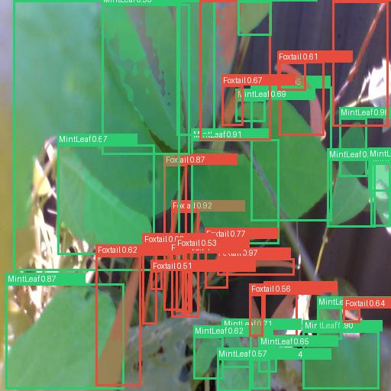

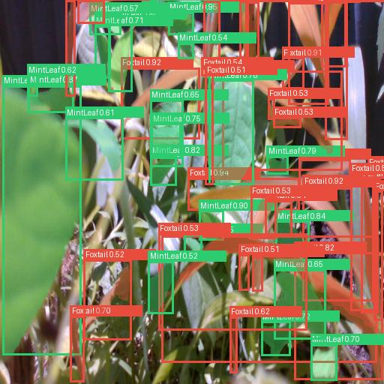

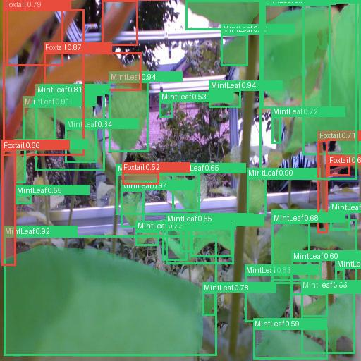

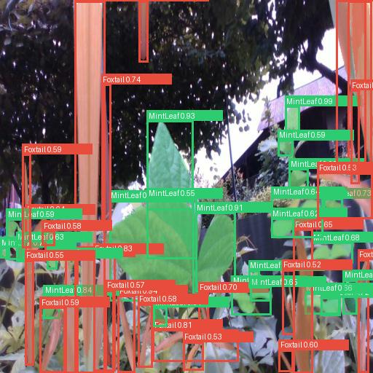



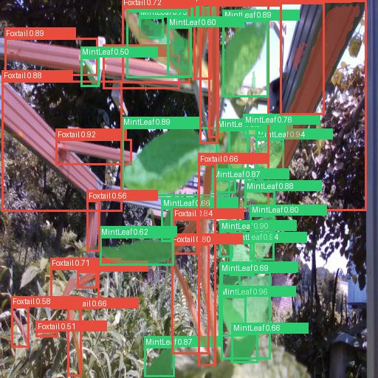

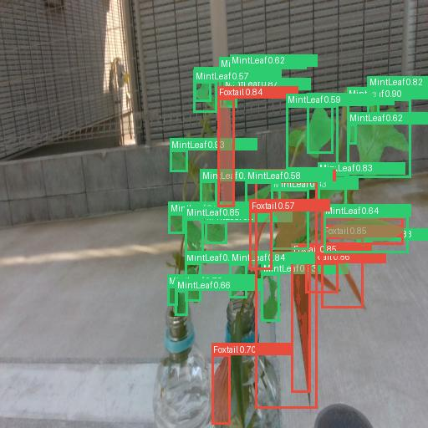

I have data.yaml file in which I adjusted the paths for dataset.I set epochs.I got best.pt weights.From roboflow I downloaded training and test images .For annotated images the json files are
I have data.yaml file too in which I set paths for my training and validation images.I set paths as
Annotations.coco.json.

I have metrics.json files in which I have saved results for my log.

{"iteration": 1, "epoch": 0, "total_loss": 8.7323, "loss_classifier": 1.628, "loss_box_reg": 0.7496, "loss_mask": 1.8608, "loss_objectness": 4.0393, "loss_rpn_box_reg": 0.4547}
{"iteration": 2, "epoch": 0, "total_loss": 3.6377, "loss_classifier": 1.0707, "loss_box_reg": 0.427, "loss_mask": 0.7828, "loss_objectness": 0.636, "loss_rpn_box_reg": 0.7211}
{"iteration": 3, "epoch": 0, "total_loss": 3.3637, "loss_classifier": 0.6188, "loss_box_reg": 0.3627, "loss_mask": 0.7793, "loss_objectness": 1.2598, "loss_rpn_box_reg": 0.3431}
{"iteration": 4, "epoch": 0, "total_loss": 2.5982, "loss_classifier": 0.5973, "loss_box_reg": 0.4125, "loss_mask": 0.7347, "loss_objectness": 0.4818, "loss_rpn_box_reg": 0.3719}
{"iteration": 5, "epoch": 0, "total_loss": 2.9276, "loss_classifier": 0.8176, "loss_box_reg": 0.4835, "loss_mask": 0.6725, "loss_objectness": 0.4357, "loss_rpn_box_reg": 0.5182}
{"iteration": 6, "epoch": 0, "total_loss": 2.7838, "loss_classifier": 0.6862, "loss_box_reg": 0.4172, "loss_mask": 0.6411, "loss_objectness": 0.6117, "loss_rpn_box_reg": 0.4276}
{"iteration": 7, "epoch": 0, "total_loss": 2.2446, "loss_classifier": 0.537, "loss_box_reg": 0.3357, "loss_mask": 0.571, "loss_objectness": 0.3951, "loss_rpn_box_reg": 0.4057}
{"iteration": 8, "epoch": 0, "total_loss": 2.9107, "loss_classifier": 0.8919, "loss_box_reg": 0.484, "loss_mask": 0.5831, "loss_objectness": 0.448, "loss_rpn_box_reg": 0.5036}
{"iteration": 9, "epoch": 0, "total_loss": 2.7783, "loss_classifier": 0.7122, "loss_box_reg": 0.4311, "loss_mask": 0.5535, "loss_objectness": 0.4785, "loss_rpn_box_reg": 0.6031}
{"iteration": 10, "epoch": 0, "total_loss": 2.7261, "loss_classifier": 0.6717, "loss_box_reg": 0.4846, "loss_mask": 0.559, "loss_objectness": 0.5377, "loss_rpn_box_reg": 0.4731}
{"iteration": 11, "epoch": 0, "total_loss": 2.383, "loss_classifier": 0.3739, "loss_box_reg": 0.2981, "loss_mask": 0.5497, "loss_objectness": 0.8195, "loss_rpn_box_reg": 0.3418}
{"iteration": 12, "epoch": 0, "total_loss": 2.8649, "loss_classifier": 0.8631, "loss_box_reg": 0.6485, "loss_mask": 0.5135, "loss_objectness": 0.3884, "loss_rpn_box_reg": 0.4514}
{"iteration": 13, "epoch": 0, "total_loss": 1.6485, "loss_classifier": 0.4085, "loss_box_reg": 0.3345, "loss_mask": 0.4678, "loss_objectness": 0.2925, "loss_rpn_box_reg": 0.1453}
{"iteration": 14, "epoch": 0, "total_loss": 1.7745, "loss_classifier": 0.3434, "loss_box_reg": 0.2995, "loss_mask": 0.3938, "loss_objectness": 0.381, "loss_rpn_box_reg": 0.3567}
{"iteration": 14, "epoch": 0, "epoch_train_loss": 3.0981, "epoch_val_loss": 2.5363}
{"iteration": 15, "epoch": 1, "total_loss": 2.5857, "loss_classifier": 0.7202, "loss_box_reg": 0.6248, "loss_mask": 0.4978, "loss_objectness": 0.3275, "loss_rpn_box_reg": 0.4154}
{"iteration": 16, "epoch": 1, "total_loss": 2.1135, "loss_classifier": 0.6229, "loss_box_reg": 0.551, "loss_mask": 0.4216, "loss_objectness": 0.3113, "loss_rpn_box_reg": 0.2067}
{"iteration": 17, "epoch": 1, "total_loss": 2.8592, "loss_classifier": 0.7891, "loss_box_reg": 0.5909, "loss_mask": 0.4467, "loss_objectness": 0.4924, "loss_rpn_box_reg": 0.54}
{"iteration": 18, "epoch": 1, "total_loss": 1.585, "loss_classifier": 0.2499, "loss_box_reg": 0.2019, "loss_mask": 0.3395, "loss_objectness": 0.3087, "loss_rpn_box_reg": 0.485}
{"iteration": 19, "epoch": 1, "total_loss": 1.6789, "loss_classifier": 0.4088, "loss_box_reg": 0.292, "loss_mask": 0.3341, "loss_objectness": 0.3615, "loss_rpn_box_reg": 0.2825}
{"iteration": 20, "epoch": 1, "total_loss": 2.526, "loss_classifier": 0.7155, "loss_box_reg": 0.555, "loss_mask": 0.4043, "loss_objectness": 0.4035, "loss_rpn_box_reg": 0.4476}
{"iteration": 21, "epoch": 1, "total_loss": 2.3515, "loss_classifier": 0.6357, "loss_box_reg": 0.5644, "loss_mask": 0.3743, "loss_objectness": 0.3433, "loss_rpn_box_reg": 0.4338}
{"iteration": 22, "epoch": 1, "total_loss": 2.0134, "loss_classifier": 0.4718, "loss_box_reg": 0.4205, "loss_mask": 0.3715, "loss_objectness": 0.3267, "loss_rpn_box_reg": 0.4228}
{"iteration": 23, "epoch": 1, "total_loss": 2.3878, "loss_classifier": 0.5537, "loss_box_reg": 0.458, "loss_mask": 0.258, "loss_objectness": 0.351, "loss_rpn_box_reg": 0.7671}
{"iteration": 24, "epoch": 1, "total_loss": 2.3196, "loss_classifier": 0.6786, "loss_box_reg": 0.5841, "loss_mask": 0.3048, "loss_objectness": 0.3901, "loss_rpn_box_reg": 0.3621}
{"iteration": 25, "epoch": 1, "total_loss": 2.5628, "loss_classifier": 0.7502, "loss_box_reg": 0.7217, "loss_mask": 0.3844, "loss_objectness": 0.3292, "loss_rpn_box_reg": 0.3773}
{"iteration": 26, "epoch": 1, "total_loss": 1.3393, "loss_classifier": 0.3215, "loss_box_reg": 0.3533, "loss_mask": 0.3723, "loss_objectness": 0.2109, "loss_rpn_box_reg": 0.0813}
{"iteration": 27, "epoch": 1, "total_loss": 2.4232, "loss_classifier": 0.7178, "loss_box_reg": 0.4842, "loss_mask": 0.3802, "loss_objectness": 0.3138, "loss_rpn_box_reg": 0.5272}
{"iteration": 28, "epoch": 1, "total_loss": 1.9953, "loss_classifier": 0.4863, "loss_box_reg": 0.3563, "loss_mask": 0.4288, "loss_objectness": 0.2851, "loss_rpn_box_reg": 0.4387}
{"iteration": 28, "epoch": 1, "epoch_train_loss": 2.1958, "epoch_val_loss": 2.1534}
{"iteration": 29, "epoch": 2, "total_loss": 2.3209, "loss_classifier": 0.7611, "loss_box_reg": 0.6373, "loss_mask": 0.3504, "loss_objectness": 0.227, "loss_rpn_box_reg": 0.345}
{"iteration": 30, "epoch": 2, "total_loss": 2.2753, "loss_classifier": 0.6075, "loss_box_reg": 0.5615, "loss_mask": 0.3841, "loss_objectness": 0.2508, "loss_rpn_box_reg": 0.4714}
{"iteration": 31, "epoch": 2, "total_loss": 1.8345, "loss_classifier": 0.476, "loss_box_reg": 0.4382, "loss_mask": 0.3653, "loss_objectness": 0.2693, "loss_rpn_box_reg": 0.2857}
{"iteration": 32, "epoch": 2, "total_loss": 2.7186, "loss_classifier": 0.6974, "loss_box_reg": 0.5862, "loss_mask": 0.321, "loss_objectness": 0.5474, "loss_rpn_box_reg": 0.5667}
{"iteration": 33, "epoch": 2, "total_loss": 1.8496, "loss_classifier": 0.5104, "loss_box_reg": 0.4825, "loss_mask": 0.2735, "loss_objectness": 0.2016, "loss_rpn_box_reg": 0.3816}
{"iteration": 34, "epoch": 2, "total_loss": 2.1259, "loss_classifier": 0.5944, "loss_box_reg": 0.5387, "loss_mask": 0.3126, "loss_objectness": 0.2447, "loss_rpn_box_reg": 0.4355}
{"iteration": 35, "epoch": 2, "total_loss": 2.3396, "loss_classifier": 0.6834, "loss_box_reg": 0.7596, "loss_mask": 0.3, "loss_objectness": 0.2731, "loss_rpn_box_reg": 0.3234}
{"iteration": 36, "epoch": 2, "total_loss": 2.3444, "loss_classifier": 0.5805, "loss_box_reg": 0.6011, "loss_mask": 0.2607, "loss_objectness": 0.262, "loss_rpn_box_reg": 0.6402}
{"iteration": 37, "epoch": 2, "total_loss": 1.6301, "loss_classifier": 0.3498, "loss_box_reg": 0.3468, "loss_mask": 0.2605, "loss_objectness": 0.2794, "loss_rpn_box_reg": 0.3936}
{"iteration": 38, "epoch": 2, "total_loss": 1.6247, "loss_classifier": 0.4342, "loss_box_reg": 0.4152, "loss_mask": 0.2672, "loss_objectness": 0.2287, "loss_rpn_box_reg": 0.2793}
{"iteration": 39, "epoch": 2, "total_loss": 1.6185, "loss_classifier": 0.4431, "loss_box_reg": 0.5325, "loss_mask": 0.2711, "loss_objectness": 0.1586, "loss_rpn_box_reg": 0.2132}
{"iteration": 40, "epoch": 2, "total_loss": 2.0797, "loss_classifier": 0.5788, "loss_box_reg": 0.4295, "loss_mask": 0.417, "loss_objectness": 0.2407, "loss_rpn_box_reg": 0.4138}
{"iteration": 41, "epoch": 2, "total_loss": 1.7948, "loss_classifier": 0.4775, "loss_box_reg": 0.5695, "loss_mask": 0.2496, "loss_objectness": 0.1924, "loss_rpn_box_reg": 0.3059}
{"iteration": 42, "epoch": 2, "total_loss": 2.618, "loss_classifier": 0.6751, "loss_box_reg": 0.7399, "loss_mask": 0.3207, "loss_objectness": 0.3992, "loss_rpn_box_reg": 0.4832}
{"iteration": 42, "epoch": 2, "epoch_train_loss": 2.0839, "epoch_val_loss": 2.1274}
{"iteration": 43, "epoch": 3, "total_loss": 2.0107, "loss_classifier": 0.4642, "loss_box_reg": 0.5082, "loss_mask": 0.3075, "loss_objectness": 0.2469, "loss_rpn_box_reg": 0.4838}
{"iteration": 44, "epoch": 3, "total_loss": 1.8006, "loss_classifier": 0.4986, "loss_box_reg": 0.4455, "loss_mask": 0.309, "loss_objectness": 0.1833, "loss_rpn_box_reg": 0.3642}
{"iteration": 45, "epoch": 3, "total_loss": 2.0315, "loss_classifier": 0.556, "loss_box_reg": 0.5231, "loss_mask": 0.2927, "loss_objectness": 0.2423, "loss_rpn_box_reg": 0.4175}
{"iteration": 46, "epoch": 3, "total_loss": 2.0878, "loss_classifier": 0.7099, "loss_box_reg": 0.6716, "loss_mask": 0.2845, "loss_objectness": 0.2016, "loss_rpn_box_reg": 0.2201}
{"iteration": 47, "epoch": 3, "total_loss": 2.2729, "loss_classifier": 0.5976, "loss_box_reg": 0.6311, "loss_mask": 0.3104, "loss_objectness": 0.2471, "loss_rpn_box_reg": 0.4868}
{"iteration": 48, "epoch": 3, "total_loss": 2.2509, "loss_classifier": 0.6427, "loss_box_reg": 0.626, "loss_mask": 0.2862, "loss_objectness": 0.323, "loss_rpn_box_reg": 0.3731}
{"iteration": 49, "epoch": 3, "total_loss": 1.9619, "loss_classifier": 0.5985, "loss_box_reg": 0.5253, "loss_mask": 0.3642, "loss_objectness": 0.1952, "loss_rpn_box_reg": 0.2787}
{"iteration": 50, "epoch": 3, "total_loss": 1.7987, "loss_classifier": 0.5142, "loss_box_reg": 0.563, "loss_mask": 0.2679, "loss_objectness": 0.1825, "loss_rpn_box_reg": 0.2712}
{"iteration": 51, "epoch": 3, "total_loss": 1.6811, "loss_classifier": 0.4687, "loss_box_reg": 0.4224, "loss_mask": 0.2665, "loss_objectness": 0.2415, "loss_rpn_box_reg": 0.2821}
{"iteration": 52, "epoch": 3, "total_loss": 1.6716, "loss_classifier": 0.3965, "loss_box_reg": 0.4587, "loss_mask": 0.2332, "loss_objectness": 0.1629, "loss_rpn_box_reg": 0.4203}
{"iteration": 53, "epoch": 3, "total_loss": 1.6488, "loss_classifier": 0.4849, "loss_box_reg": 0.4439, "loss_mask": 0.227, "loss_objectness": 0.256, "loss_rpn_box_reg": 0.2371}
{"iteration": 54, "epoch": 3, "total_loss": 1.7419, "loss_classifier": 0.4922, "loss_box_reg": 0.6082, "loss_mask": 0.2268, "loss_objectness": 0.1509, "loss_rpn_box_reg": 0.2639}
{"iteration": 55, "epoch": 3, "total_loss": 2.1045, "loss_classifier": 0.6056, "loss_box_reg": 0.6585, "loss_mask": 0.2676, "loss_objectness": 0.2079, "loss_rpn_box_reg": 0.3649}
{"iteration": 56, "epoch": 3, "total_loss": 2.1357, "loss_classifier": 0.5335, "loss_box_reg": 0.5936, "loss_mask": 0.2405, "loss_objectness": 0.1653, "loss_rpn_box_reg": 0.6028}
{"iteration": 56, "epoch": 3, "epoch_train_loss": 1.9428, "epoch_val_loss": 2.0595}
{"iteration": 57, "epoch": 4, "total_loss": 1.5362, "loss_classifier": 0.3732, "loss_box_reg": 0.4073, "loss_mask": 0.3077, "loss_objectness": 0.1473, "loss_rpn_box_reg": 0.3008}
{"iteration": 58, "epoch": 4, "total_loss": 2.2254, "loss_classifier": 0.6498, "loss_box_reg": 0.6405, "loss_mask": 0.2925, "loss_objectness": 0.2733, "loss_rpn_box_reg": 0.3693}
{"iteration": 59, "epoch": 4, "total_loss": 1.4756, "loss_classifier": 0.4079, "loss_box_reg": 0.4134, "loss_mask": 0.2273, "loss_objectness": 0.1226, "loss_rpn_box_reg": 0.3044}
{"iteration": 60, "epoch": 4, "total_loss": 1.8564, "loss_classifier": 0.5061, "loss_box_reg": 0.6205, "loss_mask": 0.2236, "loss_objectness": 0.2261, "loss_rpn_box_reg": 0.2802}
{"iteration": 61, "epoch": 4, "total_loss": 2.0075, "loss_classifier": 0.5274, "loss_box_reg": 0.5917, "loss_mask": 0.2824, "loss_objectness": 0.2361, "loss_rpn_box_reg": 0.3698}
{"iteration": 62, "epoch": 4, "total_loss": 2.0407, "loss_classifier": 0.5913, "loss_box_reg": 0.5887, "loss_mask": 0.2426, "loss_objectness": 0.2449, "loss_rpn_box_reg": 0.3733}
{"iteration": 63, "epoch": 4, "total_loss": 2.3044, "loss_classifier": 0.6031, "loss_box_reg": 0.5236, "loss_mask": 0.2815, "loss_objectness": 0.3801, "loss_rpn_box_reg": 0.5161}
{"iteration": 64, "epoch": 4, "total_loss": 1.3018, "loss_classifier": 0.2776, "loss_box_reg": 0.3818, "loss_mask": 0.141, "loss_objectness": 0.0827, "loss_rpn_box_reg": 0.4186}
{"iteration": 65, "epoch": 4, "total_loss": 1.908, "loss_classifier": 0.51, "loss_box_reg": 0.5095, "loss_mask": 0.2861, "loss_objectness": 0.1736, "loss_rpn_box_reg": 0.4287}
{"iteration": 66, "epoch": 4, "total_loss": 1.4174, "loss_classifier": 0.4313, "loss_box_reg": 0.4287, "loss_mask": 0.2271, "loss_objectness": 0.1929, "loss_rpn_box_reg": 0.1373}
{"iteration": 67, "epoch": 4, "total_loss": 1.651, "loss_classifier": 0.4743, "loss_box_reg": 0.5022, "loss_mask": 0.2564, "loss_objectness": 0.0958, "loss_rpn_box_reg": 0.3222}
{"iteration": 68, "epoch": 4, "total_loss": 2.1897, "loss_classifier": 0.7419, "loss_box_reg": 0.6026, "loss_mask": 0.2756, "loss_objectness": 0.2959, "loss_rpn_box_reg": 0.2736}
{"iteration": 69, "epoch": 4, "total_loss": 2.1922, "loss_classifier": 0.6566, "loss_box_reg": 0.5947, "loss_mask": 0.3175, "loss_objectness": 0.1874, "loss_rpn_box_reg": 0.436}
{"iteration": 70, "epoch": 4, "total_loss": 1.4598, "loss_classifier": 0.3106, "loss_box_reg": 0.4135, "loss_mask": 0.3011, "loss_objectness": 0.1188, "loss_rpn_box_reg": 0.3158}
{"iteration": 70, "epoch": 4, "epoch_train_loss": 1.8261, "epoch_val_loss": 1.9893}
{"iteration": 71, "epoch": 5, "total_loss": 1.2837, "loss_classifier": 0.2832, "loss_box_reg": 0.3238, "loss_mask": 0.2463, "loss_objectness": 0.0918, "loss_rpn_box_reg": 0.3386}
{"iteration": 72, "epoch": 5, "total_loss": 1.5036, "loss_classifier": 0.4159, "loss_box_reg": 0.4423, "loss_mask": 0.2656, "loss_objectness": 0.1366, "loss_rpn_box_reg": 0.2433}
{"iteration": 73, "epoch": 5, "total_loss": 1.5757, "loss_classifier": 0.4469, "loss_box_reg": 0.4223, "loss_mask": 0.2139, "loss_objectness": 0.226, "loss_rpn_box_reg": 0.2666}
{"iteration": 74, "epoch": 5, "total_loss": 1.8437, "loss_classifier": 0.4697, "loss_box_reg": 0.5609, "loss_mask": 0.2744, "loss_objectness": 0.1538, "loss_rpn_box_reg": 0.3847}
{"iteration": 75, "epoch": 5, "total_loss": 1.8226, "loss_classifier": 0.5006, "loss_box_reg": 0.5679, "loss_mask": 0.2617, "loss_objectness": 0.1778, "loss_rpn_box_reg": 0.3146}
{"iteration": 76, "epoch": 5, "total_loss": 1.3135, "loss_classifier": 0.3763, "loss_box_reg": 0.4643, "loss_mask": 0.2271, "loss_objectness": 0.104, "loss_rpn_box_reg": 0.1419}
{"iteration": 77, "epoch": 5, "total_loss": 1.9458, "loss_classifier": 0.5788, "loss_box_reg": 0.493, "loss_mask": 0.2617, "loss_objectness": 0.2317, "loss_rpn_box_reg": 0.3807}
{"iteration": 78, "epoch": 5, "total_loss": 1.9272, "loss_classifier": 0.5393, "loss_box_reg": 0.6012, "loss_mask": 0.2658, "loss_objectness": 0.1678, "loss_rpn_box_reg": 0.3531}
{"iteration": 79, "epoch": 5, "total_loss": 1.9993, "loss_classifier": 0.4758, "loss_box_reg": 0.5525, "loss_mask": 0.2031, "loss_objectness": 0.1857, "loss_rpn_box_reg": 0.5823}
{"iteration": 80, "epoch": 5, "total_loss": 1.9379, "loss_classifier": 0.5545, "loss_box_reg": 0.5475, "loss_mask": 0.3033, "loss_objectness": 0.1417, "loss_rpn_box_reg": 0.3908}
{"iteration": 81, "epoch": 5, "total_loss": 1.2387, "loss_classifier": 0.3376, "loss_box_reg": 0.3395, "loss_mask": 0.1856, "loss_objectness": 0.2037, "loss_rpn_box_reg": 0.1723}
{"iteration": 82, "epoch": 5, "total_loss": 1.9028, "loss_classifier": 0.5887, "loss_box_reg": 0.5645, "loss_mask": 0.2668, "loss_objectness": 0.1778, "loss_rpn_box_reg": 0.3049}
{"iteration": 83, "epoch": 5, "total_loss": 1.6124, "loss_classifier": 0.4819, "loss_box_reg": 0.4494, "loss_mask": 0.2179, "loss_objectness": 0.178, "loss_rpn_box_reg": 0.2851}
{"iteration": 84, "epoch": 5, "total_loss": 1.7538, "loss_classifier": 0.4749, "loss_box_reg": 0.5135, "loss_mask": 0.2692, "loss_objectness": 0.1248, "loss_rpn_box_reg": 0.3713}
{"iteration": 84, "epoch": 5, "epoch_train_loss": 1.69, "epoch_val_loss": 1.9053}
{"iteration": 85, "epoch": 6, "total_loss": 1.4501, "loss_classifier": 0.4311, "loss_box_reg": 0.4376, "loss_mask": 0.199, "loss_objectness": 0.1375, "loss_rpn_box_reg": 0.2449}
{"iteration": 86, "epoch": 6, "total_loss": 1.7413, "loss_classifier": 0.5115, "loss_box_reg": 0.5112, "loss_mask": 0.2342, "loss_objectness": 0.1802, "loss_rpn_box_reg": 0.3042}
{"iteration": 87, "epoch": 6, "total_loss": 1.9319, "loss_classifier": 0.5547, "loss_box_reg": 0.4981, "loss_mask": 0.2857, "loss_objectness": 0.1597, "loss_rpn_box_reg": 0.4337}
{"iteration": 88, "epoch": 6, "total_loss": 1.9925, "loss_classifier": 0.6013, "loss_box_reg": 0.6539, "loss_mask": 0.3016, "loss_objectness": 0.1615, "loss_rpn_box_reg": 0.2741}
{"iteration": 89, "epoch": 6, "total_loss": 1.7866, "loss_classifier": 0.4753, "loss_box_reg": 0.5128, "loss_mask": 0.2461, "loss_objectness": 0.1354, "loss_rpn_box_reg": 0.417}
{"iteration": 90, "epoch": 6, "total_loss": 1.4038, "loss_classifier": 0.3796, "loss_box_reg": 0.3965, "loss_mask": 0.2525, "loss_objectness": 0.1325, "loss_rpn_box_reg": 0.2428}
{"iteration": 91, "epoch": 6, "total_loss": 1.8048, "loss_classifier": 0.4112, "loss_box_reg": 0.4617, "loss_mask": 0.1946, "loss_objectness": 0.1744, "loss_rpn_box_reg": 0.563}
{"iteration": 92, "epoch": 6, "total_loss": 1.3076, "loss_classifier": 0.4022, "loss_box_reg": 0.4081, "loss_mask": 0.236, "loss_objectness": 0.1202, "loss_rpn_box_reg": 0.141}
{"iteration": 93, "epoch": 6, "total_loss": 1.3161, "loss_classifier": 0.4261, "loss_box_reg": 0.3873, "loss_mask": 0.1859, "loss_objectness": 0.094, "loss_rpn_box_reg": 0.2228}
{"iteration": 94, "epoch": 6, "total_loss": 1.5601, "loss_classifier": 0.4497, "loss_box_reg": 0.5105, "loss_mask": 0.235, "loss_objectness": 0.1326, "loss_rpn_box_reg": 0.2323}
{"iteration": 95, "epoch": 6, "total_loss": 1.3352, "loss_classifier": 0.3058, "loss_box_reg": 0.419, "loss_mask": 0.2504, "loss_objectness": 0.0745, "loss_rpn_box_reg": 0.2855}
{"iteration": 96, "epoch": 6, "total_loss": 1.4873, "loss_classifier": 0.4131, "loss_box_reg": 0.3127, "loss_mask": 0.2794, "loss_objectness": 0.2279, "loss_rpn_box_reg": 0.2543}
{"iteration": 97, "epoch": 6, "total_loss": 1.6406, "loss_classifier": 0.4364, "loss_box_reg": 0.4696, "loss_mask": 0.2094, "loss_objectness": 0.1976, "loss_rpn_box_reg": 0.3277}
{"iteration": 98, "epoch": 6, "total_loss": 2.1282, "loss_classifier": 0.5942, "loss_box_reg": 0.5496, "loss_mask": 0.2376, "loss_objectness": 0.3751, "loss_rpn_box_reg": 0.3717}
{"iteration": 98, "epoch": 6, "epoch_train_loss": 1.6347, "epoch_val_loss": 1.8992}
{"iteration": 99, "epoch": 7, "total_loss": 1.5824, "loss_classifier": 0.3863, "loss_box_reg": 0.5344, "loss_mask": 0.2185, "loss_objectness": 0.1189, "loss_rpn_box_reg": 0.3243}
{"iteration": 100, "epoch": 7, "total_loss": 1.23, "loss_classifier": 0.3787, "loss_box_reg": 0.306, "loss_mask": 0.1894, "loss_objectness": 0.1421, "loss_rpn_box_reg": 0.2138}
{"iteration": 101, "epoch": 7, "total_loss": 1.5016, "loss_classifier": 0.5151, "loss_box_reg": 0.4844, "loss_mask": 0.2288, "loss_objectness": 0.1389, "loss_rpn_box_reg": 0.1343}
{"iteration": 102, "epoch": 7, "total_loss": 1.3982, "loss_classifier": 0.2335, "loss_box_reg": 0.4022, "loss_mask": 0.1323, "loss_objectness": 0.0969, "loss_rpn_box_reg": 0.5333}
{"iteration": 103, "epoch": 7, "total_loss": 1.3885, "loss_classifier": 0.3006, "loss_box_reg": 0.322, "loss_mask": 0.2314, "loss_objectness": 0.168, "loss_rpn_box_reg": 0.3665}
{"iteration": 104, "epoch": 7, "total_loss": 1.4069, "loss_classifier": 0.4043, "loss_box_reg": 0.3341, "loss_mask": 0.2594, "loss_objectness": 0.1772, "loss_rpn_box_reg": 0.2318}
{"iteration": 105, "epoch": 7, "total_loss": 2.0225, "loss_classifier": 0.6681, "loss_box_reg": 0.5514, "loss_mask": 0.2875, "loss_objectness": 0.1554, "loss_rpn_box_reg": 0.36}
{"iteration": 106, "epoch": 7, "total_loss": 2.0939, "loss_classifier": 0.6464, "loss_box_reg": 0.5337, "loss_mask": 0.2959, "loss_objectness": 0.2744, "loss_rpn_box_reg": 0.3436}
{"iteration": 107, "epoch": 7, "total_loss": 1.7847, "loss_classifier": 0.547, "loss_box_reg": 0.471, "loss_mask": 0.2317, "loss_objectness": 0.1697, "loss_rpn_box_reg": 0.3653}
{"iteration": 108, "epoch": 7, "total_loss": 1.717, "loss_classifier": 0.4191, "loss_box_reg": 0.4087, "loss_mask": 0.2749, "loss_objectness": 0.1985, "loss_rpn_box_reg": 0.4158}
{"iteration": 109, "epoch": 7, "total_loss": 1.7911, "loss_classifier": 0.4683, "loss_box_reg": 0.5318, "loss_mask": 0.2124, "loss_objectness": 0.192, "loss_rpn_box_reg": 0.3866}
{"iteration": 110, "epoch": 7, "total_loss": 1.8875, "loss_classifier": 0.5055, "loss_box_reg": 0.5008, "loss_mask": 0.2318, "loss_objectness": 0.295, "loss_rpn_box_reg": 0.3545}
{"iteration": 111, "epoch": 7, "total_loss": 0.8223, "loss_classifier": 0.2111, "loss_box_reg": 0.258, "loss_mask": 0.1579, "loss_objectness": 0.0587, "loss_rpn_box_reg": 0.1366}
{"iteration": 112, "epoch": 7, "total_loss": 1.6641, "loss_classifier": 0.4064, "loss_box_reg": 0.4066, "loss_mask": 0.2442, "loss_objectness": 0.2246, "loss_rpn_box_reg": 0.3822}
{"iteration": 112, "epoch": 7, "epoch_train_loss": 1.5922, "epoch_val_loss": 1.8028}
{"iteration": 113, "epoch": 8, "total_loss": 1.0575, "loss_classifier": 0.3584, "loss_box_reg": 0.3849, "loss_mask": 0.1991, "loss_objectness": 0.0594, "loss_rpn_box_reg": 0.0556}
{"iteration": 114, "epoch": 8, "total_loss": 1.4676, "loss_classifier": 0.3686, "loss_box_reg": 0.3985, "loss_mask": 0.1953, "loss_objectness": 0.1566, "loss_rpn_box_reg": 0.3487}
{"iteration": 115, "epoch": 8, "total_loss": 1.6547, "loss_classifier": 0.4853, "loss_box_reg": 0.5035, "loss_mask": 0.2212, "loss_objectness": 0.1891, "loss_rpn_box_reg": 0.2556}
{"iteration": 116, "epoch": 8, "total_loss": 1.4812, "loss_classifier": 0.3679, "loss_box_reg": 0.4727, "loss_mask": 0.2761, "loss_objectness": 0.0871, "loss_rpn_box_reg": 0.2774}
{"iteration": 117, "epoch": 8, "total_loss": 1.666, "loss_classifier": 0.4643, "loss_box_reg": 0.4235, "loss_mask": 0.2592, "loss_objectness": 0.1671, "loss_rpn_box_reg": 0.3521}
{"iteration": 118, "epoch": 8, "total_loss": 1.9607, "loss_classifier": 0.5325, "loss_box_reg": 0.5214, "loss_mask": 0.2572, "loss_objectness": 0.2485, "loss_rpn_box_reg": 0.4012}
{"iteration": 119, "epoch": 8, "total_loss": 1.2584, "loss_classifier": 0.233, "loss_box_reg": 0.4184, "loss_mask": 0.1465, "loss_objectness": 0.0361, "loss_rpn_box_reg": 0.4245}
{"iteration": 120, "epoch": 8, "total_loss": 1.6052, "loss_classifier": 0.4863, "loss_box_reg": 0.4648, "loss_mask": 0.2065, "loss_objectness": 0.1581, "loss_rpn_box_reg": 0.2894}
{"iteration": 121, "epoch": 8, "total_loss": 1.3263, "loss_classifier": 0.3566, "loss_box_reg": 0.4242, "loss_mask": 0.2274, "loss_objectness": 0.0875, "loss_rpn_box_reg": 0.2305}
{"iteration": 122, "epoch": 8, "total_loss": 1.7809, "loss_classifier": 0.5399, "loss_box_reg": 0.5178, "loss_mask": 0.2353, "loss_objectness": 0.1674, "loss_rpn_box_reg": 0.3205}
{"iteration": 123, "epoch": 8, "total_loss": 0.9046, "loss_classifier": 0.2192, "loss_box_reg": 0.1654, "loss_mask": 0.1562, "loss_objectness": 0.1743, "loss_rpn_box_reg": 0.1894}
{"iteration": 124, "epoch": 8, "total_loss": 1.5355, "loss_classifier": 0.4277, "loss_box_reg": 0.4831, "loss_mask": 0.2271, "loss_objectness": 0.1805, "loss_rpn_box_reg": 0.2171}
{"iteration": 125, "epoch": 8, "total_loss": 1.6627, "loss_classifier": 0.4788, "loss_box_reg": 0.5029, "loss_mask": 0.2264, "loss_objectness": 0.1416, "loss_rpn_box_reg": 0.313}
{"iteration": 126, "epoch": 8, "total_loss": 2.1844, "loss_classifier": 0.6954, "loss_box_reg": 0.6005, "loss_mask": 0.3121, "loss_objectness": 0.1963, "loss_rpn_box_reg": 0.3802}
{"iteration": 126, "epoch": 8, "epoch_train_loss": 1.539, "epoch_val_loss": 1.9579}
{"iteration": 127, "epoch": 9, "total_loss": 1.5287, "loss_classifier": 0.4378, "loss_box_reg": 0.4675, "loss_mask": 0.1739, "loss_objectness": 0.1651, "loss_rpn_box_reg": 0.2843}
{"iteration": 128, "epoch": 9, "total_loss": 1.6194, "loss_classifier": 0.4551, "loss_box_reg": 0.4455, "loss_mask": 0.2155, "loss_objectness": 0.1548, "loss_rpn_box_reg": 0.3485}
{"iteration": 129, "epoch": 9, "total_loss": 1.8082, "loss_classifier": 0.5001, "loss_box_reg": 0.5495, "loss_mask": 0.2815, "loss_objectness": 0.1292, "loss_rpn_box_reg": 0.3479}
{"iteration": 130, "epoch": 9, "total_loss": 1.2361, "loss_classifier": 0.3474, "loss_box_reg": 0.3786, "loss_mask": 0.218, "loss_objectness": 0.1024, "loss_rpn_box_reg": 0.1898}
{"iteration": 131, "epoch": 9, "total_loss": 1.8875, "loss_classifier": 0.5479, "loss_box_reg": 0.5155, "loss_mask": 0.2477, "loss_objectness": 0.241, "loss_rpn_box_reg": 0.3354}
{"iteration": 132, "epoch": 9, "total_loss": 1.3208, "loss_classifier": 0.3912, "loss_box_reg": 0.3428, "loss_mask": 0.2483, "loss_objectness": 0.1054, "loss_rpn_box_reg": 0.2332}
{"iteration": 133, "epoch": 9, "total_loss": 1.7341, "loss_classifier": 0.3991, "loss_box_reg": 0.4359, "loss_mask": 0.197, "loss_objectness": 0.1343, "loss_rpn_box_reg": 0.5677}
{"iteration": 134, "epoch": 9, "total_loss": 1.0596, "loss_classifier": 0.3148, "loss_box_reg": 0.3732, "loss_mask": 0.1699, "loss_objectness": 0.0619, "loss_rpn_box_reg": 0.1397}
{"iteration": 135, "epoch": 9, "total_loss": 1.4933, "loss_classifier": 0.445, "loss_box_reg": 0.3578, "loss_mask": 0.2028, "loss_objectness": 0.141, "loss_rpn_box_reg": 0.3467}
{"iteration": 136, "epoch": 9, "total_loss": 1.3102, "loss_classifier": 0.3962, "loss_box_reg": 0.335, "loss_mask": 0.2139, "loss_objectness": 0.1719, "loss_rpn_box_reg": 0.1931}
{"iteration": 137, "epoch": 9, "total_loss": 1.5215, "loss_classifier": 0.4245, "loss_box_reg": 0.4583, "loss_mask": 0.2127, "loss_objectness": 0.1942, "loss_rpn_box_reg": 0.2319}
{"iteration": 138, "epoch": 9, "total_loss": 0.8548, "loss_classifier": 0.1956, "loss_box_reg": 0.2545, "loss_mask": 0.194, "loss_objectness": 0.0432, "loss_rpn_box_reg": 0.1674}
{"iteration": 139, "epoch": 9, "total_loss": 1.3126, "loss_classifier": 0.3687, "loss_box_reg": 0.404, "loss_mask": 0.2355, "loss_objectness": 0.0652, "loss_rpn_box_reg": 0.2393}
{"iteration": 140, "epoch": 9, "total_loss": 1.9987, "loss_classifier": 0.6012, "loss_box_reg": 0.5743, "loss_mask": 0.3049, "loss_objectness": 0.1257, "loss_rpn_box_reg": 0.3927}
{"iteration": 140, "epoch": 9, "epoch_train_loss": 1.4775, "epoch_val_loss": 1.938}
{"iteration": 141, "epoch": 10, "total_loss": 1.3629, "loss_classifier": 0.4158, "loss_box_reg": 0.3972, "loss_mask": 0.2035, "loss_objectness": 0.1472, "loss_rpn_box_reg": 0.1993}
{"iteration": 142, "epoch": 10, "total_loss": 1.1619, "loss_classifier": 0.3292, "loss_box_reg": 0.3575, "loss_mask": 0.2504, "loss_objectness": 0.0482, "loss_rpn_box_reg": 0.1767}
{"iteration": 143, "epoch": 10, "total_loss": 1.5397, "loss_classifier": 0.3972, "loss_box_reg": 0.4917, "loss_mask": 0.2316, "loss_objectness": 0.1233, "loss_rpn_box_reg": 0.296}
{"iteration": 144, "epoch": 10, "total_loss": 1.1948, "loss_classifier": 0.2938, "loss_box_reg": 0.2685, "loss_mask": 0.2387, "loss_objectness": 0.1073, "loss_rpn_box_reg": 0.2865}
{"iteration": 145, "epoch": 10, "total_loss": 1.9542, "loss_classifier": 0.6349, "loss_box_reg": 0.4775, "loss_mask": 0.2864, "loss_objectness": 0.1885, "loss_rpn_box_reg": 0.3668}
{"iteration": 146, "epoch": 10, "total_loss": 1.2823, "loss_classifier": 0.3624, "loss_box_reg": 0.4124, "loss_mask": 0.2158, "loss_objectness": 0.0748, "loss_rpn_box_reg": 0.2169}
{"iteration": 147, "epoch": 10, "total_loss": 1.3082, "loss_classifier": 0.402, "loss_box_reg": 0.3945, "loss_mask": 0.2025, "loss_objectness": 0.1117, "loss_rpn_box_reg": 0.1975}
{"iteration": 148, "epoch": 10, "total_loss": 1.8009, "loss_classifier": 0.5012, "loss_box_reg": 0.448, "loss_mask": 0.2386, "loss_objectness": 0.2172, "loss_rpn_box_reg": 0.3959}
{"iteration": 149, "epoch": 10, "total_loss": 1.6446, "loss_classifier": 0.4896, "loss_box_reg": 0.4157, "loss_mask": 0.2371, "loss_objectness": 0.2003, "loss_rpn_box_reg": 0.3018}
{"iteration": 150, "epoch": 10, "total_loss": 1.1164, "loss_classifier": 0.305, "loss_box_reg": 0.3233, "loss_mask": 0.187, "loss_objectness": 0.0946, "loss_rpn_box_reg": 0.2064}
{"iteration": 151, "epoch": 10, "total_loss": 1.5383, "loss_classifier": 0.4576, "loss_box_reg": 0.4313, "loss_mask": 0.2484, "loss_objectness": 0.1405, "loss_rpn_box_reg": 0.2605}
{"iteration": 152, "epoch": 10, "total_loss": 1.3727, "loss_classifier": 0.33, "loss_box_reg": 0.4471, "loss_mask": 0.1678, "loss_objectness": 0.0412, "loss_rpn_box_reg": 0.3868}
{"iteration": 153, "epoch": 10, "total_loss": 0.5929, "loss_classifier": 0.1648, "loss_box_reg": 0.1602, "loss_mask": 0.1227, "loss_objectness": 0.0725, "loss_rpn_box_reg": 0.0726}
{"iteration": 154, "epoch": 10, "total_loss": 0.9777, "loss_classifier": 0.2554, "loss_box_reg": 0.3007, "loss_mask": 0.1824, "loss_objectness": 0.0518, "loss_rpn_box_reg": 0.1873}
{"iteration": 154, "epoch": 10, "epoch_train_loss": 1.3462, "epoch_val_loss": 1.8995}
{"iteration": 155, "epoch": 11, "total_loss": 1.745, "loss_classifier": 0.5092, "loss_box_reg": 0.5482, "loss_mask": 0.2697, "loss_objectness": 0.1169, "loss_rpn_box_reg": 0.301}
{"iteration": 156, "epoch": 11, "total_loss": 1.5458, "loss_classifier": 0.4556, "loss_box_reg": 0.4153, "loss_mask": 0.2196, "loss_objectness": 0.139, "loss_rpn_box_reg": 0.3163}
{"iteration": 157, "epoch": 11, "total_loss": 1.4156, "loss_classifier": 0.2892, "loss_box_reg": 0.4184, "loss_mask": 0.1915, "loss_objectness": 0.0315, "loss_rpn_box_reg": 0.485}
{"iteration": 158, "epoch": 11, "total_loss": 1.1793, "loss_classifier": 0.2693, "loss_box_reg": 0.3578, "loss_mask": 0.2217, "loss_objectness": 0.1191, "loss_rpn_box_reg": 0.2114}
{"iteration": 159, "epoch": 11, "total_loss": 1.7323, "loss_classifier": 0.4859, "loss_box_reg": 0.4566, "loss_mask": 0.2578, "loss_objectness": 0.1832, "loss_rpn_box_reg": 0.3488}
{"iteration": 160, "epoch": 11, "total_loss": 1.0786, "loss_classifier": 0.2795, "loss_box_reg": 0.2977, "loss_mask": 0.1856, "loss_objectness": 0.1418, "loss_rpn_box_reg": 0.174}
{"iteration": 161, "epoch": 11, "total_loss": 0.9021, "loss_classifier": 0.2597, "loss_box_reg": 0.2542, "loss_mask": 0.1501, "loss_objectness": 0.0803, "loss_rpn_box_reg": 0.1579}
{"iteration": 162, "epoch": 11, "total_loss": 1.3019, "loss_classifier": 0.4522, "loss_box_reg": 0.4239, "loss_mask": 0.2087, "loss_objectness": 0.0693, "loss_rpn_box_reg": 0.1478}
{"iteration": 163, "epoch": 11, "total_loss": 1.1664, "loss_classifier": 0.2981, "loss_box_reg": 0.3561, "loss_mask": 0.2002, "loss_objectness": 0.0612, "loss_rpn_box_reg": 0.2508}
{"iteration": 164, "epoch": 11, "total_loss": 1.3486, "loss_classifier": 0.3547, "loss_box_reg": 0.3602, "loss_mask": 0.2236, "loss_objectness": 0.1181, "loss_rpn_box_reg": 0.292}
{"iteration": 165, "epoch": 11, "total_loss": 1.2194, "loss_classifier": 0.3869, "loss_box_reg": 0.402, "loss_mask": 0.1949, "loss_objectness": 0.0594, "loss_rpn_box_reg": 0.1762}
{"iteration": 166, "epoch": 11, "total_loss": 0.5887, "loss_classifier": 0.1515, "loss_box_reg": 0.1308, "loss_mask": 0.1455, "loss_objectness": 0.0392, "loss_rpn_box_reg": 0.1217}
{"iteration": 167, "epoch": 11, "total_loss": 1.5472, "loss_classifier": 0.4647, "loss_box_reg": 0.4357, "loss_mask": 0.2413, "loss_objectness": 0.1771, "loss_rpn_box_reg": 0.2284}
{"iteration": 168, "epoch": 11, "total_loss": 1.2431, "loss_classifier": 0.3537, "loss_box_reg": 0.404, "loss_mask": 0.2223, "loss_objectness": 0.0961, "loss_rpn_box_reg": 0.167}
{"iteration": 168, "epoch": 11, "epoch_train_loss": 1.2867, "epoch_val_loss": 1.8494}
{"iteration": 169, "epoch": 12, "total_loss": 1.6083, "loss_classifier": 0.4942, "loss_box_reg": 0.4563, "loss_mask": 0.2302, "loss_objectness": 0.1133, "loss_rpn_box_reg": 0.3143}
{"iteration": 170, "epoch": 12, "total_loss": 0.9455, "loss_classifier": 0.2193, "loss_box_reg": 0.2574, "loss_mask": 0.2167, "loss_objectness": 0.0828, "loss_rpn_box_reg": 0.1694}
{"iteration": 171, "epoch": 12, "total_loss": 1.2119, "loss_classifier": 0.2424, "loss_box_reg": 0.4007, "loss_mask": 0.156, "loss_objectness": 0.0381, "loss_rpn_box_reg": 0.3747}
{"iteration": 172, "epoch": 12, "total_loss": 1.2232, "loss_classifier": 0.3324, "loss_box_reg": 0.4246, "loss_mask": 0.1996, "loss_objectness": 0.0757, "loss_rpn_box_reg": 0.1909}
{"iteration": 173, "epoch": 12, "total_loss": 1.0499, "loss_classifier": 0.3314, "loss_box_reg": 0.2606, "loss_mask": 0.2055, "loss_objectness": 0.0968, "loss_rpn_box_reg": 0.1556}
{"iteration": 174, "epoch": 12, "total_loss": 1.317, "loss_classifier": 0.4069, "loss_box_reg": 0.411, "loss_mask": 0.212, "loss_objectness": 0.0677, "loss_rpn_box_reg": 0.2194}
{"iteration": 175, "epoch": 12, "total_loss": 0.6164, "loss_classifier": 0.1697, "loss_box_reg": 0.1577, "loss_mask": 0.1137, "loss_objectness": 0.0591, "loss_rpn_box_reg": 0.1162}
{"iteration": 176, "epoch": 12, "total_loss": 1.4866, "loss_classifier": 0.4019, "loss_box_reg": 0.3604, "loss_mask": 0.2639, "loss_objectness": 0.1306, "loss_rpn_box_reg": 0.3299}
{"iteration": 177, "epoch": 12, "total_loss": 1.6186, "loss_classifier": 0.4924, "loss_box_reg": 0.4586, "loss_mask": 0.2716, "loss_objectness": 0.1105, "loss_rpn_box_reg": 0.2855}
{"iteration": 178, "epoch": 12, "total_loss": 1.2692, "loss_classifier": 0.3716, "loss_box_reg": 0.3124, "loss_mask": 0.1922, "loss_objectness": 0.1754, "loss_rpn_box_reg": 0.2176}
{"iteration": 179, "epoch": 12, "total_loss": 1.5636, "loss_classifier": 0.4819, "loss_box_reg": 0.438, "loss_mask": 0.2303, "loss_objectness": 0.1688, "loss_rpn_box_reg": 0.2446}
{"iteration": 180, "epoch": 12, "total_loss": 0.9028, "loss_classifier": 0.2418, "loss_box_reg": 0.2461, "loss_mask": 0.1662, "loss_objectness": 0.0823, "loss_rpn_box_reg": 0.1663}
{"iteration": 181, "epoch": 12, "total_loss": 1.2687, "loss_classifier": 0.3672, "loss_box_reg": 0.3492, "loss_mask": 0.2036, "loss_objectness": 0.1328, "loss_rpn_box_reg": 0.216}
{"iteration": 182, "epoch": 12, "total_loss": 1.6609, "loss_classifier": 0.465, "loss_box_reg": 0.5207, "loss_mask": 0.2658, "loss_objectness": 0.1184, "loss_rpn_box_reg": 0.291}
{"iteration": 182, "epoch": 12, "epoch_train_loss": 1.2673, "epoch_val_loss": 1.7561}
{"iteration": 183, "epoch": 13, "total_loss": 1.1737, "loss_classifier": 0.2631, "loss_box_reg": 0.3277, "loss_mask": 0.1747, "loss_objectness": 0.1235, "loss_rpn_box_reg": 0.2847}
{"iteration": 184, "epoch": 13, "total_loss": 1.21, "loss_classifier": 0.3599, "loss_box_reg": 0.3085, "loss_mask": 0.2171, "loss_objectness": 0.1256, "loss_rpn_box_reg": 0.199}
{"iteration": 185, "epoch": 13, "total_loss": 1.3905, "loss_classifier": 0.3898, "loss_box_reg": 0.4656, "loss_mask": 0.2435, "loss_objectness": 0.0667, "loss_rpn_box_reg": 0.225}
{"iteration": 186, "epoch": 13, "total_loss": 1.2466, "loss_classifier": 0.2702, "loss_box_reg": 0.3271, "loss_mask": 0.163, "loss_objectness": 0.0553, "loss_rpn_box_reg": 0.4311}
{"iteration": 187, "epoch": 13, "total_loss": 1.267, "loss_classifier": 0.3774, "loss_box_reg": 0.3455, "loss_mask": 0.2214, "loss_objectness": 0.0832, "loss_rpn_box_reg": 0.2395}
{"iteration": 188, "epoch": 13, "total_loss": 1.5055, "loss_classifier": 0.3686, "loss_box_reg": 0.5057, "loss_mask": 0.2334, "loss_objectness": 0.1582, "loss_rpn_box_reg": 0.2396}
{"iteration": 189, "epoch": 13, "total_loss": 1.0412, "loss_classifier": 0.2544, "loss_box_reg": 0.3758, "loss_mask": 0.1844, "loss_objectness": 0.0491, "loss_rpn_box_reg": 0.1775}
{"iteration": 190, "epoch": 13, "total_loss": 2.0099, "loss_classifier": 0.5679, "loss_box_reg": 0.5554, "loss_mask": 0.3086, "loss_objectness": 0.1697, "loss_rpn_box_reg": 0.4083}
{"iteration": 191, "epoch": 13, "total_loss": 1.482, "loss_classifier": 0.4075, "loss_box_reg": 0.4101, "loss_mask": 0.1962, "loss_objectness": 0.2216, "loss_rpn_box_reg": 0.2465}
{"iteration": 192, "epoch": 13, "total_loss": 1.6969, "loss_classifier": 0.5057, "loss_box_reg": 0.4483, "loss_mask": 0.2669, "loss_objectness": 0.1483, "loss_rpn_box_reg": 0.3276}
{"iteration": 193, "epoch": 13, "total_loss": 1.02, "loss_classifier": 0.2369, "loss_box_reg": 0.3607, "loss_mask": 0.1848, "loss_objectness": 0.1024, "loss_rpn_box_reg": 0.1352}
{"iteration": 194, "epoch": 13, "total_loss": 0.8723, "loss_classifier": 0.2758, "loss_box_reg": 0.2189, "loss_mask": 0.1672, "loss_objectness": 0.1312, "loss_rpn_box_reg": 0.0793}
{"iteration": 195, "epoch": 13, "total_loss": 0.7772, "loss_classifier": 0.216, "loss_box_reg": 0.323, "loss_mask": 0.1708, "loss_objectness": 0.0165, "loss_rpn_box_reg": 0.0508}
{"iteration": 196, "epoch": 13, "total_loss": 0.8694, "loss_classifier": 0.1719, "loss_box_reg": 0.2387, "loss_mask": 0.1755, "loss_objectness": 0.0775, "loss_rpn_box_reg": 0.2057}
{"iteration": 196, "epoch": 13, "epoch_train_loss": 1.2545, "epoch_val_loss": 1.793}
{"iteration": 197, "epoch": 14, "total_loss": 1.438, "loss_classifier": 0.3577, "loss_box_reg": 0.3713, "loss_mask": 0.2387, "loss_objectness": 0.154, "loss_rpn_box_reg": 0.3162}
{"iteration": 198, "epoch": 14, "total_loss": 0.8799, "loss_classifier": 0.2419, "loss_box_reg": 0.2797, "loss_mask": 0.2077, "loss_objectness": 0.0484, "loss_rpn_box_reg": 0.1022}
{"iteration": 199, "epoch": 14, "total_loss": 1.3614, "loss_classifier": 0.4234, "loss_box_reg": 0.3894, "loss_mask": 0.2107, "loss_objectness": 0.1082, "loss_rpn_box_reg": 0.2297}
{"iteration": 200, "epoch": 14, "total_loss": 1.0691, "loss_classifier": 0.2788, "loss_box_reg": 0.4264, "loss_mask": 0.1968, "loss_objectness": 0.0293, "loss_rpn_box_reg": 0.1377}
{"iteration": 201, "epoch": 14, "total_loss": 0.9534, "loss_classifier": 0.2171, "loss_box_reg": 0.3125, "loss_mask": 0.1731, "loss_objectness": 0.0694, "loss_rpn_box_reg": 0.1813}
{"iteration": 202, "epoch": 14, "total_loss": 1.0835, "loss_classifier": 0.2814, "loss_box_reg": 0.301, "loss_mask": 0.2013, "loss_objectness": 0.0612, "loss_rpn_box_reg": 0.2386}
{"iteration": 203, "epoch": 14, "total_loss": 1.4964, "loss_classifier": 0.4377, "loss_box_reg": 0.4083, "loss_mask": 0.2273, "loss_objectness": 0.1696, "loss_rpn_box_reg": 0.2535}
{"iteration": 204, "epoch": 14, "total_loss": 1.5948, "loss_classifier": 0.4645, "loss_box_reg": 0.4719, "loss_mask": 0.2757, "loss_objectness": 0.083, "loss_rpn_box_reg": 0.2997}
{"iteration": 205, "epoch": 14, "total_loss": 0.6325, "loss_classifier": 0.1495, "loss_box_reg": 0.1522, "loss_mask": 0.1545, "loss_objectness": 0.0674, "loss_rpn_box_reg": 0.1089}
{"iteration": 206, "epoch": 14, "total_loss": 0.7038, "loss_classifier": 0.1815, "loss_box_reg": 0.2737, "loss_mask": 0.143, "loss_objectness": 0.0378, "loss_rpn_box_reg": 0.0678}
{"iteration": 207, "epoch": 14, "total_loss": 1.4083, "loss_classifier": 0.2923, "loss_box_reg": 0.3633, "loss_mask": 0.1569, "loss_objectness": 0.1335, "loss_rpn_box_reg": 0.4623}
{"iteration": 208, "epoch": 14, "total_loss": 1.2806, "loss_classifier": 0.3714, "loss_box_reg": 0.3599, "loss_mask": 0.1926, "loss_objectness": 0.0959, "loss_rpn_box_reg": 0.2608}
{"iteration": 209, "epoch": 14, "total_loss": 1.303, "loss_classifier": 0.3446, "loss_box_reg": 0.3649, "loss_mask": 0.2004, "loss_objectness": 0.1362, "loss_rpn_box_reg": 0.2568}
{"iteration": 210, "epoch": 14, "total_loss": 1.323, "loss_classifier": 0.4207, "loss_box_reg": 0.4182, "loss_mask": 0.2442, "loss_objectness": 0.0706, "loss_rpn_box_reg": 0.1693}
{"iteration": 210, "epoch": 14, "epoch_train_loss": 1.1805, "epoch_val_loss": 1.821}
{"iteration": 211, "epoch": 15, "total_loss": 0.7469, "loss_classifier": 0.2023, "loss_box_reg": 0.2704, "loss_mask": 0.1655, "loss_objectness": 0.0451, "loss_rpn_box_reg": 0.0636}
{"iteration": 212, "epoch": 15, "total_loss": 0.7031, "loss_classifier": 0.1561, "loss_box_reg": 0.29, "loss_mask": 0.1432, "loss_objectness": 0.0267, "loss_rpn_box_reg": 0.0873}
{"iteration": 213, "epoch": 15, "total_loss": 1.3522, "loss_classifier": 0.3991, "loss_box_reg": 0.4089, "loss_mask": 0.2084, "loss_objectness": 0.12, "loss_rpn_box_reg": 0.2158}
{"iteration": 214, "epoch": 15, "total_loss": 1.5499, "loss_classifier": 0.4026, "loss_box_reg": 0.3865, "loss_mask": 0.2611, "loss_objectness": 0.1597, "loss_rpn_box_reg": 0.34}
{"iteration": 215, "epoch": 15, "total_loss": 1.218, "loss_classifier": 0.3182, "loss_box_reg": 0.3964, "loss_mask": 0.2283, "loss_objectness": 0.0972, "loss_rpn_box_reg": 0.178}
{"iteration": 216, "epoch": 15, "total_loss": 0.5961, "loss_classifier": 0.1254, "loss_box_reg": 0.1774, "loss_mask": 0.1005, "loss_objectness": 0.0781, "loss_rpn_box_reg": 0.1147}
{"iteration": 217, "epoch": 15, "total_loss": 1.0184, "loss_classifier": 0.2303, "loss_box_reg": 0.3192, "loss_mask": 0.1489, "loss_objectness": 0.0191, "loss_rpn_box_reg": 0.301}
{"iteration": 218, "epoch": 15, "total_loss": 1.5077, "loss_classifier": 0.4249, "loss_box_reg": 0.4418, "loss_mask": 0.2599, "loss_objectness": 0.1224, "loss_rpn_box_reg": 0.2587}
{"iteration": 219, "epoch": 15, "total_loss": 0.8103, "loss_classifier": 0.2153, "loss_box_reg": 0.2392, "loss_mask": 0.1651, "loss_objectness": 0.0393, "loss_rpn_box_reg": 0.1514}
{"iteration": 220, "epoch": 15, "total_loss": 1.1587, "loss_classifier": 0.3177, "loss_box_reg": 0.3507, "loss_mask": 0.2092, "loss_objectness": 0.0943, "loss_rpn_box_reg": 0.1868}
{"iteration": 221, "epoch": 15, "total_loss": 1.0974, "loss_classifier": 0.2919, "loss_box_reg": 0.2861, "loss_mask": 0.2223, "loss_objectness": 0.0958, "loss_rpn_box_reg": 0.2013}
{"iteration": 222, "epoch": 15, "total_loss": 1.6905, "loss_classifier": 0.4907, "loss_box_reg": 0.4523, "loss_mask": 0.2441, "loss_objectness": 0.1861, "loss_rpn_box_reg": 0.3174}
{"iteration": 223, "epoch": 15, "total_loss": 1.1334, "loss_classifier": 0.3122, "loss_box_reg": 0.3749, "loss_mask": 0.2318, "loss_objectness": 0.0802, "loss_rpn_box_reg": 0.1343}
{"iteration": 224, "epoch": 15, "total_loss": 1.4828, "loss_classifier": 0.3813, "loss_box_reg": 0.4205, "loss_mask": 0.2789, "loss_objectness": 0.0798, "loss_rpn_box_reg": 0.3223}
{"iteration": 224, "epoch": 15, "epoch_train_loss": 1.1475, "epoch_val_loss": 1.8109}
{"iteration": 225, "epoch": 16, "total_loss": 0.6903, "loss_classifier": 0.1556, "loss_box_reg": 0.2443, "loss_mask": 0.1858, "loss_objectness": 0.0377, "loss_rpn_box_reg": 0.067}
{"iteration": 226, "epoch": 16, "total_loss": 1.1327, "loss_classifier": 0.3183, "loss_box_reg": 0.4044, "loss_mask": 0.238, "loss_objectness": 0.025, "loss_rpn_box_reg": 0.147}
{"iteration": 227, "epoch": 16, "total_loss": 1.0303, "loss_classifier": 0.3074, "loss_box_reg": 0.301, "loss_mask": 0.1833, "loss_objectness": 0.06, "loss_rpn_box_reg": 0.1786}
{"iteration": 228, "epoch": 16, "total_loss": 0.8068, "loss_classifier": 0.1781, "loss_box_reg": 0.2638, "loss_mask": 0.143, "loss_objectness": 0.0537, "loss_rpn_box_reg": 0.1682}
{"iteration": 229, "epoch": 16, "total_loss": 1.0565, "loss_classifier": 0.2589, "loss_box_reg": 0.2737, "loss_mask": 0.2311, "loss_objectness": 0.0904, "loss_rpn_box_reg": 0.2024}
{"iteration": 230, "epoch": 16, "total_loss": 1.5505, "loss_classifier": 0.4667, "loss_box_reg": 0.4193, "loss_mask": 0.2483, "loss_objectness": 0.1567, "loss_rpn_box_reg": 0.2594}
{"iteration": 231, "epoch": 16, "total_loss": 0.7956, "loss_classifier": 0.1259, "loss_box_reg": 0.228, "loss_mask": 0.123, "loss_objectness": 0.0084, "loss_rpn_box_reg": 0.3103}
{"iteration": 232, "epoch": 16, "total_loss": 1.05, "loss_classifier": 0.3021, "loss_box_reg": 0.2938, "loss_mask": 0.1926, "loss_objectness": 0.0966, "loss_rpn_box_reg": 0.1648}
{"iteration": 233, "epoch": 16, "total_loss": 1.8372, "loss_classifier": 0.5065, "loss_box_reg": 0.4896, "loss_mask": 0.2925, "loss_objectness": 0.1543, "loss_rpn_box_reg": 0.3943}
{"iteration": 234, "epoch": 16, "total_loss": 1.0347, "loss_classifier": 0.2638, "loss_box_reg": 0.2179, "loss_mask": 0.2138, "loss_objectness": 0.1227, "loss_rpn_box_reg": 0.2165}
{"iteration": 235, "epoch": 16, "total_loss": 1.1305, "loss_classifier": 0.3139, "loss_box_reg": 0.3649, "loss_mask": 0.18, "loss_objectness": 0.1017, "loss_rpn_box_reg": 0.1699}
{"iteration": 236, "epoch": 16, "total_loss": 1.1514, "loss_classifier": 0.2974, "loss_box_reg": 0.3758, "loss_mask": 0.2037, "loss_objectness": 0.0965, "loss_rpn_box_reg": 0.1781}
{"iteration": 237, "epoch": 16, "total_loss": 1.1584, "loss_classifier": 0.3359, "loss_box_reg": 0.3709, "loss_mask": 0.2129, "loss_objectness": 0.0548, "loss_rpn_box_reg": 0.1839}
{"iteration": 238, "epoch": 16, "total_loss": 0.9354, "loss_classifier": 0.2636, "loss_box_reg": 0.2771, "loss_mask": 0.1663, "loss_objectness": 0.0703, "loss_rpn_box_reg": 0.1581}
{"iteration": 238, "epoch": 16, "epoch_train_loss": 1.0972, "epoch_val_loss": 1.8182}
{"iteration": 239, "epoch": 17, "total_loss": 0.996, "loss_classifier": 0.3194, "loss_box_reg": 0.3256, "loss_mask": 0.191, "loss_objectness": 0.0531, "loss_rpn_box_reg": 0.1069}
{"iteration": 240, "epoch": 17, "total_loss": 1.228, "loss_classifier": 0.3609, "loss_box_reg": 0.3779, "loss_mask": 0.2119, "loss_objectness": 0.0703, "loss_rpn_box_reg": 0.207}
{"iteration": 241, "epoch": 17, "total_loss": 1.0883, "loss_classifier": 0.2744, "loss_box_reg": 0.298, "loss_mask": 0.2159, "loss_objectness": 0.0902, "loss_rpn_box_reg": 0.2098}
{"iteration": 242, "epoch": 17, "total_loss": 1.1533, "loss_classifier": 0.2451, "loss_box_reg": 0.336, "loss_mask": 0.1768, "loss_objectness": 0.0176, "loss_rpn_box_reg": 0.3776}
{"iteration": 243, "epoch": 17, "total_loss": 0.7652, "loss_classifier": 0.1752, "loss_box_reg": 0.2689, "loss_mask": 0.1704, "loss_objectness": 0.0508, "loss_rpn_box_reg": 0.0998}
{"iteration": 244, "epoch": 17, "total_loss": 1.7032, "loss_classifier": 0.4684, "loss_box_reg": 0.3902, "loss_mask": 0.2695, "loss_objectness": 0.2213, "loss_rpn_box_reg": 0.3537}
{"iteration": 245, "epoch": 17, "total_loss": 1.7414, "loss_classifier": 0.4987, "loss_box_reg": 0.5241, "loss_mask": 0.2939, "loss_objectness": 0.1232, "loss_rpn_box_reg": 0.3014}
{"iteration": 246, "epoch": 17, "total_loss": 0.8316, "loss_classifier": 0.253, "loss_box_reg": 0.263, "loss_mask": 0.1755, "loss_objectness": 0.0393, "loss_rpn_box_reg": 0.1009}
{"iteration": 247, "epoch": 17, "total_loss": 0.9587, "loss_classifier": 0.2519, "loss_box_reg": 0.2397, "loss_mask": 0.2144, "loss_objectness": 0.0525, "loss_rpn_box_reg": 0.2002}
{"iteration": 248, "epoch": 17, "total_loss": 0.7249, "loss_classifier": 0.2005, "loss_box_reg": 0.2001, "loss_mask": 0.1571, "loss_objectness": 0.0695, "loss_rpn_box_reg": 0.0977}
{"iteration": 249, "epoch": 17, "total_loss": 0.6126, "loss_classifier": 0.1523, "loss_box_reg": 0.1806, "loss_mask": 0.1603, "loss_objectness": 0.0575, "loss_rpn_box_reg": 0.062}
{"iteration": 250, "epoch": 17, "total_loss": 1.2701, "loss_classifier": 0.3253, "loss_box_reg": 0.3791, "loss_mask": 0.2269, "loss_objectness": 0.1437, "loss_rpn_box_reg": 0.195}
{"iteration": 251, "epoch": 17, "total_loss": 0.8488, "loss_classifier": 0.2474, "loss_box_reg": 0.2484, "loss_mask": 0.1617, "loss_objectness": 0.0798, "loss_rpn_box_reg": 0.1115}
{"iteration": 252, "epoch": 17, "total_loss": 0.738, "loss_classifier": 0.2019, "loss_box_reg": 0.2319, "loss_mask": 0.1443, "loss_objectness": 0.0318, "loss_rpn_box_reg": 0.128}
{"iteration": 252, "epoch": 17, "epoch_train_loss": 1.0471, "epoch_val_loss": 1.8658}
{"iteration": 253, "epoch": 18, "total_loss": 1.464, "loss_classifier": 0.4166, "loss_box_reg": 0.4755, "loss_mask": 0.2801, "loss_objectness": 0.0865, "loss_rpn_box_reg": 0.2054}
{"iteration": 254, "epoch": 18, "total_loss": 1.2453, "loss_classifier": 0.3603, "loss_box_reg": 0.3661, "loss_mask": 0.2229, "loss_objectness": 0.1179, "loss_rpn_box_reg": 0.1781}
{"iteration": 255, "epoch": 18, "total_loss": 0.6546, "loss_classifier": 0.1329, "loss_box_reg": 0.218, "loss_mask": 0.1551, "loss_objectness": 0.0339, "loss_rpn_box_reg": 0.1146}
{"iteration": 256, "epoch": 18, "total_loss": 1.2331, "loss_classifier": 0.2728, "loss_box_reg": 0.3021, "loss_mask": 0.145, "loss_objectness": 0.0949, "loss_rpn_box_reg": 0.4183}
{"iteration": 257, "epoch": 18, "total_loss": 1.2373, "loss_classifier": 0.3788, "loss_box_reg": 0.3013, "loss_mask": 0.2222, "loss_objectness": 0.1654, "loss_rpn_box_reg": 0.1696}
{"iteration": 258, "epoch": 18, "total_loss": 0.5208, "loss_classifier": 0.0874, "loss_box_reg": 0.1718, "loss_mask": 0.1595, "loss_objectness": 0.0266, "loss_rpn_box_reg": 0.0755}
{"iteration": 259, "epoch": 18, "total_loss": 1.0822, "loss_classifier": 0.3165, "loss_box_reg": 0.3129, "loss_mask": 0.1824, "loss_objectness": 0.062, "loss_rpn_box_reg": 0.2085}
{"iteration": 260, "epoch": 18, "total_loss": 1.0707, "loss_classifier": 0.2683, "loss_box_reg": 0.3256, "loss_mask": 0.1865, "loss_objectness": 0.0838, "loss_rpn_box_reg": 0.2065}
{"iteration": 261, "epoch": 18, "total_loss": 1.0901, "loss_classifier": 0.2814, "loss_box_reg": 0.2964, "loss_mask": 0.2011, "loss_objectness": 0.07, "loss_rpn_box_reg": 0.2412}
{"iteration": 262, "epoch": 18, "total_loss": 1.1168, "loss_classifier": 0.3067, "loss_box_reg": 0.3307, "loss_mask": 0.1878, "loss_objectness": 0.083, "loss_rpn_box_reg": 0.2085}
{"iteration": 263, "epoch": 18, "total_loss": 1.6015, "loss_classifier": 0.4438, "loss_box_reg": 0.455, "loss_mask": 0.2625, "loss_objectness": 0.1391, "loss_rpn_box_reg": 0.301}
{"iteration": 264, "epoch": 18, "total_loss": 0.6722, "loss_classifier": 0.1884, "loss_box_reg": 0.2394, "loss_mask": 0.1719, "loss_objectness": 0.0155, "loss_rpn_box_reg": 0.0571}
{"iteration": 265, "epoch": 18, "total_loss": 0.5062, "loss_classifier": 0.136, "loss_box_reg": 0.1542, "loss_mask": 0.1257, "loss_objectness": 0.0525, "loss_rpn_box_reg": 0.0377}
{"iteration": 266, "epoch": 18, "total_loss": 1.1674, "loss_classifier": 0.3008, "loss_box_reg": 0.3351, "loss_mask": 0.2407, "loss_objectness": 0.0889, "loss_rpn_box_reg": 0.2019}
{"iteration": 266, "epoch": 18, "epoch_train_loss": 1.0473, "epoch_val_loss": 1.8801}
{"iteration": 267, "epoch": 19, "total_loss": 0.605, "loss_classifier": 0.1833, "loss_box_reg": 0.1552, "loss_mask": 0.144, "loss_objectness": 0.0509, "loss_rpn_box_reg": 0.0717}
{"iteration": 268, "epoch": 19, "total_loss": 1.2508, "loss_classifier": 0.3436, "loss_box_reg": 0.4037, "loss_mask": 0.224, "loss_objectness": 0.0927, "loss_rpn_box_reg": 0.1868}
{"iteration": 269, "epoch": 19, "total_loss": 1.3103, "loss_classifier": 0.353, "loss_box_reg": 0.3943, "loss_mask": 0.2236, "loss_objectness": 0.1234, "loss_rpn_box_reg": 0.2161}
{"iteration": 270, "epoch": 19, "total_loss": 0.7791, "loss_classifier": 0.2012, "loss_box_reg": 0.2691, "loss_mask": 0.1755, "loss_objectness": 0.0438, "loss_rpn_box_reg": 0.0895}
{"iteration": 271, "epoch": 19, "total_loss": 1.1124, "loss_classifier": 0.2023, "loss_box_reg": 0.2914, "loss_mask": 0.168, "loss_objectness": 0.0251, "loss_rpn_box_reg": 0.4257}
{"iteration": 272, "epoch": 19, "total_loss": 0.6654, "loss_classifier": 0.1767, "loss_box_reg": 0.1969, "loss_mask": 0.1527, "loss_objectness": 0.0486, "loss_rpn_box_reg": 0.0906}
{"iteration": 273, "epoch": 19, "total_loss": 0.6978, "loss_classifier": 0.1976, "loss_box_reg": 0.2408, "loss_mask": 0.1512, "loss_objectness": 0.0107, "loss_rpn_box_reg": 0.0975}
{"iteration": 274, "epoch": 19, "total_loss": 0.859, "loss_classifier": 0.2022, "loss_box_reg": 0.25, "loss_mask": 0.2282, "loss_objectness": 0.0342, "loss_rpn_box_reg": 0.1443}
{"iteration": 275, "epoch": 19, "total_loss": 1.4963, "loss_classifier": 0.4201, "loss_box_reg": 0.4248, "loss_mask": 0.2434, "loss_objectness": 0.1543, "loss_rpn_box_reg": 0.2537}
{"iteration": 276, "epoch": 19, "total_loss": 1.4321, "loss_classifier": 0.4319, "loss_box_reg": 0.439, "loss_mask": 0.2564, "loss_objectness": 0.0752, "loss_rpn_box_reg": 0.2297}
{"iteration": 277, "epoch": 19, "total_loss": 1.3918, "loss_classifier": 0.374, "loss_box_reg": 0.3802, "loss_mask": 0.2256, "loss_objectness": 0.1529, "loss_rpn_box_reg": 0.259}
{"iteration": 278, "epoch": 19, "total_loss": 1.3938, "loss_classifier": 0.3645, "loss_box_reg": 0.3454, "loss_mask": 0.2248, "loss_objectness": 0.1385, "loss_rpn_box_reg": 0.3206}
{"iteration": 279, "epoch": 19, "total_loss": 0.6825, "loss_classifier": 0.1857, "loss_box_reg": 0.2037, "loss_mask": 0.1396, "loss_objectness": 0.0485, "loss_rpn_box_reg": 0.105}
{"iteration": 280, "epoch": 19, "total_loss": 0.7799, "loss_classifier": 0.2235, "loss_box_reg": 0.2456, "loss_mask": 0.1807, "loss_objectness": 0.0521, "loss_rpn_box_reg": 0.078}
{"iteration": 280, "epoch": 19, "epoch_train_loss": 1.0326, "epoch_val_loss": 1.8653}
{"iteration": 281, "epoch": 20, "total_loss": 1.0484, "loss_classifier": 0.2998, "loss_box_reg": 0.3575, "loss_mask": 0.2346, "loss_objectness": 0.0294, "loss_rpn_box_reg": 0.1271}
{"iteration": 282, "epoch": 20, "total_loss": 0.9935, "loss_classifier": 0.2672, "loss_box_reg": 0.2919, "loss_mask": 0.2044, "loss_objectness": 0.077, "loss_rpn_box_reg": 0.1531}
{"iteration": 283, "epoch": 20, "total_loss": 1.076, "loss_classifier": 0.2945, "loss_box_reg": 0.3221, "loss_mask": 0.2036, "loss_objectness": 0.0657, "loss_rpn_box_reg": 0.1901}
{"iteration": 284, "epoch": 20, "total_loss": 1.0152, "loss_classifier": 0.2671, "loss_box_reg": 0.2621, "loss_mask": 0.2049, "loss_objectness": 0.0801, "loss_rpn_box_reg": 0.2009}
{"iteration": 285, "epoch": 20, "total_loss": 0.6995, "loss_classifier": 0.1675, "loss_box_reg": 0.2293, "loss_mask": 0.1815, "loss_objectness": 0.0356, "loss_rpn_box_reg": 0.0856}
{"iteration": 286, "epoch": 20, "total_loss": 0.3338, "loss_classifier": 0.1069, "loss_box_reg": 0.0737, "loss_mask": 0.0934, "loss_objectness": 0.0367, "loss_rpn_box_reg": 0.0231}
{"iteration": 287, "epoch": 20, "total_loss": 0.9194, "loss_classifier": 0.2658, "loss_box_reg": 0.2971, "loss_mask": 0.1909, "loss_objectness": 0.034, "loss_rpn_box_reg": 0.1315}
{"iteration": 288, "epoch": 20, "total_loss": 0.7071, "loss_classifier": 0.1647, "loss_box_reg": 0.223, "loss_mask": 0.166, "loss_objectness": 0.0557, "loss_rpn_box_reg": 0.0978}
{"iteration": 289, "epoch": 20, "total_loss": 1.3256, "loss_classifier": 0.4089, "loss_box_reg": 0.3471, "loss_mask": 0.2007, "loss_objectness": 0.1473, "loss_rpn_box_reg": 0.2217}
{"iteration": 290, "epoch": 20, "total_loss": 1.1016, "loss_classifier": 0.2407, "loss_box_reg": 0.3033, "loss_mask": 0.1598, "loss_objectness": 0.0294, "loss_rpn_box_reg": 0.3684}
{"iteration": 291, "epoch": 20, "total_loss": 1.4146, "loss_classifier": 0.3737, "loss_box_reg": 0.4165, "loss_mask": 0.218, "loss_objectness": 0.1309, "loss_rpn_box_reg": 0.2755}
{"iteration": 292, "epoch": 20, "total_loss": 1.1338, "loss_classifier": 0.3324, "loss_box_reg": 0.3149, "loss_mask": 0.2017, "loss_objectness": 0.0848, "loss_rpn_box_reg": 0.2}
{"iteration": 293, "epoch": 20, "total_loss": 1.4565, "loss_classifier": 0.4279, "loss_box_reg": 0.4295, "loss_mask": 0.259, "loss_objectness": 0.0899, "loss_rpn_box_reg": 0.2502}
{"iteration": 294, "epoch": 20, "total_loss": 0.5155, "loss_classifier": 0.1006, "loss_box_reg": 0.1438, "loss_mask": 0.1405, "loss_objectness": 0.0179, "loss_rpn_box_reg": 0.1128}
{"iteration": 294, "epoch": 20, "epoch_train_loss": 0.9815, "epoch_val_loss": 1.8485}
{"iteration": 295, "epoch": 21, "total_loss": 0.949, "loss_classifier": 0.2574, "loss_box_reg": 0.2941, "loss_mask": 0.1995, "loss_objectness": 0.0528, "loss_rpn_box_reg": 0.1453}
{"iteration": 296, "epoch": 21, "total_loss": 1.0206, "loss_classifier": 0.3185, "loss_box_reg": 0.3275, "loss_mask": 0.1819, "loss_objectness": 0.0863, "loss_rpn_box_reg": 0.1064}
{"iteration": 297, "epoch": 21, "total_loss": 0.7574, "loss_classifier": 0.1683, "loss_box_reg": 0.2239, "loss_mask": 0.1843, "loss_objectness": 0.0652, "loss_rpn_box_reg": 0.1157}
{"iteration": 298, "epoch": 21, "total_loss": 1.1754, "loss_classifier": 0.3261, "loss_box_reg": 0.3672, "loss_mask": 0.2482, "loss_objectness": 0.0656, "loss_rpn_box_reg": 0.1683}
{"iteration": 299, "epoch": 21, "total_loss": 1.1906, "loss_classifier": 0.3338, "loss_box_reg": 0.3081, "loss_mask": 0.1862, "loss_objectness": 0.1237, "loss_rpn_box_reg": 0.2387}
{"iteration": 300, "epoch": 21, "total_loss": 0.718, "loss_classifier": 0.1724, "loss_box_reg": 0.2621, "loss_mask": 0.1735, "loss_objectness": 0.0283, "loss_rpn_box_reg": 0.0817}
{"iteration": 301, "epoch": 21, "total_loss": 1.3393, "loss_classifier": 0.367, "loss_box_reg": 0.3479, "loss_mask": 0.2582, "loss_objectness": 0.096, "loss_rpn_box_reg": 0.2703}
{"iteration": 302, "epoch": 21, "total_loss": 1.4299, "loss_classifier": 0.3438, "loss_box_reg": 0.4281, "loss_mask": 0.2304, "loss_objectness": 0.1556, "loss_rpn_box_reg": 0.2721}
{"iteration": 303, "epoch": 21, "total_loss": 0.3598, "loss_classifier": 0.1066, "loss_box_reg": 0.0952, "loss_mask": 0.0935, "loss_objectness": 0.0315, "loss_rpn_box_reg": 0.033}
{"iteration": 304, "epoch": 21, "total_loss": 0.9168, "loss_classifier": 0.2484, "loss_box_reg": 0.2864, "loss_mask": 0.1782, "loss_objectness": 0.071, "loss_rpn_box_reg": 0.1328}
{"iteration": 305, "epoch": 21, "total_loss": 1.1823, "loss_classifier": 0.2631, "loss_box_reg": 0.2859, "loss_mask": 0.1733, "loss_objectness": 0.0532, "loss_rpn_box_reg": 0.4067}
{"iteration": 306, "epoch": 21, "total_loss": 0.8198, "loss_classifier": 0.2676, "loss_box_reg": 0.2407, "loss_mask": 0.1679, "loss_objectness": 0.0543, "loss_rpn_box_reg": 0.0893}
{"iteration": 307, "epoch": 21, "total_loss": 1.7154, "loss_classifier": 0.4896, "loss_box_reg": 0.4634, "loss_mask": 0.3013, "loss_objectness": 0.1157, "loss_rpn_box_reg": 0.3454}
{"iteration": 308, "epoch": 21, "total_loss": 0.495, "loss_classifier": 0.132, "loss_box_reg": 0.1573, "loss_mask": 0.1449, "loss_objectness": 0.0149, "loss_rpn_box_reg": 0.0459}
{"iteration": 308, "epoch": 21, "epoch_train_loss": 1.005, "epoch_val_loss": 1.8257}
{"iteration": 309, "epoch": 22, "total_loss": 1.0539, "loss_classifier": 0.2948, "loss_box_reg": 0.3056, "loss_mask": 0.2266, "loss_objectness": 0.0438, "loss_rpn_box_reg": 0.1831}
{"iteration": 310, "epoch": 22, "total_loss": 0.5814, "loss_classifier": 0.1376, "loss_box_reg": 0.2069, "loss_mask": 0.1486, "loss_objectness": 0.0181, "loss_rpn_box_reg": 0.0703}
{"iteration": 311, "epoch": 22, "total_loss": 1.1796, "loss_classifier": 0.3244, "loss_box_reg": 0.3521, "loss_mask": 0.2639, "loss_objectness": 0.0671, "loss_rpn_box_reg": 0.1721}
{"iteration": 312, "epoch": 22, "total_loss": 0.7206, "loss_classifier": 0.163, "loss_box_reg": 0.2149, "loss_mask": 0.1513, "loss_objectness": 0.034, "loss_rpn_box_reg": 0.1574}
{"iteration": 313, "epoch": 22, "total_loss": 0.8124, "loss_classifier": 0.2133, "loss_box_reg": 0.2159, "loss_mask": 0.1995, "loss_objectness": 0.0485, "loss_rpn_box_reg": 0.1352}
{"iteration": 314, "epoch": 22, "total_loss": 1.221, "loss_classifier": 0.3077, "loss_box_reg": 0.3773, "loss_mask": 0.2062, "loss_objectness": 0.135, "loss_rpn_box_reg": 0.195}
{"iteration": 315, "epoch": 22, "total_loss": 0.6499, "loss_classifier": 0.228, "loss_box_reg": 0.1841, "loss_mask": 0.1427, "loss_objectness": 0.041, "loss_rpn_box_reg": 0.0541}
{"iteration": 316, "epoch": 22, "total_loss": 0.747, "loss_classifier": 0.2137, "loss_box_reg": 0.2203, "loss_mask": 0.1989, "loss_objectness": 0.0203, "loss_rpn_box_reg": 0.0938}
{"iteration": 317, "epoch": 22, "total_loss": 1.0547, "loss_classifier": 0.2613, "loss_box_reg": 0.2963, "loss_mask": 0.2233, "loss_objectness": 0.0614, "loss_rpn_box_reg": 0.2124}
{"iteration": 318, "epoch": 22, "total_loss": 1.0967, "loss_classifier": 0.3487, "loss_box_reg": 0.3435, "loss_mask": 0.2095, "loss_objectness": 0.0594, "loss_rpn_box_reg": 0.1355}
{"iteration": 319, "epoch": 22, "total_loss": 1.3082, "loss_classifier": 0.3705, "loss_box_reg": 0.4196, "loss_mask": 0.2139, "loss_objectness": 0.1125, "loss_rpn_box_reg": 0.1917}
{"iteration": 320, "epoch": 22, "total_loss": 1.4234, "loss_classifier": 0.392, "loss_box_reg": 0.3896, "loss_mask": 0.2582, "loss_objectness": 0.1275, "loss_rpn_box_reg": 0.2561}
{"iteration": 321, "epoch": 22, "total_loss": 0.9262, "loss_classifier": 0.2013, "loss_box_reg": 0.2026, "loss_mask": 0.1205, "loss_objectness": 0.0551, "loss_rpn_box_reg": 0.3467}
{"iteration": 322, "epoch": 22, "total_loss": 0.8495, "loss_classifier": 0.2517, "loss_box_reg": 0.2677, "loss_mask": 0.1853, "loss_objectness": 0.0551, "loss_rpn_box_reg": 0.0896}
{"iteration": 322, "epoch": 22, "epoch_train_loss": 0.9732, "epoch_val_loss": 1.9772}
{"iteration": 323, "epoch": 23, "total_loss": 0.933, "loss_classifier": 0.2373, "loss_box_reg": 0.2375, "loss_mask": 0.2494, "loss_objectness": 0.0621, "loss_rpn_box_reg": 0.1467}
{"iteration": 324, "epoch": 23, "total_loss": 1.0867, "loss_classifier": 0.3176, "loss_box_reg": 0.3372, "loss_mask": 0.1973, "loss_objectness": 0.0827, "loss_rpn_box_reg": 0.1518}
{"iteration": 325, "epoch": 23, "total_loss": 0.5904, "loss_classifier": 0.122, "loss_box_reg": 0.2263, "loss_mask": 0.1741, "loss_objectness": 0.0173, "loss_rpn_box_reg": 0.0508}
{"iteration": 326, "epoch": 23, "total_loss": 1.0123, "loss_classifier": 0.2634, "loss_box_reg": 0.3269, "loss_mask": 0.1899, "loss_objectness": 0.0951, "loss_rpn_box_reg": 0.137}
{"iteration": 327, "epoch": 23, "total_loss": 0.571, "loss_classifier": 0.1839, "loss_box_reg": 0.212, "loss_mask": 0.1462, "loss_objectness": 0.0125, "loss_rpn_box_reg": 0.0163}
{"iteration": 328, "epoch": 23, "total_loss": 0.6913, "loss_classifier": 0.2267, "loss_box_reg": 0.1607, "loss_mask": 0.153, "loss_objectness": 0.0558, "loss_rpn_box_reg": 0.0952}
{"iteration": 329, "epoch": 23, "total_loss": 1.3447, "loss_classifier": 0.3912, "loss_box_reg": 0.4206, "loss_mask": 0.2237, "loss_objectness": 0.0952, "loss_rpn_box_reg": 0.2139}
{"iteration": 330, "epoch": 23, "total_loss": 0.5442, "loss_classifier": 0.1332, "loss_box_reg": 0.1822, "loss_mask": 0.1362, "loss_objectness": 0.0404, "loss_rpn_box_reg": 0.0522}
{"iteration": 331, "epoch": 23, "total_loss": 1.314, "loss_classifier": 0.332, "loss_box_reg": 0.3743, "loss_mask": 0.2557, "loss_objectness": 0.0963, "loss_rpn_box_reg": 0.2557}
{"iteration": 332, "epoch": 23, "total_loss": 1.2416, "loss_classifier": 0.2593, "loss_box_reg": 0.2815, "loss_mask": 0.1759, "loss_objectness": 0.087, "loss_rpn_box_reg": 0.4379}
{"iteration": 333, "epoch": 23, "total_loss": 1.0418, "loss_classifier": 0.304, "loss_box_reg": 0.329, "loss_mask": 0.1835, "loss_objectness": 0.0822, "loss_rpn_box_reg": 0.1431}
{"iteration": 334, "epoch": 23, "total_loss": 0.9388, "loss_classifier": 0.2263, "loss_box_reg": 0.2773, "loss_mask": 0.168, "loss_objectness": 0.0523, "loss_rpn_box_reg": 0.215}
{"iteration": 335, "epoch": 23, "total_loss": 1.4793, "loss_classifier": 0.4446, "loss_box_reg": 0.3989, "loss_mask": 0.2618, "loss_objectness": 0.137, "loss_rpn_box_reg": 0.2371}
{"iteration": 336, "epoch": 23, "total_loss": 1.0804, "loss_classifier": 0.2754, "loss_box_reg": 0.3279, "loss_mask": 0.2323, "loss_objectness": 0.0585, "loss_rpn_box_reg": 0.1863}
{"iteration": 336, "epoch": 23, "epoch_train_loss": 0.9907, "epoch_val_loss": 1.8604}
{"iteration": 337, "epoch": 24, "total_loss": 0.984, "loss_classifier": 0.2812, "loss_box_reg": 0.3057, "loss_mask": 0.1832, "loss_objectness": 0.0575, "loss_rpn_box_reg": 0.1563}
{"iteration": 338, "epoch": 24, "total_loss": 0.4917, "loss_classifier": 0.1215, "loss_box_reg": 0.1679, "loss_mask": 0.133, "loss_objectness": 0.0184, "loss_rpn_box_reg": 0.0509}
{"iteration": 339, "epoch": 24, "total_loss": 0.824, "loss_classifier": 0.2094, "loss_box_reg": 0.2804, "loss_mask": 0.21, "loss_objectness": 0.0427, "loss_rpn_box_reg": 0.0815}
{"iteration": 340, "epoch": 24, "total_loss": 1.3529, "loss_classifier": 0.3526, "loss_box_reg": 0.3899, "loss_mask": 0.22, "loss_objectness": 0.1412, "loss_rpn_box_reg": 0.2493}
{"iteration": 341, "epoch": 24, "total_loss": 1.0874, "loss_classifier": 0.2799, "loss_box_reg": 0.3395, "loss_mask": 0.2376, "loss_objectness": 0.0317, "loss_rpn_box_reg": 0.1988}
{"iteration": 342, "epoch": 24, "total_loss": 1.2482, "loss_classifier": 0.3728, "loss_box_reg": 0.3718, "loss_mask": 0.1936, "loss_objectness": 0.1243, "loss_rpn_box_reg": 0.1858}
{"iteration": 343, "epoch": 24, "total_loss": 1.1861, "loss_classifier": 0.275, "loss_box_reg": 0.2937, "loss_mask": 0.1621, "loss_objectness": 0.0809, "loss_rpn_box_reg": 0.3745}
{"iteration": 344, "epoch": 24, "total_loss": 1.0025, "loss_classifier": 0.2983, "loss_box_reg": 0.3629, "loss_mask": 0.2062, "loss_objectness": 0.0317, "loss_rpn_box_reg": 0.1035}
{"iteration": 345, "epoch": 24, "total_loss": 0.6015, "loss_classifier": 0.1752, "loss_box_reg": 0.1638, "loss_mask": 0.1308, "loss_objectness": 0.0612, "loss_rpn_box_reg": 0.0705}
{"iteration": 346, "epoch": 24, "total_loss": 0.453, "loss_classifier": 0.1, "loss_box_reg": 0.142, "loss_mask": 0.112, "loss_objectness": 0.0156, "loss_rpn_box_reg": 0.0835}
{"iteration": 347, "epoch": 24, "total_loss": 1.2763, "loss_classifier": 0.3293, "loss_box_reg": 0.3607, "loss_mask": 0.3078, "loss_objectness": 0.0691, "loss_rpn_box_reg": 0.2095}
{"iteration": 348, "epoch": 24, "total_loss": 1.2296, "loss_classifier": 0.3459, "loss_box_reg": 0.3056, "loss_mask": 0.2073, "loss_objectness": 0.0988, "loss_rpn_box_reg": 0.2719}
{"iteration": 349, "epoch": 24, "total_loss": 1.1639, "loss_classifier": 0.2898, "loss_box_reg": 0.2991, "loss_mask": 0.2348, "loss_objectness": 0.094, "loss_rpn_box_reg": 0.2463}
{"iteration": 350, "epoch": 24, "total_loss": 0.5798, "loss_classifier": 0.1958, "loss_box_reg": 0.1546, "loss_mask": 0.1373, "loss_objectness": 0.0411, "loss_rpn_box_reg": 0.0511}
{"iteration": 350, "epoch": 24, "epoch_train_loss": 0.9629, "epoch_val_loss": 1.9148}
{"iteration": 351, "epoch": 25, "total_loss": 1.4056, "loss_classifier": 0.4068, "loss_box_reg": 0.422, "loss_mask": 0.2303, "loss_objectness": 0.1142, "loss_rpn_box_reg": 0.2324}
{"iteration": 352, "epoch": 25, "total_loss": 1.233, "loss_classifier": 0.3335, "loss_box_reg": 0.3439, "loss_mask": 0.2317, "loss_objectness": 0.0745, "loss_rpn_box_reg": 0.2493}
{"iteration": 353, "epoch": 25, "total_loss": 0.8207, "loss_classifier": 0.2119, "loss_box_reg": 0.2785, "loss_mask": 0.2113, "loss_objectness": 0.0407, "loss_rpn_box_reg": 0.0783}
{"iteration": 354, "epoch": 25, "total_loss": 0.6639, "loss_classifier": 0.2081, "loss_box_reg": 0.1579, "loss_mask": 0.1575, "loss_objectness": 0.0576, "loss_rpn_box_reg": 0.0828}
{"iteration": 355, "epoch": 25, "total_loss": 0.8708, "loss_classifier": 0.2468, "loss_box_reg": 0.2556, "loss_mask": 0.1734, "loss_objectness": 0.072, "loss_rpn_box_reg": 0.123}
{"iteration": 356, "epoch": 25, "total_loss": 0.9354, "loss_classifier": 0.2347, "loss_box_reg": 0.1992, "loss_mask": 0.219, "loss_objectness": 0.0963, "loss_rpn_box_reg": 0.1862}
{"iteration": 357, "epoch": 25, "total_loss": 0.877, "loss_classifier": 0.287, "loss_box_reg": 0.2708, "loss_mask": 0.1715, "loss_objectness": 0.0497, "loss_rpn_box_reg": 0.098}
{"iteration": 358, "epoch": 25, "total_loss": 1.1774, "loss_classifier": 0.3301, "loss_box_reg": 0.3772, "loss_mask": 0.24, "loss_objectness": 0.0569, "loss_rpn_box_reg": 0.1733}
{"iteration": 359, "epoch": 25, "total_loss": 0.9306, "loss_classifier": 0.2497, "loss_box_reg": 0.2489, "loss_mask": 0.1963, "loss_objectness": 0.077, "loss_rpn_box_reg": 0.1588}
{"iteration": 360, "epoch": 25, "total_loss": 1.2563, "loss_classifier": 0.344, "loss_box_reg": 0.3633, "loss_mask": 0.2402, "loss_objectness": 0.0798, "loss_rpn_box_reg": 0.229}
{"iteration": 361, "epoch": 25, "total_loss": 1.2183, "loss_classifier": 0.3043, "loss_box_reg": 0.347, "loss_mask": 0.236, "loss_objectness": 0.0999, "loss_rpn_box_reg": 0.2311}
{"iteration": 362, "epoch": 25, "total_loss": 0.9755, "loss_classifier": 0.1928, "loss_box_reg": 0.2545, "loss_mask": 0.1419, "loss_objectness": 0.0612, "loss_rpn_box_reg": 0.3251}
{"iteration": 363, "epoch": 25, "total_loss": 0.3976, "loss_classifier": 0.0653, "loss_box_reg": 0.1302, "loss_mask": 0.1502, "loss_objectness": 0.0088, "loss_rpn_box_reg": 0.0431}
{"iteration": 364, "epoch": 25, "total_loss": 0.8092, "loss_classifier": 0.2402, "loss_box_reg": 0.2953, "loss_mask": 0.1741, "loss_objectness": 0.0248, "loss_rpn_box_reg": 0.0748}
{"iteration": 364, "epoch": 25, "epoch_train_loss": 0.9694, "epoch_val_loss": 1.9248}
{"iteration": 365, "epoch": 26, "total_loss": 1.1112, "loss_classifier": 0.359, "loss_box_reg": 0.3393, "loss_mask": 0.1953, "loss_objectness": 0.0859, "loss_rpn_box_reg": 0.1317}
{"iteration": 366, "epoch": 26, "total_loss": 1.2058, "loss_classifier": 0.3675, "loss_box_reg": 0.3718, "loss_mask": 0.238, "loss_objectness": 0.0536, "loss_rpn_box_reg": 0.1749}
{"iteration": 367, "epoch": 26, "total_loss": 1.3253, "loss_classifier": 0.4154, "loss_box_reg": 0.3694, "loss_mask": 0.2282, "loss_objectness": 0.1117, "loss_rpn_box_reg": 0.2006}
{"iteration": 368, "epoch": 26, "total_loss": 1.0174, "loss_classifier": 0.2551, "loss_box_reg": 0.2495, "loss_mask": 0.2376, "loss_objectness": 0.0908, "loss_rpn_box_reg": 0.1843}
{"iteration": 369, "epoch": 26, "total_loss": 0.7582, "loss_classifier": 0.1771, "loss_box_reg": 0.2461, "loss_mask": 0.2225, "loss_objectness": 0.0285, "loss_rpn_box_reg": 0.0841}
{"iteration": 370, "epoch": 26, "total_loss": 0.4273, "loss_classifier": 0.1134, "loss_box_reg": 0.1362, "loss_mask": 0.1224, "loss_objectness": 0.0197, "loss_rpn_box_reg": 0.0355}
{"iteration": 371, "epoch": 26, "total_loss": 1.0273, "loss_classifier": 0.2461, "loss_box_reg": 0.2497, "loss_mask": 0.1415, "loss_objectness": 0.0581, "loss_rpn_box_reg": 0.3318}
{"iteration": 372, "epoch": 26, "total_loss": 1.0873, "loss_classifier": 0.3214, "loss_box_reg": 0.2768, "loss_mask": 0.2006, "loss_objectness": 0.0975, "loss_rpn_box_reg": 0.1909}
{"iteration": 373, "epoch": 26, "total_loss": 1.2236, "loss_classifier": 0.3329, "loss_box_reg": 0.3587, "loss_mask": 0.252, "loss_objectness": 0.061, "loss_rpn_box_reg": 0.2191}
{"iteration": 374, "epoch": 26, "total_loss": 0.5738, "loss_classifier": 0.1337, "loss_box_reg": 0.2146, "loss_mask": 0.1526, "loss_objectness": 0.0128, "loss_rpn_box_reg": 0.0601}
{"iteration": 375, "epoch": 26, "total_loss": 0.6576, "loss_classifier": 0.1669, "loss_box_reg": 0.1696, "loss_mask": 0.1314, "loss_objectness": 0.0596, "loss_rpn_box_reg": 0.1302}
{"iteration": 376, "epoch": 26, "total_loss": 1.382, "loss_classifier": 0.3819, "loss_box_reg": 0.3749, "loss_mask": 0.2584, "loss_objectness": 0.1097, "loss_rpn_box_reg": 0.2571}
{"iteration": 377, "epoch": 26, "total_loss": 1.1137, "loss_classifier": 0.2883, "loss_box_reg": 0.3236, "loss_mask": 0.1948, "loss_objectness": 0.1321, "loss_rpn_box_reg": 0.1748}
{"iteration": 378, "epoch": 26, "total_loss": 0.5487, "loss_classifier": 0.1109, "loss_box_reg": 0.2005, "loss_mask": 0.1606, "loss_objectness": 0.0461, "loss_rpn_box_reg": 0.0307}
{"iteration": 378, "epoch": 26, "epoch_train_loss": 0.9614, "epoch_val_loss": 1.9123}
{"iteration": 379, "epoch": 27, "total_loss": 0.9501, "loss_classifier": 0.2897, "loss_box_reg": 0.3474, "loss_mask": 0.2111, "loss_objectness": 0.0296, "loss_rpn_box_reg": 0.0722}
{"iteration": 380, "epoch": 27, "total_loss": 1.2343, "loss_classifier": 0.3292, "loss_box_reg": 0.2883, "loss_mask": 0.2316, "loss_objectness": 0.1297, "loss_rpn_box_reg": 0.2555}
{"iteration": 381, "epoch": 27, "total_loss": 0.7998, "loss_classifier": 0.2296, "loss_box_reg": 0.2813, "loss_mask": 0.1863, "loss_objectness": 0.0282, "loss_rpn_box_reg": 0.0745}
{"iteration": 382, "epoch": 27, "total_loss": 0.5801, "loss_classifier": 0.1049, "loss_box_reg": 0.2052, "loss_mask": 0.2019, "loss_objectness": 0.0156, "loss_rpn_box_reg": 0.0524}
{"iteration": 383, "epoch": 27, "total_loss": 0.5801, "loss_classifier": 0.1509, "loss_box_reg": 0.1775, "loss_mask": 0.1734, "loss_objectness": 0.0157, "loss_rpn_box_reg": 0.0627}
{"iteration": 384, "epoch": 27, "total_loss": 1.1007, "loss_classifier": 0.2136, "loss_box_reg": 0.2864, "loss_mask": 0.1459, "loss_objectness": 0.0597, "loss_rpn_box_reg": 0.3952}
{"iteration": 385, "epoch": 27, "total_loss": 1.3963, "loss_classifier": 0.4219, "loss_box_reg": 0.3475, "loss_mask": 0.2625, "loss_objectness": 0.1135, "loss_rpn_box_reg": 0.2509}
{"iteration": 386, "epoch": 27, "total_loss": 0.5372, "loss_classifier": 0.1467, "loss_box_reg": 0.1628, "loss_mask": 0.1464, "loss_objectness": 0.0199, "loss_rpn_box_reg": 0.0613}
{"iteration": 387, "epoch": 27, "total_loss": 0.6198, "loss_classifier": 0.195, "loss_box_reg": 0.1802, "loss_mask": 0.1349, "loss_objectness": 0.0277, "loss_rpn_box_reg": 0.0821}
{"iteration": 388, "epoch": 27, "total_loss": 1.1511, "loss_classifier": 0.3123, "loss_box_reg": 0.3396, "loss_mask": 0.2513, "loss_objectness": 0.0541, "loss_rpn_box_reg": 0.1939}
{"iteration": 389, "epoch": 27, "total_loss": 0.4961, "loss_classifier": 0.1239, "loss_box_reg": 0.1062, "loss_mask": 0.1023, "loss_objectness": 0.0723, "loss_rpn_box_reg": 0.0914}
{"iteration": 390, "epoch": 27, "total_loss": 1.2014, "loss_classifier": 0.3378, "loss_box_reg": 0.4013, "loss_mask": 0.2359, "loss_objectness": 0.0466, "loss_rpn_box_reg": 0.1798}
{"iteration": 391, "epoch": 27, "total_loss": 1.47, "loss_classifier": 0.4324, "loss_box_reg": 0.4114, "loss_mask": 0.2309, "loss_objectness": 0.1487, "loss_rpn_box_reg": 0.2466}
{"iteration": 392, "epoch": 27, "total_loss": 1.178, "loss_classifier": 0.3027, "loss_box_reg": 0.3486, "loss_mask": 0.2158, "loss_objectness": 0.0955, "loss_rpn_box_reg": 0.2155}
{"iteration": 392, "epoch": 27, "epoch_train_loss": 0.9497, "epoch_val_loss": 1.9948}
{"iteration": 393, "epoch": 28, "total_loss": 0.9375, "loss_classifier": 0.2463, "loss_box_reg": 0.32, "loss_mask": 0.2116, "loss_objectness": 0.0338, "loss_rpn_box_reg": 0.1258}
{"iteration": 394, "epoch": 28, "total_loss": 1.2605, "loss_classifier": 0.3206, "loss_box_reg": 0.373, "loss_mask": 0.2137, "loss_objectness": 0.1581, "loss_rpn_box_reg": 0.1951}
{"iteration": 395, "epoch": 28, "total_loss": 0.82, "loss_classifier": 0.2325, "loss_box_reg": 0.272, "loss_mask": 0.1794, "loss_objectness": 0.0508, "loss_rpn_box_reg": 0.0853}
{"iteration": 396, "epoch": 28, "total_loss": 0.3822, "loss_classifier": 0.0993, "loss_box_reg": 0.096, "loss_mask": 0.0983, "loss_objectness": 0.0685, "loss_rpn_box_reg": 0.0201}
{"iteration": 397, "epoch": 28, "total_loss": 1.5368, "loss_classifier": 0.4356, "loss_box_reg": 0.4213, "loss_mask": 0.273, "loss_objectness": 0.1133, "loss_rpn_box_reg": 0.2935}
{"iteration": 398, "epoch": 28, "total_loss": 1.0464, "loss_classifier": 0.2684, "loss_box_reg": 0.3289, "loss_mask": 0.2071, "loss_objectness": 0.0822, "loss_rpn_box_reg": 0.1597}
{"iteration": 399, "epoch": 28, "total_loss": 0.7673, "loss_classifier": 0.2059, "loss_box_reg": 0.2504, "loss_mask": 0.1757, "loss_objectness": 0.0501, "loss_rpn_box_reg": 0.0853}
{"iteration": 400, "epoch": 28, "total_loss": 0.8689, "loss_classifier": 0.2256, "loss_box_reg": 0.2649, "loss_mask": 0.2004, "loss_objectness": 0.0667, "loss_rpn_box_reg": 0.1113}
{"iteration": 401, "epoch": 28, "total_loss": 1.364, "loss_classifier": 0.3561, "loss_box_reg": 0.3915, "loss_mask": 0.2359, "loss_objectness": 0.0959, "loss_rpn_box_reg": 0.2847}
{"iteration": 402, "epoch": 28, "total_loss": 0.4165, "loss_classifier": 0.0672, "loss_box_reg": 0.1375, "loss_mask": 0.1583, "loss_objectness": 0.0141, "loss_rpn_box_reg": 0.0395}
{"iteration": 403, "epoch": 28, "total_loss": 0.9876, "loss_classifier": 0.2324, "loss_box_reg": 0.2658, "loss_mask": 0.2152, "loss_objectness": 0.084, "loss_rpn_box_reg": 0.1902}
{"iteration": 404, "epoch": 28, "total_loss": 0.9218, "loss_classifier": 0.2299, "loss_box_reg": 0.2397, "loss_mask": 0.1672, "loss_objectness": 0.0857, "loss_rpn_box_reg": 0.1992}
{"iteration": 405, "epoch": 28, "total_loss": 1.0589, "loss_classifier": 0.3154, "loss_box_reg": 0.3346, "loss_mask": 0.2024, "loss_objectness": 0.0498, "loss_rpn_box_reg": 0.1567}
{"iteration": 406, "epoch": 28, "total_loss": 0.8571, "loss_classifier": 0.1767, "loss_box_reg": 0.1871, "loss_mask": 0.1287, "loss_objectness": 0.0482, "loss_rpn_box_reg": 0.3164}
{"iteration": 406, "epoch": 28, "epoch_train_loss": 0.9447, "epoch_val_loss": 1.9425}
{"iteration": 407, "epoch": 29, "total_loss": 1.0935, "loss_classifier": 0.2373, "loss_box_reg": 0.2507, "loss_mask": 0.1632, "loss_objectness": 0.069, "loss_rpn_box_reg": 0.3733}
{"iteration": 408, "epoch": 29, "total_loss": 0.7886, "loss_classifier": 0.1911, "loss_box_reg": 0.2511, "loss_mask": 0.2055, "loss_objectness": 0.0178, "loss_rpn_box_reg": 0.1232}
{"iteration": 409, "epoch": 29, "total_loss": 1.3629, "loss_classifier": 0.4155, "loss_box_reg": 0.4006, "loss_mask": 0.24, "loss_objectness": 0.1134, "loss_rpn_box_reg": 0.1935}
{"iteration": 410, "epoch": 29, "total_loss": 1.5228, "loss_classifier": 0.3734, "loss_box_reg": 0.3722, "loss_mask": 0.26, "loss_objectness": 0.1414, "loss_rpn_box_reg": 0.3758}
{"iteration": 411, "epoch": 29, "total_loss": 1.2373, "loss_classifier": 0.3092, "loss_box_reg": 0.3612, "loss_mask": 0.2257, "loss_objectness": 0.1373, "loss_rpn_box_reg": 0.2038}
{"iteration": 412, "epoch": 29, "total_loss": 0.8419, "loss_classifier": 0.2317, "loss_box_reg": 0.2438, "loss_mask": 0.1773, "loss_objectness": 0.0529, "loss_rpn_box_reg": 0.1362}
{"iteration": 413, "epoch": 29, "total_loss": 0.8223, "loss_classifier": 0.2027, "loss_box_reg": 0.2434, "loss_mask": 0.1697, "loss_objectness": 0.0429, "loss_rpn_box_reg": 0.1637}
{"iteration": 414, "epoch": 29, "total_loss": 0.7064, "loss_classifier": 0.2131, "loss_box_reg": 0.2305, "loss_mask": 0.166, "loss_objectness": 0.0306, "loss_rpn_box_reg": 0.0662}
{"iteration": 415, "epoch": 29, "total_loss": 0.6814, "loss_classifier": 0.1856, "loss_box_reg": 0.2695, "loss_mask": 0.1843, "loss_objectness": 0.0111, "loss_rpn_box_reg": 0.0308}
{"iteration": 416, "epoch": 29, "total_loss": 0.544, "loss_classifier": 0.1517, "loss_box_reg": 0.1391, "loss_mask": 0.1381, "loss_objectness": 0.05, "loss_rpn_box_reg": 0.0651}
{"iteration": 417, "epoch": 29, "total_loss": 1.1777, "loss_classifier": 0.3443, "loss_box_reg": 0.3524, "loss_mask": 0.2293, "loss_objectness": 0.0598, "loss_rpn_box_reg": 0.1919}
{"iteration": 418, "epoch": 29, "total_loss": 0.6487, "loss_classifier": 0.1685, "loss_box_reg": 0.1891, "loss_mask": 0.1929, "loss_objectness": 0.0409, "loss_rpn_box_reg": 0.0572}
{"iteration": 419, "epoch": 29, "total_loss": 0.4071, "loss_classifier": 0.0897, "loss_box_reg": 0.1002, "loss_mask": 0.1438, "loss_objectness": 0.0324, "loss_rpn_box_reg": 0.041}
{"iteration": 420, "epoch": 29, "total_loss": 1.3599, "loss_classifier": 0.4015, "loss_box_reg": 0.4267, "loss_mask": 0.2275, "loss_objectness": 0.1048, "loss_rpn_box_reg": 0.1994}
{"iteration": 420, "epoch": 29, "epoch_train_loss": 0.9425, "epoch_val_loss": 1.9999}
{"iteration": 421, "epoch": 30, "total_loss": 0.8522, "loss_classifier": 0.218, "loss_box_reg": 0.256, "loss_mask": 0.1972, "loss_objectness": 0.0497, "loss_rpn_box_reg": 0.1312}
{"iteration": 422, "epoch": 30, "total_loss": 1.029, "loss_classifier": 0.2768, "loss_box_reg": 0.2815, "loss_mask": 0.2538, "loss_objectness": 0.0629, "loss_rpn_box_reg": 0.154}
{"iteration": 423, "epoch": 30, "total_loss": 0.5137, "loss_classifier": 0.1387, "loss_box_reg": 0.1764, "loss_mask": 0.1519, "loss_objectness": 0.009, "loss_rpn_box_reg": 0.0377}
{"iteration": 424, "epoch": 30, "total_loss": 0.8256, "loss_classifier": 0.2391, "loss_box_reg": 0.231, "loss_mask": 0.1577, "loss_objectness": 0.0848, "loss_rpn_box_reg": 0.113}
{"iteration": 425, "epoch": 30, "total_loss": 0.6789, "loss_classifier": 0.142, "loss_box_reg": 0.1973, "loss_mask": 0.1897, "loss_objectness": 0.0467, "loss_rpn_box_reg": 0.1033}
{"iteration": 426, "epoch": 30, "total_loss": 0.9047, "loss_classifier": 0.2664, "loss_box_reg": 0.3005, "loss_mask": 0.1923, "loss_objectness": 0.0619, "loss_rpn_box_reg": 0.0836}
{"iteration": 427, "epoch": 30, "total_loss": 0.73, "loss_classifier": 0.1784, "loss_box_reg": 0.2447, "loss_mask": 0.1881, "loss_objectness": 0.0272, "loss_rpn_box_reg": 0.0915}
{"iteration": 428, "epoch": 30, "total_loss": 1.1511, "loss_classifier": 0.3236, "loss_box_reg": 0.3134, "loss_mask": 0.2234, "loss_objectness": 0.0993, "loss_rpn_box_reg": 0.1916}
{"iteration": 429, "epoch": 30, "total_loss": 1.0343, "loss_classifier": 0.2956, "loss_box_reg": 0.2903, "loss_mask": 0.1893, "loss_objectness": 0.0999, "loss_rpn_box_reg": 0.1593}
{"iteration": 430, "epoch": 30, "total_loss": 1.2357, "loss_classifier": 0.3672, "loss_box_reg": 0.3101, "loss_mask": 0.2182, "loss_objectness": 0.1185, "loss_rpn_box_reg": 0.2217}
{"iteration": 431, "epoch": 30, "total_loss": 0.9696, "loss_classifier": 0.2257, "loss_box_reg": 0.2526, "loss_mask": 0.2196, "loss_objectness": 0.077, "loss_rpn_box_reg": 0.1947}
{"iteration": 432, "epoch": 30, "total_loss": 0.7956, "loss_classifier": 0.1999, "loss_box_reg": 0.2507, "loss_mask": 0.17, "loss_objectness": 0.05, "loss_rpn_box_reg": 0.1251}
{"iteration": 433, "epoch": 30, "total_loss": 0.9994, "loss_classifier": 0.2134, "loss_box_reg": 0.2846, "loss_mask": 0.1677, "loss_objectness": 0.0157, "loss_rpn_box_reg": 0.3181}
{"iteration": 434, "epoch": 30, "total_loss": 1.0918, "loss_classifier": 0.2976, "loss_box_reg": 0.3344, "loss_mask": 0.1863, "loss_objectness": 0.1097, "loss_rpn_box_reg": 0.1638}
{"iteration": 434, "epoch": 30, "epoch_train_loss": 0.9151, "epoch_val_loss": 1.9359}
{"iteration": 435, "epoch": 31, "total_loss": 0.8788, "loss_classifier": 0.2316, "loss_box_reg": 0.2519, "loss_mask": 0.1895, "loss_objectness": 0.0916, "loss_rpn_box_reg": 0.1142}
{"iteration": 436, "epoch": 31, "total_loss": 1.4558, "loss_classifier": 0.3897, "loss_box_reg": 0.4191, "loss_mask": 0.3003, "loss_objectness": 0.0681, "loss_rpn_box_reg": 0.2786}
{"iteration": 437, "epoch": 31, "total_loss": 0.8199, "loss_classifier": 0.2358, "loss_box_reg": 0.2208, "loss_mask": 0.1445, "loss_objectness": 0.0624, "loss_rpn_box_reg": 0.1564}
{"iteration": 438, "epoch": 31, "total_loss": 0.6385, "loss_classifier": 0.1844, "loss_box_reg": 0.1719, "loss_mask": 0.1675, "loss_objectness": 0.0421, "loss_rpn_box_reg": 0.0726}
{"iteration": 439, "epoch": 31, "total_loss": 0.9249, "loss_classifier": 0.2213, "loss_box_reg": 0.3136, "loss_mask": 0.1911, "loss_objectness": 0.0927, "loss_rpn_box_reg": 0.1062}
{"iteration": 440, "epoch": 31, "total_loss": 0.8942, "loss_classifier": 0.2848, "loss_box_reg": 0.2879, "loss_mask": 0.1807, "loss_objectness": 0.0497, "loss_rpn_box_reg": 0.0911}
{"iteration": 441, "epoch": 31, "total_loss": 1.2412, "loss_classifier": 0.2403, "loss_box_reg": 0.2866, "loss_mask": 0.1977, "loss_objectness": 0.0801, "loss_rpn_box_reg": 0.4365}
{"iteration": 442, "epoch": 31, "total_loss": 0.9049, "loss_classifier": 0.2277, "loss_box_reg": 0.321, "loss_mask": 0.221, "loss_objectness": 0.0338, "loss_rpn_box_reg": 0.1015}
{"iteration": 443, "epoch": 31, "total_loss": 0.7679, "loss_classifier": 0.2337, "loss_box_reg": 0.2519, "loss_mask": 0.1685, "loss_objectness": 0.0382, "loss_rpn_box_reg": 0.0755}
{"iteration": 444, "epoch": 31, "total_loss": 1.0743, "loss_classifier": 0.2907, "loss_box_reg": 0.3505, "loss_mask": 0.2068, "loss_objectness": 0.063, "loss_rpn_box_reg": 0.1632}
{"iteration": 445, "epoch": 31, "total_loss": 0.7094, "loss_classifier": 0.2021, "loss_box_reg": 0.2332, "loss_mask": 0.1554, "loss_objectness": 0.0398, "loss_rpn_box_reg": 0.079}
{"iteration": 446, "epoch": 31, "total_loss": 0.9224, "loss_classifier": 0.2765, "loss_box_reg": 0.2656, "loss_mask": 0.2049, "loss_objectness": 0.0512, "loss_rpn_box_reg": 0.1242}
{"iteration": 447, "epoch": 31, "total_loss": 0.7731, "loss_classifier": 0.2086, "loss_box_reg": 0.2197, "loss_mask": 0.178, "loss_objectness": 0.0495, "loss_rpn_box_reg": 0.1174}
{"iteration": 448, "epoch": 31, "total_loss": 1.0133, "loss_classifier": 0.2495, "loss_box_reg": 0.2441, "loss_mask": 0.2575, "loss_objectness": 0.0712, "loss_rpn_box_reg": 0.1911}
{"iteration": 448, "epoch": 31, "epoch_train_loss": 0.9299, "epoch_val_loss": 1.9775}
{"iteration": 449, "epoch": 32, "total_loss": 0.3403, "loss_classifier": 0.0729, "loss_box_reg": 0.1127, "loss_mask": 0.1183, "loss_objectness": 0.0154, "loss_rpn_box_reg": 0.0209}
{"iteration": 450, "epoch": 32, "total_loss": 0.6657, "loss_classifier": 0.1352, "loss_box_reg": 0.1441, "loss_mask": 0.093, "loss_objectness": 0.0204, "loss_rpn_box_reg": 0.273}
{"iteration": 451, "epoch": 32, "total_loss": 0.8997, "loss_classifier": 0.275, "loss_box_reg": 0.3086, "loss_mask": 0.2052, "loss_objectness": 0.0205, "loss_rpn_box_reg": 0.0905}
{"iteration": 452, "epoch": 32, "total_loss": 0.9501, "loss_classifier": 0.2367, "loss_box_reg": 0.2947, "loss_mask": 0.1741, "loss_objectness": 0.1176, "loss_rpn_box_reg": 0.1271}
{"iteration": 453, "epoch": 32, "total_loss": 0.8873, "loss_classifier": 0.2308, "loss_box_reg": 0.3105, "loss_mask": 0.204, "loss_objectness": 0.0396, "loss_rpn_box_reg": 0.1024}
{"iteration": 454, "epoch": 32, "total_loss": 1.0734, "loss_classifier": 0.3012, "loss_box_reg": 0.3276, "loss_mask": 0.217, "loss_objectness": 0.0802, "loss_rpn_box_reg": 0.1473}
{"iteration": 455, "epoch": 32, "total_loss": 0.7381, "loss_classifier": 0.1797, "loss_box_reg": 0.2349, "loss_mask": 0.1634, "loss_objectness": 0.0351, "loss_rpn_box_reg": 0.1249}
{"iteration": 456, "epoch": 32, "total_loss": 0.4012, "loss_classifier": 0.0696, "loss_box_reg": 0.1294, "loss_mask": 0.1488, "loss_objectness": 0.0173, "loss_rpn_box_reg": 0.0361}
{"iteration": 457, "epoch": 32, "total_loss": 0.8264, "loss_classifier": 0.1967, "loss_box_reg": 0.2882, "loss_mask": 0.1899, "loss_objectness": 0.0339, "loss_rpn_box_reg": 0.1178}
{"iteration": 458, "epoch": 32, "total_loss": 0.8905, "loss_classifier": 0.2324, "loss_box_reg": 0.3129, "loss_mask": 0.2045, "loss_objectness": 0.0196, "loss_rpn_box_reg": 0.1212}
{"iteration": 459, "epoch": 32, "total_loss": 1.0706, "loss_classifier": 0.2695, "loss_box_reg": 0.2571, "loss_mask": 0.2046, "loss_objectness": 0.0899, "loss_rpn_box_reg": 0.2494}
{"iteration": 460, "epoch": 32, "total_loss": 1.2048, "loss_classifier": 0.3762, "loss_box_reg": 0.321, "loss_mask": 0.2022, "loss_objectness": 0.0951, "loss_rpn_box_reg": 0.2102}
{"iteration": 461, "epoch": 32, "total_loss": 1.4083, "loss_classifier": 0.3889, "loss_box_reg": 0.3808, "loss_mask": 0.2442, "loss_objectness": 0.1126, "loss_rpn_box_reg": 0.2818}
{"iteration": 462, "epoch": 32, "total_loss": 1.565, "loss_classifier": 0.4588, "loss_box_reg": 0.4373, "loss_mask": 0.2988, "loss_objectness": 0.1072, "loss_rpn_box_reg": 0.2629}
{"iteration": 462, "epoch": 32, "epoch_train_loss": 0.923, "epoch_val_loss": 1.9728}
{"iteration": 463, "epoch": 33, "total_loss": 0.86, "loss_classifier": 0.2624, "loss_box_reg": 0.3033, "loss_mask": 0.2126, "loss_objectness": 0.0168, "loss_rpn_box_reg": 0.0649}
{"iteration": 464, "epoch": 33, "total_loss": 1.053, "loss_classifier": 0.2803, "loss_box_reg": 0.3137, "loss_mask": 0.2208, "loss_objectness": 0.0775, "loss_rpn_box_reg": 0.1606}
{"iteration": 465, "epoch": 33, "total_loss": 1.4694, "loss_classifier": 0.4261, "loss_box_reg": 0.4314, "loss_mask": 0.2937, "loss_objectness": 0.0754, "loss_rpn_box_reg": 0.2429}
{"iteration": 466, "epoch": 33, "total_loss": 0.6541, "loss_classifier": 0.1658, "loss_box_reg": 0.2096, "loss_mask": 0.1887, "loss_objectness": 0.0189, "loss_rpn_box_reg": 0.071}
{"iteration": 467, "epoch": 33, "total_loss": 0.431, "loss_classifier": 0.1321, "loss_box_reg": 0.1142, "loss_mask": 0.1118, "loss_objectness": 0.0313, "loss_rpn_box_reg": 0.0416}
{"iteration": 468, "epoch": 33, "total_loss": 0.7739, "loss_classifier": 0.1457, "loss_box_reg": 0.2046, "loss_mask": 0.1426, "loss_objectness": 0.0141, "loss_rpn_box_reg": 0.2668}
{"iteration": 469, "epoch": 33, "total_loss": 1.2082, "loss_classifier": 0.3336, "loss_box_reg": 0.3833, "loss_mask": 0.2185, "loss_objectness": 0.0965, "loss_rpn_box_reg": 0.1762}
{"iteration": 470, "epoch": 33, "total_loss": 1.0295, "loss_classifier": 0.2623, "loss_box_reg": 0.2818, "loss_mask": 0.1921, "loss_objectness": 0.123, "loss_rpn_box_reg": 0.1704}
{"iteration": 471, "epoch": 33, "total_loss": 1.0908, "loss_classifier": 0.2665, "loss_box_reg": 0.3094, "loss_mask": 0.2353, "loss_objectness": 0.0694, "loss_rpn_box_reg": 0.2103}
{"iteration": 472, "epoch": 33, "total_loss": 0.309, "loss_classifier": 0.0735, "loss_box_reg": 0.0962, "loss_mask": 0.105, "loss_objectness": 0.0203, "loss_rpn_box_reg": 0.0141}
{"iteration": 473, "epoch": 33, "total_loss": 1.0032, "loss_classifier": 0.2401, "loss_box_reg": 0.2308, "loss_mask": 0.241, "loss_objectness": 0.0967, "loss_rpn_box_reg": 0.1944}
{"iteration": 474, "epoch": 33, "total_loss": 0.6741, "loss_classifier": 0.2184, "loss_box_reg": 0.2015, "loss_mask": 0.1669, "loss_objectness": 0.0297, "loss_rpn_box_reg": 0.0575}
{"iteration": 475, "epoch": 33, "total_loss": 1.1459, "loss_classifier": 0.3216, "loss_box_reg": 0.3257, "loss_mask": 0.2028, "loss_objectness": 0.1171, "loss_rpn_box_reg": 0.1786}
{"iteration": 476, "epoch": 33, "total_loss": 0.9414, "loss_classifier": 0.2173, "loss_box_reg": 0.2236, "loss_mask": 0.1893, "loss_objectness": 0.067, "loss_rpn_box_reg": 0.2442}
{"iteration": 476, "epoch": 33, "epoch_train_loss": 0.9031, "epoch_val_loss": 1.9456}
{"iteration": 477, "epoch": 34, "total_loss": 0.4879, "loss_classifier": 0.1018, "loss_box_reg": 0.1826, "loss_mask": 0.1576, "loss_objectness": 0.0111, "loss_rpn_box_reg": 0.0348}
{"iteration": 478, "epoch": 34, "total_loss": 1.4462, "loss_classifier": 0.3461, "loss_box_reg": 0.3762, "loss_mask": 0.2606, "loss_objectness": 0.1318, "loss_rpn_box_reg": 0.3316}
{"iteration": 479, "epoch": 34, "total_loss": 0.7565, "loss_classifier": 0.1723, "loss_box_reg": 0.2191, "loss_mask": 0.1417, "loss_objectness": 0.0611, "loss_rpn_box_reg": 0.1624}
{"iteration": 480, "epoch": 34, "total_loss": 1.174, "loss_classifier": 0.3299, "loss_box_reg": 0.3174, "loss_mask": 0.2013, "loss_objectness": 0.1061, "loss_rpn_box_reg": 0.2192}
{"iteration": 481, "epoch": 34, "total_loss": 0.8337, "loss_classifier": 0.2573, "loss_box_reg": 0.2672, "loss_mask": 0.1891, "loss_objectness": 0.0386, "loss_rpn_box_reg": 0.0815}
{"iteration": 482, "epoch": 34, "total_loss": 0.4521, "loss_classifier": 0.0929, "loss_box_reg": 0.1411, "loss_mask": 0.154, "loss_objectness": 0.0139, "loss_rpn_box_reg": 0.0503}
{"iteration": 483, "epoch": 34, "total_loss": 1.1091, "loss_classifier": 0.3098, "loss_box_reg": 0.3654, "loss_mask": 0.2308, "loss_objectness": 0.0585, "loss_rpn_box_reg": 0.1445}
{"iteration": 484, "epoch": 34, "total_loss": 0.9634, "loss_classifier": 0.2241, "loss_box_reg": 0.3012, "loss_mask": 0.2238, "loss_objectness": 0.0476, "loss_rpn_box_reg": 0.1667}
{"iteration": 485, "epoch": 34, "total_loss": 0.2921, "loss_classifier": 0.0973, "loss_box_reg": 0.0639, "loss_mask": 0.0915, "loss_objectness": 0.0206, "loss_rpn_box_reg": 0.0188}
{"iteration": 486, "epoch": 34, "total_loss": 0.7071, "loss_classifier": 0.1913, "loss_box_reg": 0.2125, "loss_mask": 0.1475, "loss_objectness": 0.0549, "loss_rpn_box_reg": 0.101}
{"iteration": 487, "epoch": 34, "total_loss": 1.1452, "loss_classifier": 0.3231, "loss_box_reg": 0.3594, "loss_mask": 0.224, "loss_objectness": 0.0693, "loss_rpn_box_reg": 0.1695}
{"iteration": 488, "epoch": 34, "total_loss": 0.9336, "loss_classifier": 0.206, "loss_box_reg": 0.2176, "loss_mask": 0.1411, "loss_objectness": 0.0359, "loss_rpn_box_reg": 0.333}
{"iteration": 489, "epoch": 34, "total_loss": 1.1288, "loss_classifier": 0.3013, "loss_box_reg": 0.3336, "loss_mask": 0.2388, "loss_objectness": 0.0577, "loss_rpn_box_reg": 0.1974}
{"iteration": 490, "epoch": 34, "total_loss": 1.1071, "loss_classifier": 0.2878, "loss_box_reg": 0.3445, "loss_mask": 0.232, "loss_objectness": 0.0626, "loss_rpn_box_reg": 0.1801}
{"iteration": 490, "epoch": 34, "epoch_train_loss": 0.8955, "epoch_val_loss": 1.9278}
{"iteration": 491, "epoch": 35, "total_loss": 0.5051, "loss_classifier": 0.1498, "loss_box_reg": 0.1329, "loss_mask": 0.1321, "loss_objectness": 0.0336, "loss_rpn_box_reg": 0.0566}
{"iteration": 492, "epoch": 35, "total_loss": 0.8859, "loss_classifier": 0.2715, "loss_box_reg": 0.3136, "loss_mask": 0.204, "loss_objectness": 0.0301, "loss_rpn_box_reg": 0.0666}
{"iteration": 493, "epoch": 35, "total_loss": 0.961, "loss_classifier": 0.2491, "loss_box_reg": 0.2642, "loss_mask": 0.182, "loss_objectness": 0.0803, "loss_rpn_box_reg": 0.1854}
{"iteration": 494, "epoch": 35, "total_loss": 0.9879, "loss_classifier": 0.2472, "loss_box_reg": 0.2919, "loss_mask": 0.1931, "loss_objectness": 0.0769, "loss_rpn_box_reg": 0.1788}
{"iteration": 495, "epoch": 35, "total_loss": 1.008, "loss_classifier": 0.2881, "loss_box_reg": 0.2852, "loss_mask": 0.1992, "loss_objectness": 0.0789, "loss_rpn_box_reg": 0.1566}
{"iteration": 496, "epoch": 35, "total_loss": 0.9221, "loss_classifier": 0.2034, "loss_box_reg": 0.2241, "loss_mask": 0.2036, "loss_objectness": 0.1098, "loss_rpn_box_reg": 0.1812}
{"iteration": 497, "epoch": 35, "total_loss": 1.2081, "loss_classifier": 0.2756, "loss_box_reg": 0.3129, "loss_mask": 0.1782, "loss_objectness": 0.0822, "loss_rpn_box_reg": 0.3593}
{"iteration": 498, "epoch": 35, "total_loss": 0.7884, "loss_classifier": 0.205, "loss_box_reg": 0.2309, "loss_mask": 0.1617, "loss_objectness": 0.0413, "loss_rpn_box_reg": 0.1495}
{"iteration": 499, "epoch": 35, "total_loss": 0.8344, "loss_classifier": 0.2516, "loss_box_reg": 0.2558, "loss_mask": 0.1909, "loss_objectness": 0.0498, "loss_rpn_box_reg": 0.0863}
{"iteration": 500, "epoch": 35, "total_loss": 0.6831, "loss_classifier": 0.1272, "loss_box_reg": 0.2168, "loss_mask": 0.2208, "loss_objectness": 0.0364, "loss_rpn_box_reg": 0.082}
{"iteration": 501, "epoch": 35, "total_loss": 1.412, "loss_classifier": 0.4006, "loss_box_reg": 0.3947, "loss_mask": 0.261, "loss_objectness": 0.0927, "loss_rpn_box_reg": 0.2632}
{"iteration": 502, "epoch": 35, "total_loss": 0.7514, "loss_classifier": 0.1804, "loss_box_reg": 0.2343, "loss_mask": 0.2076, "loss_objectness": 0.0149, "loss_rpn_box_reg": 0.1142}
{"iteration": 503, "epoch": 35, "total_loss": 0.9302, "loss_classifier": 0.2834, "loss_box_reg": 0.2392, "loss_mask": 0.198, "loss_objectness": 0.0718, "loss_rpn_box_reg": 0.1378}
{"iteration": 504, "epoch": 35, "total_loss": 0.8996, "loss_classifier": 0.2417, "loss_box_reg": 0.3124, "loss_mask": 0.1866, "loss_objectness": 0.0488, "loss_rpn_box_reg": 0.1102}
{"iteration": 504, "epoch": 35, "epoch_train_loss": 0.9127, "epoch_val_loss": 1.9749}
{"iteration": 505, "epoch": 36, "total_loss": 0.9904, "loss_classifier": 0.2271, "loss_box_reg": 0.2874, "loss_mask": 0.2191, "loss_objectness": 0.087, "loss_rpn_box_reg": 0.1697}
{"iteration": 506, "epoch": 36, "total_loss": 0.5483, "loss_classifier": 0.1375, "loss_box_reg": 0.1525, "loss_mask": 0.1382, "loss_objectness": 0.0575, "loss_rpn_box_reg": 0.0626}
{"iteration": 507, "epoch": 36, "total_loss": 1.1878, "loss_classifier": 0.3293, "loss_box_reg": 0.3306, "loss_mask": 0.2088, "loss_objectness": 0.1205, "loss_rpn_box_reg": 0.1986}
{"iteration": 508, "epoch": 36, "total_loss": 0.805, "loss_classifier": 0.2493, "loss_box_reg": 0.2571, "loss_mask": 0.1953, "loss_objectness": 0.0238, "loss_rpn_box_reg": 0.0795}
{"iteration": 509, "epoch": 36, "total_loss": 0.9691, "loss_classifier": 0.2455, "loss_box_reg": 0.267, "loss_mask": 0.2023, "loss_objectness": 0.0614, "loss_rpn_box_reg": 0.193}
{"iteration": 510, "epoch": 36, "total_loss": 0.6702, "loss_classifier": 0.1748, "loss_box_reg": 0.2471, "loss_mask": 0.1641, "loss_objectness": 0.0276, "loss_rpn_box_reg": 0.0565}
{"iteration": 511, "epoch": 36, "total_loss": 1.529, "loss_classifier": 0.4445, "loss_box_reg": 0.4405, "loss_mask": 0.2619, "loss_objectness": 0.0921, "loss_rpn_box_reg": 0.29}
{"iteration": 512, "epoch": 36, "total_loss": 0.835, "loss_classifier": 0.2279, "loss_box_reg": 0.2675, "loss_mask": 0.1762, "loss_objectness": 0.0497, "loss_rpn_box_reg": 0.1137}
{"iteration": 513, "epoch": 36, "total_loss": 0.4602, "loss_classifier": 0.0959, "loss_box_reg": 0.1587, "loss_mask": 0.1565, "loss_objectness": 0.0249, "loss_rpn_box_reg": 0.0242}
{"iteration": 514, "epoch": 36, "total_loss": 0.6284, "loss_classifier": 0.121, "loss_box_reg": 0.1262, "loss_mask": 0.0908, "loss_objectness": 0.0204, "loss_rpn_box_reg": 0.2701}
{"iteration": 515, "epoch": 36, "total_loss": 1.1568, "loss_classifier": 0.3522, "loss_box_reg": 0.39, "loss_mask": 0.2166, "loss_objectness": 0.0591, "loss_rpn_box_reg": 0.139}
{"iteration": 516, "epoch": 36, "total_loss": 0.9684, "loss_classifier": 0.2263, "loss_box_reg": 0.2783, "loss_mask": 0.1783, "loss_objectness": 0.0858, "loss_rpn_box_reg": 0.1997}
{"iteration": 517, "epoch": 36, "total_loss": 0.9705, "loss_classifier": 0.2111, "loss_box_reg": 0.2382, "loss_mask": 0.2592, "loss_objectness": 0.0595, "loss_rpn_box_reg": 0.2025}
{"iteration": 518, "epoch": 36, "total_loss": 1.0134, "loss_classifier": 0.2998, "loss_box_reg": 0.2913, "loss_mask": 0.1973, "loss_objectness": 0.0656, "loss_rpn_box_reg": 0.1595}
{"iteration": 518, "epoch": 36, "epoch_train_loss": 0.9095, "epoch_val_loss": 1.9827}
{"iteration": 519, "epoch": 37, "total_loss": 1.085, "loss_classifier": 0.3063, "loss_box_reg": 0.318, "loss_mask": 0.2522, "loss_objectness": 0.0601, "loss_rpn_box_reg": 0.1483}
{"iteration": 520, "epoch": 37, "total_loss": 0.8311, "loss_classifier": 0.2777, "loss_box_reg": 0.2463, "loss_mask": 0.1731, "loss_objectness": 0.0598, "loss_rpn_box_reg": 0.0743}
{"iteration": 521, "epoch": 37, "total_loss": 0.7989, "loss_classifier": 0.2159, "loss_box_reg": 0.2081, "loss_mask": 0.1746, "loss_objectness": 0.073, "loss_rpn_box_reg": 0.1273}
{"iteration": 522, "epoch": 37, "total_loss": 1.1421, "loss_classifier": 0.2343, "loss_box_reg": 0.297, "loss_mask": 0.1674, "loss_objectness": 0.0358, "loss_rpn_box_reg": 0.4077}
{"iteration": 523, "epoch": 37, "total_loss": 0.4348, "loss_classifier": 0.0792, "loss_box_reg": 0.1386, "loss_mask": 0.1179, "loss_objectness": 0.0129, "loss_rpn_box_reg": 0.0862}
{"iteration": 524, "epoch": 37, "total_loss": 0.6468, "loss_classifier": 0.1631, "loss_box_reg": 0.1797, "loss_mask": 0.1662, "loss_objectness": 0.0543, "loss_rpn_box_reg": 0.0835}
{"iteration": 525, "epoch": 37, "total_loss": 0.9759, "loss_classifier": 0.2426, "loss_box_reg": 0.2923, "loss_mask": 0.1944, "loss_objectness": 0.0729, "loss_rpn_box_reg": 0.1737}
{"iteration": 526, "epoch": 37, "total_loss": 1.1885, "loss_classifier": 0.3453, "loss_box_reg": 0.3565, "loss_mask": 0.2117, "loss_objectness": 0.1047, "loss_rpn_box_reg": 0.1702}
{"iteration": 527, "epoch": 37, "total_loss": 1.4638, "loss_classifier": 0.3967, "loss_box_reg": 0.3832, "loss_mask": 0.2725, "loss_objectness": 0.1314, "loss_rpn_box_reg": 0.2799}
{"iteration": 528, "epoch": 37, "total_loss": 1.0998, "loss_classifier": 0.3166, "loss_box_reg": 0.3171, "loss_mask": 0.2279, "loss_objectness": 0.0742, "loss_rpn_box_reg": 0.164}
{"iteration": 529, "epoch": 37, "total_loss": 0.913, "loss_classifier": 0.2657, "loss_box_reg": 0.2901, "loss_mask": 0.2001, "loss_objectness": 0.0382, "loss_rpn_box_reg": 0.119}
{"iteration": 530, "epoch": 37, "total_loss": 0.8699, "loss_classifier": 0.1957, "loss_box_reg": 0.3024, "loss_mask": 0.2228, "loss_objectness": 0.0245, "loss_rpn_box_reg": 0.1246}
{"iteration": 531, "epoch": 37, "total_loss": 1.0434, "loss_classifier": 0.2851, "loss_box_reg": 0.2892, "loss_mask": 0.1914, "loss_objectness": 0.0822, "loss_rpn_box_reg": 0.1954}
{"iteration": 532, "epoch": 37, "total_loss": 0.5447, "loss_classifier": 0.1239, "loss_box_reg": 0.1861, "loss_mask": 0.1925, "loss_objectness": 0.0088, "loss_rpn_box_reg": 0.0334}
{"iteration": 532, "epoch": 37, "epoch_train_loss": 0.9313, "epoch_val_loss": 2.0358}
{"iteration": 533, "epoch": 38, "total_loss": 0.8533, "loss_classifier": 0.2649, "loss_box_reg": 0.2733, "loss_mask": 0.1962, "loss_objectness": 0.0387, "loss_rpn_box_reg": 0.0803}
{"iteration": 534, "epoch": 38, "total_loss": 0.8379, "loss_classifier": 0.2404, "loss_box_reg": 0.2485, "loss_mask": 0.1856, "loss_objectness": 0.0646, "loss_rpn_box_reg": 0.0987}
{"iteration": 535, "epoch": 38, "total_loss": 1.3422, "loss_classifier": 0.3934, "loss_box_reg": 0.3816, "loss_mask": 0.2537, "loss_objectness": 0.0797, "loss_rpn_box_reg": 0.2338}
{"iteration": 536, "epoch": 38, "total_loss": 0.7547, "loss_classifier": 0.1849, "loss_box_reg": 0.2468, "loss_mask": 0.1598, "loss_objectness": 0.0533, "loss_rpn_box_reg": 0.11}
{"iteration": 537, "epoch": 38, "total_loss": 0.5406, "loss_classifier": 0.1218, "loss_box_reg": 0.1921, "loss_mask": 0.1403, "loss_objectness": 0.0333, "loss_rpn_box_reg": 0.0531}
{"iteration": 538, "epoch": 38, "total_loss": 0.9345, "loss_classifier": 0.2389, "loss_box_reg": 0.3064, "loss_mask": 0.2086, "loss_objectness": 0.0397, "loss_rpn_box_reg": 0.1409}
{"iteration": 539, "epoch": 38, "total_loss": 0.995, "loss_classifier": 0.2478, "loss_box_reg": 0.2092, "loss_mask": 0.2267, "loss_objectness": 0.0996, "loss_rpn_box_reg": 0.2118}
{"iteration": 540, "epoch": 38, "total_loss": 0.913, "loss_classifier": 0.2739, "loss_box_reg": 0.2921, "loss_mask": 0.1818, "loss_objectness": 0.0634, "loss_rpn_box_reg": 0.1018}
{"iteration": 541, "epoch": 38, "total_loss": 0.9528, "loss_classifier": 0.2325, "loss_box_reg": 0.2614, "loss_mask": 0.1713, "loss_objectness": 0.101, "loss_rpn_box_reg": 0.1865}
{"iteration": 542, "epoch": 38, "total_loss": 1.0138, "loss_classifier": 0.2594, "loss_box_reg": 0.2625, "loss_mask": 0.1885, "loss_objectness": 0.1106, "loss_rpn_box_reg": 0.1928}
{"iteration": 543, "epoch": 38, "total_loss": 0.6035, "loss_classifier": 0.1165, "loss_box_reg": 0.1872, "loss_mask": 0.1952, "loss_objectness": 0.0218, "loss_rpn_box_reg": 0.0828}
{"iteration": 544, "epoch": 38, "total_loss": 0.7334, "loss_classifier": 0.158, "loss_box_reg": 0.2544, "loss_mask": 0.195, "loss_objectness": 0.0196, "loss_rpn_box_reg": 0.1063}
{"iteration": 545, "epoch": 38, "total_loss": 1.1823, "loss_classifier": 0.2748, "loss_box_reg": 0.2774, "loss_mask": 0.1707, "loss_objectness": 0.074, "loss_rpn_box_reg": 0.3854}
{"iteration": 546, "epoch": 38, "total_loss": 1.2769, "loss_classifier": 0.3614, "loss_box_reg": 0.3943, "loss_mask": 0.241, "loss_objectness": 0.0804, "loss_rpn_box_reg": 0.1998}
{"iteration": 546, "epoch": 38, "epoch_train_loss": 0.9238, "epoch_val_loss": 1.996}
{"iteration": 547, "epoch": 39, "total_loss": 1.2516, "loss_classifier": 0.3171, "loss_box_reg": 0.3723, "loss_mask": 0.2455, "loss_objectness": 0.0989, "loss_rpn_box_reg": 0.2177}
{"iteration": 548, "epoch": 39, "total_loss": 0.5158, "loss_classifier": 0.1548, "loss_box_reg": 0.1242, "loss_mask": 0.1293, "loss_objectness": 0.0411, "loss_rpn_box_reg": 0.0664}
{"iteration": 549, "epoch": 39, "total_loss": 1.2223, "loss_classifier": 0.3134, "loss_box_reg": 0.3991, "loss_mask": 0.2719, "loss_objectness": 0.0619, "loss_rpn_box_reg": 0.176}
{"iteration": 550, "epoch": 39, "total_loss": 0.921, "loss_classifier": 0.1988, "loss_box_reg": 0.2049, "loss_mask": 0.2187, "loss_objectness": 0.1128, "loss_rpn_box_reg": 0.1859}
{"iteration": 551, "epoch": 39, "total_loss": 0.7368, "loss_classifier": 0.1614, "loss_box_reg": 0.2328, "loss_mask": 0.163, "loss_objectness": 0.0816, "loss_rpn_box_reg": 0.098}
{"iteration": 552, "epoch": 39, "total_loss": 1.2151, "loss_classifier": 0.2605, "loss_box_reg": 0.2619, "loss_mask": 0.1686, "loss_objectness": 0.0898, "loss_rpn_box_reg": 0.4344}
{"iteration": 553, "epoch": 39, "total_loss": 0.7583, "loss_classifier": 0.2087, "loss_box_reg": 0.2663, "loss_mask": 0.1744, "loss_objectness": 0.0305, "loss_rpn_box_reg": 0.0783}
{"iteration": 554, "epoch": 39, "total_loss": 0.4381, "loss_classifier": 0.073, "loss_box_reg": 0.1204, "loss_mask": 0.1361, "loss_objectness": 0.0084, "loss_rpn_box_reg": 0.1001}
{"iteration": 555, "epoch": 39, "total_loss": 0.848, "loss_classifier": 0.2161, "loss_box_reg": 0.279, "loss_mask": 0.1995, "loss_objectness": 0.0561, "loss_rpn_box_reg": 0.0973}
{"iteration": 556, "epoch": 39, "total_loss": 1.3679, "loss_classifier": 0.3909, "loss_box_reg": 0.4014, "loss_mask": 0.2379, "loss_objectness": 0.1165, "loss_rpn_box_reg": 0.2212}
{"iteration": 557, "epoch": 39, "total_loss": 1.0973, "loss_classifier": 0.3218, "loss_box_reg": 0.3542, "loss_mask": 0.1989, "loss_objectness": 0.053, "loss_rpn_box_reg": 0.1695}
{"iteration": 558, "epoch": 39, "total_loss": 0.9794, "loss_classifier": 0.2785, "loss_box_reg": 0.3019, "loss_mask": 0.2067, "loss_objectness": 0.0458, "loss_rpn_box_reg": 0.1466}
{"iteration": 559, "epoch": 39, "total_loss": 0.7875, "loss_classifier": 0.1935, "loss_box_reg": 0.2238, "loss_mask": 0.1887, "loss_objectness": 0.0548, "loss_rpn_box_reg": 0.1266}
{"iteration": 560, "epoch": 39, "total_loss": 0.8366, "loss_classifier": 0.2368, "loss_box_reg": 0.2843, "loss_mask": 0.1893, "loss_objectness": 0.0326, "loss_rpn_box_reg": 0.0936}
{"iteration": 560, "epoch": 39, "epoch_train_loss": 0.9268, "epoch_val_loss": 1.9661}
{"iteration": 561, "epoch": 40, "total_loss": 0.7025, "loss_classifier": 0.1997, "loss_box_reg": 0.2223, "loss_mask": 0.1839, "loss_objectness": 0.0148, "loss_rpn_box_reg": 0.0818}
{"iteration": 562, "epoch": 40, "total_loss": 0.5813, "loss_classifier": 0.1704, "loss_box_reg": 0.1859, "loss_mask": 0.1545, "loss_objectness": 0.0409, "loss_rpn_box_reg": 0.0297}
{"iteration": 563, "epoch": 40, "total_loss": 0.9023, "loss_classifier": 0.2234, "loss_box_reg": 0.2668, "loss_mask": 0.1974, "loss_objectness": 0.0685, "loss_rpn_box_reg": 0.1463}
{"iteration": 564, "epoch": 40, "total_loss": 0.8971, "loss_classifier": 0.272, "loss_box_reg": 0.2664, "loss_mask": 0.1946, "loss_objectness": 0.0468, "loss_rpn_box_reg": 0.1173}
{"iteration": 565, "epoch": 40, "total_loss": 0.6133, "loss_classifier": 0.1769, "loss_box_reg": 0.1835, "loss_mask": 0.1425, "loss_objectness": 0.037, "loss_rpn_box_reg": 0.0733}
{"iteration": 566, "epoch": 40, "total_loss": 1.0149, "loss_classifier": 0.2554, "loss_box_reg": 0.2496, "loss_mask": 0.2096, "loss_objectness": 0.0985, "loss_rpn_box_reg": 0.2018}
{"iteration": 567, "epoch": 40, "total_loss": 1.3981, "loss_classifier": 0.3578, "loss_box_reg": 0.3832, "loss_mask": 0.2469, "loss_objectness": 0.1178, "loss_rpn_box_reg": 0.2924}
{"iteration": 568, "epoch": 40, "total_loss": 1.2211, "loss_classifier": 0.3461, "loss_box_reg": 0.3953, "loss_mask": 0.2777, "loss_objectness": 0.0446, "loss_rpn_box_reg": 0.1574}
{"iteration": 569, "epoch": 40, "total_loss": 0.9739, "loss_classifier": 0.2516, "loss_box_reg": 0.2731, "loss_mask": 0.2423, "loss_objectness": 0.0508, "loss_rpn_box_reg": 0.156}
{"iteration": 570, "epoch": 40, "total_loss": 1.0475, "loss_classifier": 0.3003, "loss_box_reg": 0.2826, "loss_mask": 0.1706, "loss_objectness": 0.0884, "loss_rpn_box_reg": 0.2055}
{"iteration": 571, "epoch": 40, "total_loss": 1.1916, "loss_classifier": 0.316, "loss_box_reg": 0.35, "loss_mask": 0.2052, "loss_objectness": 0.144, "loss_rpn_box_reg": 0.1763}
{"iteration": 572, "epoch": 40, "total_loss": 0.4108, "loss_classifier": 0.0574, "loss_box_reg": 0.1387, "loss_mask": 0.1565, "loss_objectness": 0.0154, "loss_rpn_box_reg": 0.0429}
{"iteration": 573, "epoch": 40, "total_loss": 0.8442, "loss_classifier": 0.2288, "loss_box_reg": 0.2812, "loss_mask": 0.1899, "loss_objectness": 0.0637, "loss_rpn_box_reg": 0.0806}
{"iteration": 574, "epoch": 40, "total_loss": 1.0955, "loss_classifier": 0.2414, "loss_box_reg": 0.2848, "loss_mask": 0.1526, "loss_objectness": 0.0592, "loss_rpn_box_reg": 0.3576}
{"iteration": 574, "epoch": 40, "epoch_train_loss": 0.921, "epoch_val_loss": 1.9281}
{"iteration": 575, "epoch": 41, "total_loss": 0.786, "loss_classifier": 0.2175, "loss_box_reg": 0.2048, "loss_mask": 0.1791, "loss_objectness": 0.0448, "loss_rpn_box_reg": 0.1398}
{"iteration": 576, "epoch": 41, "total_loss": 1.4123, "loss_classifier": 0.3583, "loss_box_reg": 0.4104, "loss_mask": 0.2359, "loss_objectness": 0.1116, "loss_rpn_box_reg": 0.2961}
{"iteration": 577, "epoch": 41, "total_loss": 1.1085, "loss_classifier": 0.3087, "loss_box_reg": 0.3304, "loss_mask": 0.2189, "loss_objectness": 0.0914, "loss_rpn_box_reg": 0.1591}
{"iteration": 578, "epoch": 41, "total_loss": 0.6661, "loss_classifier": 0.1807, "loss_box_reg": 0.1729, "loss_mask": 0.1548, "loss_objectness": 0.0618, "loss_rpn_box_reg": 0.0958}
{"iteration": 579, "epoch": 41, "total_loss": 0.6, "loss_classifier": 0.1427, "loss_box_reg": 0.1624, "loss_mask": 0.1617, "loss_objectness": 0.0482, "loss_rpn_box_reg": 0.085}
{"iteration": 580, "epoch": 41, "total_loss": 0.9721, "loss_classifier": 0.2762, "loss_box_reg": 0.2869, "loss_mask": 0.2112, "loss_objectness": 0.0755, "loss_rpn_box_reg": 0.1223}
{"iteration": 581, "epoch": 41, "total_loss": 0.4622, "loss_classifier": 0.0854, "loss_box_reg": 0.1539, "loss_mask": 0.1186, "loss_objectness": 0.0103, "loss_rpn_box_reg": 0.094}
{"iteration": 582, "epoch": 41, "total_loss": 1.052, "loss_classifier": 0.2736, "loss_box_reg": 0.359, "loss_mask": 0.2227, "loss_objectness": 0.0259, "loss_rpn_box_reg": 0.1709}
{"iteration": 583, "epoch": 41, "total_loss": 0.9651, "loss_classifier": 0.3017, "loss_box_reg": 0.3035, "loss_mask": 0.1873, "loss_objectness": 0.0613, "loss_rpn_box_reg": 0.1113}
{"iteration": 584, "epoch": 41, "total_loss": 0.8838, "loss_classifier": 0.2813, "loss_box_reg": 0.2828, "loss_mask": 0.2074, "loss_objectness": 0.0272, "loss_rpn_box_reg": 0.0852}
{"iteration": 585, "epoch": 41, "total_loss": 0.9827, "loss_classifier": 0.2266, "loss_box_reg": 0.2751, "loss_mask": 0.2363, "loss_objectness": 0.0585, "loss_rpn_box_reg": 0.1862}
{"iteration": 586, "epoch": 41, "total_loss": 1.4492, "loss_classifier": 0.3844, "loss_box_reg": 0.4322, "loss_mask": 0.2987, "loss_objectness": 0.0706, "loss_rpn_box_reg": 0.2632}
{"iteration": 587, "epoch": 41, "total_loss": 0.846, "loss_classifier": 0.1672, "loss_box_reg": 0.2158, "loss_mask": 0.1338, "loss_objectness": 0.0368, "loss_rpn_box_reg": 0.2924}
{"iteration": 588, "epoch": 41, "total_loss": 0.4351, "loss_classifier": 0.115, "loss_box_reg": 0.1338, "loss_mask": 0.1211, "loss_objectness": 0.0398, "loss_rpn_box_reg": 0.0254}
{"iteration": 588, "epoch": 41, "epoch_train_loss": 0.9015, "epoch_val_loss": 2.0113}
{"iteration": 589, "epoch": 42, "total_loss": 1.0169, "loss_classifier": 0.1975, "loss_box_reg": 0.2638, "loss_mask": 0.1455, "loss_objectness": 0.0553, "loss_rpn_box_reg": 0.3548}
{"iteration": 590, "epoch": 42, "total_loss": 1.2942, "loss_classifier": 0.301, "loss_box_reg": 0.3596, "loss_mask": 0.2662, "loss_objectness": 0.103, "loss_rpn_box_reg": 0.2644}
{"iteration": 591, "epoch": 42, "total_loss": 1.0549, "loss_classifier": 0.2917, "loss_box_reg": 0.3718, "loss_mask": 0.2207, "loss_objectness": 0.0516, "loss_rpn_box_reg": 0.1191}
{"iteration": 592, "epoch": 42, "total_loss": 0.9153, "loss_classifier": 0.2308, "loss_box_reg": 0.2438, "loss_mask": 0.1616, "loss_objectness": 0.0698, "loss_rpn_box_reg": 0.2092}
{"iteration": 593, "epoch": 42, "total_loss": 0.576, "loss_classifier": 0.147, "loss_box_reg": 0.1939, "loss_mask": 0.1401, "loss_objectness": 0.0246, "loss_rpn_box_reg": 0.0705}
{"iteration": 594, "epoch": 42, "total_loss": 0.7481, "loss_classifier": 0.173, "loss_box_reg": 0.2391, "loss_mask": 0.2292, "loss_objectness": 0.0237, "loss_rpn_box_reg": 0.0831}
{"iteration": 595, "epoch": 42, "total_loss": 0.5313, "loss_classifier": 0.1462, "loss_box_reg": 0.1362, "loss_mask": 0.1355, "loss_objectness": 0.0467, "loss_rpn_box_reg": 0.0667}
{"iteration": 596, "epoch": 42, "total_loss": 1.3101, "loss_classifier": 0.3589, "loss_box_reg": 0.3936, "loss_mask": 0.2639, "loss_objectness": 0.068, "loss_rpn_box_reg": 0.2257}
{"iteration": 597, "epoch": 42, "total_loss": 1.2312, "loss_classifier": 0.3374, "loss_box_reg": 0.3445, "loss_mask": 0.2451, "loss_objectness": 0.0851, "loss_rpn_box_reg": 0.2191}
{"iteration": 598, "epoch": 42, "total_loss": 0.5704, "loss_classifier": 0.1657, "loss_box_reg": 0.1926, "loss_mask": 0.1511, "loss_objectness": 0.0315, "loss_rpn_box_reg": 0.0295}
{"iteration": 599, "epoch": 42, "total_loss": 0.9598, "loss_classifier": 0.2924, "loss_box_reg": 0.2715, "loss_mask": 0.1911, "loss_objectness": 0.0712, "loss_rpn_box_reg": 0.1337}
{"iteration": 600, "epoch": 42, "total_loss": 0.8835, "loss_classifier": 0.2386, "loss_box_reg": 0.2573, "loss_mask": 0.1984, "loss_objectness": 0.0598, "loss_rpn_box_reg": 0.1294}
{"iteration": 601, "epoch": 42, "total_loss": 0.5552, "loss_classifier": 0.1409, "loss_box_reg": 0.1996, "loss_mask": 0.16, "loss_objectness": 0.0144, "loss_rpn_box_reg": 0.0403}
{"iteration": 602, "epoch": 42, "total_loss": 1.2758, "loss_classifier": 0.3228, "loss_box_reg": 0.3402, "loss_mask": 0.2268, "loss_objectness": 0.1567, "loss_rpn_box_reg": 0.2293}
{"iteration": 602, "epoch": 42, "epoch_train_loss": 0.9231, "epoch_val_loss": 1.9788}
{"iteration": 603, "epoch": 43, "total_loss": 0.9746, "loss_classifier": 0.2198, "loss_box_reg": 0.3037, "loss_mask": 0.23, "loss_objectness": 0.0329, "loss_rpn_box_reg": 0.1881}
{"iteration": 604, "epoch": 43, "total_loss": 0.8098, "loss_classifier": 0.2109, "loss_box_reg": 0.2293, "loss_mask": 0.2035, "loss_objectness": 0.0469, "loss_rpn_box_reg": 0.1192}
{"iteration": 605, "epoch": 43, "total_loss": 0.7287, "loss_classifier": 0.1907, "loss_box_reg": 0.1768, "loss_mask": 0.1442, "loss_objectness": 0.0745, "loss_rpn_box_reg": 0.1426}
{"iteration": 606, "epoch": 43, "total_loss": 0.9328, "loss_classifier": 0.2841, "loss_box_reg": 0.3246, "loss_mask": 0.205, "loss_objectness": 0.0381, "loss_rpn_box_reg": 0.0811}
{"iteration": 607, "epoch": 43, "total_loss": 1.6409, "loss_classifier": 0.432, "loss_box_reg": 0.4189, "loss_mask": 0.3029, "loss_objectness": 0.1272, "loss_rpn_box_reg": 0.3599}
{"iteration": 608, "epoch": 43, "total_loss": 0.9259, "loss_classifier": 0.2326, "loss_box_reg": 0.2583, "loss_mask": 0.1757, "loss_objectness": 0.0851, "loss_rpn_box_reg": 0.1741}
{"iteration": 609, "epoch": 43, "total_loss": 0.4323, "loss_classifier": 0.0988, "loss_box_reg": 0.1491, "loss_mask": 0.1288, "loss_objectness": 0.0161, "loss_rpn_box_reg": 0.0394}
{"iteration": 610, "epoch": 43, "total_loss": 1.0274, "loss_classifier": 0.2625, "loss_box_reg": 0.3584, "loss_mask": 0.199, "loss_objectness": 0.0958, "loss_rpn_box_reg": 0.1118}
{"iteration": 611, "epoch": 43, "total_loss": 0.9842, "loss_classifier": 0.1945, "loss_box_reg": 0.2637, "loss_mask": 0.159, "loss_objectness": 0.0504, "loss_rpn_box_reg": 0.3166}
{"iteration": 612, "epoch": 43, "total_loss": 1.3994, "loss_classifier": 0.4179, "loss_box_reg": 0.4005, "loss_mask": 0.2301, "loss_objectness": 0.1234, "loss_rpn_box_reg": 0.2275}
{"iteration": 613, "epoch": 43, "total_loss": 1.3211, "loss_classifier": 0.3708, "loss_box_reg": 0.3794, "loss_mask": 0.2391, "loss_objectness": 0.0995, "loss_rpn_box_reg": 0.2322}
{"iteration": 614, "epoch": 43, "total_loss": 0.4985, "loss_classifier": 0.1303, "loss_box_reg": 0.1422, "loss_mask": 0.1284, "loss_objectness": 0.0395, "loss_rpn_box_reg": 0.0581}
{"iteration": 615, "epoch": 43, "total_loss": 0.534, "loss_classifier": 0.1614, "loss_box_reg": 0.1892, "loss_mask": 0.1513, "loss_objectness": 0.0196, "loss_rpn_box_reg": 0.0126}
{"iteration": 616, "epoch": 43, "total_loss": 0.7514, "loss_classifier": 0.2037, "loss_box_reg": 0.2002, "loss_mask": 0.1661, "loss_objectness": 0.059, "loss_rpn_box_reg": 0.1225}
{"iteration": 616, "epoch": 43, "epoch_train_loss": 0.9258, "epoch_val_loss": 1.9767}
{"iteration": 617, "epoch": 44, "total_loss": 1.3201, "loss_classifier": 0.3323, "loss_box_reg": 0.3139, "loss_mask": 0.2369, "loss_objectness": 0.1337, "loss_rpn_box_reg": 0.3032}
{"iteration": 618, "epoch": 44, "total_loss": 1.09, "loss_classifier": 0.3059, "loss_box_reg": 0.3284, "loss_mask": 0.1891, "loss_objectness": 0.1053, "loss_rpn_box_reg": 0.1613}
{"iteration": 619, "epoch": 44, "total_loss": 0.7568, "loss_classifier": 0.2238, "loss_box_reg": 0.2219, "loss_mask": 0.1714, "loss_objectness": 0.0574, "loss_rpn_box_reg": 0.0823}
{"iteration": 620, "epoch": 44, "total_loss": 0.922, "loss_classifier": 0.2429, "loss_box_reg": 0.2625, "loss_mask": 0.1706, "loss_objectness": 0.0807, "loss_rpn_box_reg": 0.1653}
{"iteration": 621, "epoch": 44, "total_loss": 0.7971, "loss_classifier": 0.1906, "loss_box_reg": 0.236, "loss_mask": 0.1842, "loss_objectness": 0.0276, "loss_rpn_box_reg": 0.1587}
{"iteration": 622, "epoch": 44, "total_loss": 0.632, "loss_classifier": 0.1217, "loss_box_reg": 0.2202, "loss_mask": 0.1814, "loss_objectness": 0.0317, "loss_rpn_box_reg": 0.077}
{"iteration": 623, "epoch": 44, "total_loss": 1.497, "loss_classifier": 0.4115, "loss_box_reg": 0.3725, "loss_mask": 0.2341, "loss_objectness": 0.1534, "loss_rpn_box_reg": 0.3255}
{"iteration": 624, "epoch": 44, "total_loss": 0.5004, "loss_classifier": 0.1313, "loss_box_reg": 0.1596, "loss_mask": 0.1432, "loss_objectness": 0.0194, "loss_rpn_box_reg": 0.0469}
{"iteration": 625, "epoch": 44, "total_loss": 0.6736, "loss_classifier": 0.1759, "loss_box_reg": 0.2228, "loss_mask": 0.1832, "loss_objectness": 0.0246, "loss_rpn_box_reg": 0.067}
{"iteration": 626, "epoch": 44, "total_loss": 1.1407, "loss_classifier": 0.3185, "loss_box_reg": 0.293, "loss_mask": 0.2727, "loss_objectness": 0.0721, "loss_rpn_box_reg": 0.1844}
{"iteration": 627, "epoch": 44, "total_loss": 0.8226, "loss_classifier": 0.1687, "loss_box_reg": 0.2182, "loss_mask": 0.1336, "loss_objectness": 0.0477, "loss_rpn_box_reg": 0.2543}
{"iteration": 628, "epoch": 44, "total_loss": 0.6922, "loss_classifier": 0.1636, "loss_box_reg": 0.1899, "loss_mask": 0.212, "loss_objectness": 0.0372, "loss_rpn_box_reg": 0.0894}
{"iteration": 629, "epoch": 44, "total_loss": 0.9643, "loss_classifier": 0.267, "loss_box_reg": 0.2884, "loss_mask": 0.1854, "loss_objectness": 0.0793, "loss_rpn_box_reg": 0.1442}
{"iteration": 630, "epoch": 44, "total_loss": 0.9957, "loss_classifier": 0.2483, "loss_box_reg": 0.3158, "loss_mask": 0.2077, "loss_objectness": 0.0646, "loss_rpn_box_reg": 0.1594}
{"iteration": 630, "epoch": 44, "epoch_train_loss": 0.9146, "epoch_val_loss": 1.9379}
{"iteration": 631, "epoch": 45, "total_loss": 1.008, "loss_classifier": 0.2702, "loss_box_reg": 0.3027, "loss_mask": 0.2177, "loss_objectness": 0.0793, "loss_rpn_box_reg": 0.1381}
{"iteration": 632, "epoch": 45, "total_loss": 0.7589, "loss_classifier": 0.1863, "loss_box_reg": 0.2182, "loss_mask": 0.1811, "loss_objectness": 0.0789, "loss_rpn_box_reg": 0.0944}
{"iteration": 633, "epoch": 45, "total_loss": 0.864, "loss_classifier": 0.2218, "loss_box_reg": 0.2592, "loss_mask": 0.1749, "loss_objectness": 0.0795, "loss_rpn_box_reg": 0.1287}
{"iteration": 634, "epoch": 45, "total_loss": 0.7066, "loss_classifier": 0.1905, "loss_box_reg": 0.1889, "loss_mask": 0.1512, "loss_objectness": 0.0743, "loss_rpn_box_reg": 0.1019}
{"iteration": 635, "epoch": 45, "total_loss": 0.9981, "loss_classifier": 0.2684, "loss_box_reg": 0.2357, "loss_mask": 0.2039, "loss_objectness": 0.0707, "loss_rpn_box_reg": 0.2194}
{"iteration": 636, "epoch": 45, "total_loss": 1.2438, "loss_classifier": 0.3282, "loss_box_reg": 0.3611, "loss_mask": 0.2481, "loss_objectness": 0.0621, "loss_rpn_box_reg": 0.2443}
{"iteration": 637, "epoch": 45, "total_loss": 0.9857, "loss_classifier": 0.3053, "loss_box_reg": 0.3139, "loss_mask": 0.2011, "loss_objectness": 0.0385, "loss_rpn_box_reg": 0.1269}
{"iteration": 638, "epoch": 45, "total_loss": 0.3958, "loss_classifier": 0.0539, "loss_box_reg": 0.1326, "loss_mask": 0.161, "loss_objectness": 0.0065, "loss_rpn_box_reg": 0.0419}
{"iteration": 639, "epoch": 45, "total_loss": 0.9987, "loss_classifier": 0.2198, "loss_box_reg": 0.2586, "loss_mask": 0.1698, "loss_objectness": 0.0385, "loss_rpn_box_reg": 0.312}
{"iteration": 640, "epoch": 45, "total_loss": 0.4985, "loss_classifier": 0.1173, "loss_box_reg": 0.1442, "loss_mask": 0.1173, "loss_objectness": 0.0245, "loss_rpn_box_reg": 0.0953}
{"iteration": 641, "epoch": 45, "total_loss": 0.6655, "loss_classifier": 0.1601, "loss_box_reg": 0.2226, "loss_mask": 0.1778, "loss_objectness": 0.0247, "loss_rpn_box_reg": 0.0804}
{"iteration": 642, "epoch": 45, "total_loss": 0.8965, "loss_classifier": 0.2205, "loss_box_reg": 0.2776, "loss_mask": 0.1945, "loss_objectness": 0.0442, "loss_rpn_box_reg": 0.1597}
{"iteration": 643, "epoch": 45, "total_loss": 1.0347, "loss_classifier": 0.2824, "loss_box_reg": 0.3025, "loss_mask": 0.2044, "loss_objectness": 0.0738, "loss_rpn_box_reg": 0.1717}
{"iteration": 644, "epoch": 45, "total_loss": 1.4903, "loss_classifier": 0.4201, "loss_box_reg": 0.4394, "loss_mask": 0.2822, "loss_objectness": 0.0881, "loss_rpn_box_reg": 0.2605}
{"iteration": 644, "epoch": 45, "epoch_train_loss": 0.8961, "epoch_val_loss": 1.9289}
{"iteration": 645, "epoch": 46, "total_loss": 1.0486, "loss_classifier": 0.3143, "loss_box_reg": 0.2978, "loss_mask": 0.2101, "loss_objectness": 0.0724, "loss_rpn_box_reg": 0.154}
{"iteration": 646, "epoch": 46, "total_loss": 1.1527, "loss_classifier": 0.2428, "loss_box_reg": 0.3106, "loss_mask": 0.168, "loss_objectness": 0.067, "loss_rpn_box_reg": 0.3643}
{"iteration": 647, "epoch": 46, "total_loss": 0.7012, "loss_classifier": 0.2021, "loss_box_reg": 0.2151, "loss_mask": 0.1605, "loss_objectness": 0.0255, "loss_rpn_box_reg": 0.0981}
{"iteration": 648, "epoch": 46, "total_loss": 0.6567, "loss_classifier": 0.1531, "loss_box_reg": 0.2023, "loss_mask": 0.1512, "loss_objectness": 0.0323, "loss_rpn_box_reg": 0.1178}
{"iteration": 649, "epoch": 46, "total_loss": 0.5469, "loss_classifier": 0.1469, "loss_box_reg": 0.2076, "loss_mask": 0.1557, "loss_objectness": 0.0099, "loss_rpn_box_reg": 0.0267}
{"iteration": 650, "epoch": 46, "total_loss": 0.8364, "loss_classifier": 0.216, "loss_box_reg": 0.2468, "loss_mask": 0.169, "loss_objectness": 0.0602, "loss_rpn_box_reg": 0.1444}
{"iteration": 651, "epoch": 46, "total_loss": 1.4081, "loss_classifier": 0.359, "loss_box_reg": 0.3431, "loss_mask": 0.2457, "loss_objectness": 0.1271, "loss_rpn_box_reg": 0.3332}
{"iteration": 652, "epoch": 46, "total_loss": 0.7889, "loss_classifier": 0.2248, "loss_box_reg": 0.2545, "loss_mask": 0.1736, "loss_objectness": 0.033, "loss_rpn_box_reg": 0.1029}
{"iteration": 653, "epoch": 46, "total_loss": 0.4114, "loss_classifier": 0.1017, "loss_box_reg": 0.1288, "loss_mask": 0.1509, "loss_objectness": 0.0076, "loss_rpn_box_reg": 0.0225}
{"iteration": 654, "epoch": 46, "total_loss": 0.8131, "loss_classifier": 0.2126, "loss_box_reg": 0.2217, "loss_mask": 0.1982, "loss_objectness": 0.0533, "loss_rpn_box_reg": 0.1273}
{"iteration": 655, "epoch": 46, "total_loss": 1.0202, "loss_classifier": 0.2631, "loss_box_reg": 0.3437, "loss_mask": 0.21, "loss_objectness": 0.0682, "loss_rpn_box_reg": 0.1352}
{"iteration": 656, "epoch": 46, "total_loss": 1.4547, "loss_classifier": 0.3886, "loss_box_reg": 0.437, "loss_mask": 0.3017, "loss_objectness": 0.0678, "loss_rpn_box_reg": 0.2596}
{"iteration": 657, "epoch": 46, "total_loss": 0.5385, "loss_classifier": 0.1488, "loss_box_reg": 0.1283, "loss_mask": 0.1259, "loss_objectness": 0.0527, "loss_rpn_box_reg": 0.0827}
{"iteration": 658, "epoch": 46, "total_loss": 1.0558, "loss_classifier": 0.2818, "loss_box_reg": 0.3117, "loss_mask": 0.2332, "loss_objectness": 0.0446, "loss_rpn_box_reg": 0.1844}
{"iteration": 658, "epoch": 46, "epoch_train_loss": 0.8881, "epoch_val_loss": 2.0449}
{"iteration": 659, "epoch": 47, "total_loss": 0.9827, "loss_classifier": 0.2842, "loss_box_reg": 0.2808, "loss_mask": 0.1906, "loss_objectness": 0.0727, "loss_rpn_box_reg": 0.1543}
{"iteration": 660, "epoch": 47, "total_loss": 1.1308, "loss_classifier": 0.2986, "loss_box_reg": 0.3153, "loss_mask": 0.2482, "loss_objectness": 0.0517, "loss_rpn_box_reg": 0.2169}
{"iteration": 661, "epoch": 47, "total_loss": 1.0275, "loss_classifier": 0.31, "loss_box_reg": 0.2831, "loss_mask": 0.1855, "loss_objectness": 0.0818, "loss_rpn_box_reg": 0.1671}
{"iteration": 662, "epoch": 47, "total_loss": 0.5446, "loss_classifier": 0.1125, "loss_box_reg": 0.1685, "loss_mask": 0.1274, "loss_objectness": 0.0217, "loss_rpn_box_reg": 0.1145}
{"iteration": 663, "epoch": 47, "total_loss": 0.5076, "loss_classifier": 0.1642, "loss_box_reg": 0.1566, "loss_mask": 0.1496, "loss_objectness": 0.0251, "loss_rpn_box_reg": 0.0121}
{"iteration": 664, "epoch": 47, "total_loss": 0.7692, "loss_classifier": 0.1977, "loss_box_reg": 0.2534, "loss_mask": 0.1911, "loss_objectness": 0.0424, "loss_rpn_box_reg": 0.0846}
{"iteration": 665, "epoch": 47, "total_loss": 0.8339, "loss_classifier": 0.2285, "loss_box_reg": 0.252, "loss_mask": 0.1907, "loss_objectness": 0.0313, "loss_rpn_box_reg": 0.1315}
{"iteration": 666, "epoch": 47, "total_loss": 0.8896, "loss_classifier": 0.1776, "loss_box_reg": 0.2338, "loss_mask": 0.1421, "loss_objectness": 0.0284, "loss_rpn_box_reg": 0.3077}
{"iteration": 667, "epoch": 47, "total_loss": 1.2444, "loss_classifier": 0.3175, "loss_box_reg": 0.3291, "loss_mask": 0.2294, "loss_objectness": 0.1083, "loss_rpn_box_reg": 0.26}
{"iteration": 668, "epoch": 47, "total_loss": 1.0151, "loss_classifier": 0.2679, "loss_box_reg": 0.2696, "loss_mask": 0.1869, "loss_objectness": 0.122, "loss_rpn_box_reg": 0.1686}
{"iteration": 669, "epoch": 47, "total_loss": 0.5229, "loss_classifier": 0.0909, "loss_box_reg": 0.1847, "loss_mask": 0.1915, "loss_objectness": 0.0141, "loss_rpn_box_reg": 0.0418}
{"iteration": 670, "epoch": 47, "total_loss": 1.6582, "loss_classifier": 0.463, "loss_box_reg": 0.466, "loss_mask": 0.3019, "loss_objectness": 0.1077, "loss_rpn_box_reg": 0.3196}
{"iteration": 671, "epoch": 47, "total_loss": 0.777, "loss_classifier": 0.2356, "loss_box_reg": 0.2503, "loss_mask": 0.1802, "loss_objectness": 0.032, "loss_rpn_box_reg": 0.0789}
{"iteration": 672, "epoch": 47, "total_loss": 0.8573, "loss_classifier": 0.2325, "loss_box_reg": 0.26, "loss_mask": 0.2132, "loss_objectness": 0.0423, "loss_rpn_box_reg": 0.1093}
{"iteration": 672, "epoch": 47, "epoch_train_loss": 0.9115, "epoch_val_loss": 1.9787}
{"iteration": 673, "epoch": 48, "total_loss": 0.6622, "loss_classifier": 0.1853, "loss_box_reg": 0.2018, "loss_mask": 0.1861, "loss_objectness": 0.0341, "loss_rpn_box_reg": 0.055}
{"iteration": 674, "epoch": 48, "total_loss": 1.223, "loss_classifier": 0.3628, "loss_box_reg": 0.382, "loss_mask": 0.2551, "loss_objectness": 0.0616, "loss_rpn_box_reg": 0.1614}
{"iteration": 675, "epoch": 48, "total_loss": 0.8667, "loss_classifier": 0.2393, "loss_box_reg": 0.2963, "loss_mask": 0.1938, "loss_objectness": 0.0393, "loss_rpn_box_reg": 0.098}
{"iteration": 676, "epoch": 48, "total_loss": 0.7507, "loss_classifier": 0.2047, "loss_box_reg": 0.2022, "loss_mask": 0.1616, "loss_objectness": 0.0762, "loss_rpn_box_reg": 0.1059}
{"iteration": 677, "epoch": 48, "total_loss": 0.8228, "loss_classifier": 0.2117, "loss_box_reg": 0.2246, "loss_mask": 0.1959, "loss_objectness": 0.0584, "loss_rpn_box_reg": 0.1322}
{"iteration": 678, "epoch": 48, "total_loss": 1.3182, "loss_classifier": 0.3302, "loss_box_reg": 0.3409, "loss_mask": 0.2633, "loss_objectness": 0.0837, "loss_rpn_box_reg": 0.3002}
{"iteration": 679, "epoch": 48, "total_loss": 0.7628, "loss_classifier": 0.205, "loss_box_reg": 0.2839, "loss_mask": 0.1742, "loss_objectness": 0.0317, "loss_rpn_box_reg": 0.0682}
{"iteration": 680, "epoch": 48, "total_loss": 0.9078, "loss_classifier": 0.2406, "loss_box_reg": 0.2822, "loss_mask": 0.1715, "loss_objectness": 0.0309, "loss_rpn_box_reg": 0.1827}
{"iteration": 681, "epoch": 48, "total_loss": 0.6175, "loss_classifier": 0.1464, "loss_box_reg": 0.1609, "loss_mask": 0.1681, "loss_objectness": 0.0425, "loss_rpn_box_reg": 0.0996}
{"iteration": 682, "epoch": 48, "total_loss": 0.9822, "loss_classifier": 0.2459, "loss_box_reg": 0.2756, "loss_mask": 0.2066, "loss_objectness": 0.0691, "loss_rpn_box_reg": 0.185}
{"iteration": 683, "epoch": 48, "total_loss": 0.9496, "loss_classifier": 0.2774, "loss_box_reg": 0.2895, "loss_mask": 0.1785, "loss_objectness": 0.0837, "loss_rpn_box_reg": 0.1204}
{"iteration": 684, "epoch": 48, "total_loss": 0.7104, "loss_classifier": 0.2135, "loss_box_reg": 0.2033, "loss_mask": 0.1532, "loss_objectness": 0.045, "loss_rpn_box_reg": 0.0954}
{"iteration": 685, "epoch": 48, "total_loss": 0.8223, "loss_classifier": 0.1747, "loss_box_reg": 0.1832, "loss_mask": 0.1276, "loss_objectness": 0.0255, "loss_rpn_box_reg": 0.3113}
{"iteration": 686, "epoch": 48, "total_loss": 1.1633, "loss_classifier": 0.3049, "loss_box_reg": 0.3627, "loss_mask": 0.2087, "loss_objectness": 0.116, "loss_rpn_box_reg": 0.1711}
{"iteration": 686, "epoch": 48, "epoch_train_loss": 0.8971, "epoch_val_loss": 1.9331}
{"iteration": 687, "epoch": 49, "total_loss": 0.4129, "loss_classifier": 0.0771, "loss_box_reg": 0.1157, "loss_mask": 0.1069, "loss_objectness": 0.038, "loss_rpn_box_reg": 0.0753}
{"iteration": 688, "epoch": 49, "total_loss": 1.0981, "loss_classifier": 0.3144, "loss_box_reg": 0.3164, "loss_mask": 0.2247, "loss_objectness": 0.0688, "loss_rpn_box_reg": 0.1739}
{"iteration": 689, "epoch": 49, "total_loss": 1.3771, "loss_classifier": 0.3453, "loss_box_reg": 0.4047, "loss_mask": 0.2339, "loss_objectness": 0.1118, "loss_rpn_box_reg": 0.2815}
{"iteration": 690, "epoch": 49, "total_loss": 1.4457, "loss_classifier": 0.4038, "loss_box_reg": 0.4423, "loss_mask": 0.2783, "loss_objectness": 0.0915, "loss_rpn_box_reg": 0.2299}
{"iteration": 691, "epoch": 49, "total_loss": 0.4909, "loss_classifier": 0.0893, "loss_box_reg": 0.1961, "loss_mask": 0.163, "loss_objectness": 0.009, "loss_rpn_box_reg": 0.0335}
{"iteration": 692, "epoch": 49, "total_loss": 0.58, "loss_classifier": 0.1475, "loss_box_reg": 0.1812, "loss_mask": 0.1819, "loss_objectness": 0.0168, "loss_rpn_box_reg": 0.0525}
{"iteration": 693, "epoch": 49, "total_loss": 0.9577, "loss_classifier": 0.2527, "loss_box_reg": 0.315, "loss_mask": 0.1984, "loss_objectness": 0.0274, "loss_rpn_box_reg": 0.1641}
{"iteration": 694, "epoch": 49, "total_loss": 1.1307, "loss_classifier": 0.2883, "loss_box_reg": 0.3301, "loss_mask": 0.1956, "loss_objectness": 0.1143, "loss_rpn_box_reg": 0.2025}
{"iteration": 695, "epoch": 49, "total_loss": 0.8048, "loss_classifier": 0.22, "loss_box_reg": 0.2905, "loss_mask": 0.1866, "loss_objectness": 0.0425, "loss_rpn_box_reg": 0.0653}
{"iteration": 696, "epoch": 49, "total_loss": 0.9928, "loss_classifier": 0.226, "loss_box_reg": 0.2455, "loss_mask": 0.2209, "loss_objectness": 0.0982, "loss_rpn_box_reg": 0.2022}
{"iteration": 697, "epoch": 49, "total_loss": 0.9962, "loss_classifier": 0.2412, "loss_box_reg": 0.3145, "loss_mask": 0.2351, "loss_objectness": 0.045, "loss_rpn_box_reg": 0.1604}
{"iteration": 698, "epoch": 49, "total_loss": 0.9697, "loss_classifier": 0.2775, "loss_box_reg": 0.2451, "loss_mask": 0.1978, "loss_objectness": 0.0894, "loss_rpn_box_reg": 0.1598}
{"iteration": 699, "epoch": 49, "total_loss": 0.807, "loss_classifier": 0.2434, "loss_box_reg": 0.2107, "loss_mask": 0.1611, "loss_objectness": 0.0673, "loss_rpn_box_reg": 0.1245}
{"iteration": 700, "epoch": 49, "total_loss": 0.7175, "loss_classifier": 0.1434, "loss_box_reg": 0.1799, "loss_mask": 0.1149, "loss_objectness": 0.0154, "loss_rpn_box_reg": 0.2639}
{"iteration": 700, "epoch": 49, "epoch_train_loss": 0.9129, "epoch_val_loss": 1.9323}

Weeds Detection Using Mask R-CNN Complete set of requested sections

Problem Statement
Manual detection and localization of weeds in the agricultural land are extremely cumbersome, laborious, and susceptible to error by humans. The existing approaches are incapable of scaling up to cover extensive agricultural areas and also fail to provide the required accuracy necessary for specific actions like spraying or weeding using robots. Therefore, there arises a need for developing an automated computer vision system capable of detecting, classifying, and segmenting crops and weeds concurrently.

Objective
Creating an effective instance segmentation framework employing the Mask R-CNN technique, which will be able to:
•Detect and classify crops and weed in agriculture images.
•Produce bounding boxes and instance segmentation masks with high accuracy.
•Generate confidence scores for all detections.
•Be used in practical applications for making predictions on unseen images with visualizations.
•Perform downstream quantification via prediction output in COCO format.

Goals
1.Train a Mask R-CNN (ResNet-50 + FPN) model on a Roboflow COCO-formatted dataset of weeds and crops.
2.Provide instance segmentation of two classes (crops and weeds) even though the dataset is very small (~40 images).
3.Develop an inference pipeline for drawing colored masks, bounding boxes, class names, and confidence scores.
4.Generate COCO-formatted prediction files for evaluation purposes.
5.Provide a replicable and customizable solution controlled by one configuration file (data.yaml).
6.Showcase the real-world applicability of weed detection using deep learning to precision agriculture.

Methodology
1. Dataset Preparation
- Roboflow export in COCO format.
- Splits: dataset/train, dataset/valid, dataset/test.
- Annotations stored as _annotations.coco.json in each split folder.
- Classes: background (0), crop (1), weed (2).
2. Model Architecture
- Base: torchvision.models.detection.maskrcnn_resnet50_fpn.
- Custom box predictor (FastRCNNPredictor) and mask predictor (MaskRCNNPredictor) adapted for 3 classes.
- Outputs: bounding boxes, class labels, confidence scores, and binary instance masks.
3. Training Configuration (from data.yaml)
- Epochs: 50
- Batch size: 2 (dictated by the small dataset size)
- Optimizer: SGD (lr = 0.005, momentum = 0.9, weight_decay = 0.0005)
- Learning-rate schedule: StepLR (step size = 15, gamma = 0.1)
- Data augmentation: random horizontal flip + random vertical flip + geometric transforms
- Seed: 42 for reproducibility
- Checkpoints and metrics logged to checkpoints/ and logs/metrics.json
4. Inference Pipeline (detect_weeds.py)
- Load best weights.
- Run prediction on single images or entire folders.
- Filter detections by confidence threshold (default 0.5).
- Overlay semi-transparent colored masks (green = crop, red = weed), bounding boxes, and labels with scores.
- Optionally export all detections in COCO results format (predictions.json).
5. Evaluation Path
- Predictions can be compared against ground-truth COCO annotations using mAP, IoU, and error-analysis scripts.

Results
Training Dynamics (from logs/metrics.json)
- Initial total loss ≈ 8.73 (iteration 1).
- Rapid early decrease; by epoch 1–2 total loss typically ranges 1.5–2.8.
- Later epochs (45–49): training loss stabilizes around 0.89–0.91.
- Validation loss settles near 1.93–2.04.
- All component losses (classifier, box regression, mask, objectness, RPN box regression) show consistent downward trends.
Quantitative Summary
- The model successfully converges on the small dataset.
- Best weights are saved and ready for inference.
- Confidence scores are produced for every detection and can be thresholded.
Qualitative / Segmentation Results
- On test/inference images the system produces: – Accurate bounding boxes around individual crop and weed plants. – Pixel-level segmentation masks that closely follow plant boundaries. – Clear color coding (green masks for crops, red masks for weeds). – Confidence scores displayed next to each label (e.g., “weed 0.87”, “crop 0.92”).
- Visual overlays make it easy to verify detection quality at a glance.
- Example output images show multiple instances correctly segmented even in moderately cluttered field scenes.

Discussions
The project demonstrates that Mask R-CNN can learn meaningful crop-versus-weed segmentation even from a very limited number of annotated images when proper augmentation and a conservative training regime are used. The dual output of boxes + masks is particularly valuable for precision agriculture: boxes support counting and localization, while masks enable more precise area estimation or selective treatment.
The observed gap between training and validation loss is expected given the tiny dataset size; it indicates that further data collection or stronger regularization would be beneficial for real-world generalization. Confidence thresholding (default 0.5) provides a practical way to control the trade-off between precision and recall during field deployment. Overall, the pipeline is well-structured, fully reproducible, and ready for incremental improvement.

Limitations
- Extremely small dataset (~40 images total) severely limits generalization to new fields, lighting conditions, growth stages, or weed species.
- High risk of overfitting; the train–val loss gap confirms this.
- Computational cost of Mask R-CNN is relatively high compared with lighter single-stage detectors (YOLO, etc.).
- Performance is highly dependent on the quality and consistency of Roboflow annotations.
- No multi-farm or multi-season validation has been performed.
- Real-time performance on edge devices has not been optimized.
- Class imbalance (if present in the original data) is not explicitly addressed beyond standard Mask R-CNN loss weighting.
These sections are ready to be copied into a report, thesis chapter, or presentation. Would you like any section expanded into longer academic paragraphs, converted to bullet-point slides, or adjusted in tone?

Weeds Detection Using Mask R-CNN Complete set of requested sections

Problem Statement

Manual identification and localization of weeds in agricultural lands is a tedious process, highly dependent on human labor, and subject to errors. Conventional approaches are hard to scale up to cover large areas and may not provide sufficient accuracy required for selective treatments (e.g., spraying). Therefore, there is an evident need to develop an automated computer vision system capable of instance-level detection, classification, and segmentation of crops and weeds in field photos.

Objective

Design a robust instance segmentation algorithm based on Mask R-CNN, which is capable of:

•Detection and classification of crops and weeds in agricultural images.

•Generation of precise bounding boxes and pixel-wise segmentation masks for each instance.

•Assignment of confidence scores for all detections.

•Inference on new images with overlaid visual output.

•Evaluation (mAP, IoU) via export in COCO prediction format.

Goals

1.Train Mask R-CNN (ResNet-50 + FPN) instance segmentation model on COCO-formatted Roboflow weed/crop dataset.

2.Get reliable instance segmentation of two foreground classes (crop and weed) in spite of a very small dataset (~40 images).

3.Implement inference pipeline with coloring of masks, bounding boxes, class labels, and confidence scores.

4.Produce predictions in COCO results format for evaluation.

5.Provide a reproducible, configurable solution governed by a single data.yaml file.

6.Show the practical applicability of weed detection based on deep learning to agriculture.

Methodology
1. Dataset Preparation
- Roboflow export in COCO format.
- Splits: dataset/train, dataset/valid, dataset/test.
- Annotations stored as _annotations.coco.json in each split folder.
- Classes: background (0), crop (1), weed (2).
2. Model Architecture
- Base: torchvision.models.detection.maskrcnn_resnet50_fpn.
- Custom box predictor (FastRCNNPredictor) and mask predictor (MaskRCNNPredictor) adapted for 3 classes.
- Outputs: bounding boxes, class labels, confidence scores, and binary instance masks.
3. Training Configuration (from data.yaml)
- Epochs: 50
- Batch size: 2 (dictated by the small dataset size)
- Optimizer: SGD (lr = 0.005, momentum = 0.9, weight_decay = 0.0005)
- Learning-rate schedule: StepLR (step size = 15, gamma = 0.1)
- Data augmentation: random horizontal flip + random vertical flip + geometric transforms
- Seed: 42 for reproducibility
- Checkpoints and metrics logged to checkpoints/ and logs/metrics.json
4. Inference Pipeline (detect_weeds.py)
- Load best weights.
- Run prediction on single images or entire folders.
- Filter detections by confidence threshold (default 0.5).
- Overlay semi-transparent colored masks (green = crop, red = weed), bounding boxes, and labels with scores.
- Optionally export all detections in COCO results format (predictions.json).
5. Evaluation Path
- Predictions can be compared against ground-truth COCO annotations using mAP, IoU, and error-analysis scripts.

Results
Training Dynamics (from logs/metrics.json)
- Initial total loss ≈ 8.73 (iteration 1).
- Rapid early decrease; by epoch 1–2 total loss typically ranges 1.5–2.8.
- Later epochs (45–49): training loss stabilizes around 0.89–0.91.
- Validation loss settles near 1.93–2.04.
- All component losses (classifier, box regression, mask, objectness, RPN box regression) show consistent downward trends.
Quantitative Summary
- The model successfully converges on the small dataset.
- Best weights are saved and ready for inference.
- Confidence scores are produced for every detection and can be thresholded.
Qualitative / Segmentation Results
- On test/inference images the system produces: – Accurate bounding boxes around individual crop and weed plants. – Pixel-level segmentation masks that closely follow plant boundaries. – Clear color coding (green masks for crops, red masks for weeds). – Confidence scores displayed next to each label (e.g., “weed 0.87”, “crop 0.92”).
- Visual overlays make it easy to verify detection quality at a glance.
- Example output images show multiple instances correctly segmented even in moderately cluttered field scenes.

Discussions
The project demonstrates that Mask R-CNN can learn meaningful crop-versus-weed segmentation even from a very limited number of annotated images when proper augmentation and a conservative training regime are used. The dual output of boxes + masks is particularly valuable for precision agriculture: boxes support counting and localization, while masks enable more precise area estimation or selective treatment.
The observed gap between training and validation loss is expected given the tiny dataset size; it indicates that further data collection or stronger regularization would be beneficial for real-world generalization. Confidence thresholding (default 0.5) provides a practical way to control the trade-off between precision and recall during field deployment. Overall, the pipeline is well-structured, fully reproducible, and ready for incremental improvement.

Limitations
- Extremely small dataset (~40 images total) severely limits generalization to new fields, lighting conditions, growth stages, or weed species.
- High risk of overfitting; the train–val loss gap confirms this.
- Computational cost of Mask R-CNN is relatively high compared with lighter single-stage detectors (YOLO, etc.).
- Performance is highly dependent on the quality and consistency of Roboflow annotations.
- No multi-farm or multi-season validation has been performed.
- Real-time performance on edge devices has not been optimized.
- Class imbalance (if present in the original data) is not explicitly addressed beyond standard Mask R-CNN loss weighting.
Model output comparison,network architecture,weights
model output comparison,network architecture,weightsWeeds Detection Using Mask R-CNN
Requested sections: Model Output Comparison • Network Architecture • Weights

Network Architecture

The model is a Mask R-CNN built on a ResNet-50 Feature Pyramid Network (FPN) backbone, taken from torchvision.models.detection.maskrcnn_resnet50_fpn.

High-level structure
textInput Image (RGB)
│
▼
┌──────────────────────────────────────┐
│ Backbone: ResNet-50 + FPN │
│ (extracts multi-scale feature maps) │
└──────────────────────────────────────┘
│
├──────────────────┬──────────────────┐
▼ ▼ ▼
┌─────────────┐ ┌──────────────┐ ┌─────────────────┐
│ Region │ │ Box Head │ │ Mask Head │
│ Proposal │ │ (Fast R-CNN) │ │ (FCN-style) │
│ Network │ │ │ │ │
│ (RPN) │ │ class scores │ │ per-instance │
│ │ │ + box deltas │ │ binary masks │
└─────────────┘ └──────────────┘ └─────────────────┘
│ │ │
└──────────────────┴──────────────────┘
│
▼
Final Outputs per image:
• boxes
• labels
• scores
• masks
Custom heads (adapted for this project)

Box predictor → replaced with FastRCNNPredictor
Input features: 1024
Output classes: 3 (background + crop + weed)

Mask predictor → replaced with MaskRCNNPredictor
Input channels: 256
Hidden layer: 256
Output classes: 3

Class mapping used throughout the pipeline
PythonCLASS_NAMES = {1: "crop", 2: "weed"}
CLASS_COLORS = {1: (46, 204, 113), # green
2: (231, 76, 60)} # red

Weights
Training weights

Framework: PyTorch
Saved format: .pth (state dictionary)
Primary checkpoint: checkpoints/best.pth
(selected according to the lowest validation loss or best overall performance during the 50-epoch training run)
Additional checkpoints may exist in the checkpoints/ directory (one per epoch or at fixed intervals, depending on the training script).

Loading weights at inference time (detect_weeds.py)
Pythonstate_dict = torch.load(weights_path, map_location=device)
model.load_state_dict(state_dict)
model.to(device)
model.eval()
Key points about the weights

Trained from a randomly initialized Mask R-CNN head (backbone starts from ImageNet-pretrained weights provided by torchvision, then the whole network is fine-tuned).
Because the dataset is extremely small (~40 images), the final weights are highly specialized to the visual characteristics of that particular Roboflow collection.
The best checkpoint is the one recommended for all downstream inference and evaluation.

Model Output Comparison
Mask R-CNN produces four synchronized outputs for every image. Below is a clear comparison of what each output represents and how it is used.

OutputShape / TypeDescription

Typical Use in this Project
Visualizationboxes[N, 4] (x1, y1, x2, y2)

Axis-aligned bounding boxes for each detection

Localization, counting, cropping
Drawn as colored rectangleslabels[N] (integer)
Class index of each detection (1 = crop, 2 = weed)
Classification
Converted to text labelscores[N] (float 0–1)Confidence / probability of each detectionFiltering (score_thresh), ranking

Shown next to the label (e.g. “weed 0.87”)
masks[N, 1, H, W]
(float)Soft segmentation masks (later thresholded at 0.5)
Precise plant delineation, area estimationSemi-transparent colored overlay

Comparison highlights

Boxes vs Masks
Boxes give a quick, coarse localization (useful for counting or generating attention regions).
Masks give pixel-accurate boundaries (essential for measuring weed coverage or guiding precision sprayers).

Scores
Act as a reliability filter.
Default threshold = 0.5 (configurable via --score_thresh).
Higher thresholds → fewer but more reliable detections; lower thresholds → higher recall at the cost of more false positives.

Crop vs Weed outputs
Crop instances are rendered in green.
Weed instances are rendered in red.
This color coding makes visual inspection immediate and intuitive.

Example of a single detection record (COCO export format)
JSON{
"image_id": 3,
"file_name": "color_0703103717_jpg.rf.69af260be97dff2a34dae95f2050e590.jpg",
"category_id": 2,
"bbox": [142.3, 87.1, 95.6, 120.4],
"score": 0.91,
"segmentation": { "counts": "...", "size": [height, width] }
}
Summary of output usefulness

For quick scouting → rely mainly on boxes + scores.
For precision spraying / area calculation → use the masks.
For quantitative benchmarking → export all four outputs in COCO format and compute mAP / IoU.

Weeds Detection Using Mask R-CNN Requested sections: Model Output Comparison • Network Architecture • Weights

Network Architecture
The model is a Mask R-CNN built on a ResNet-50 Feature Pyramid Network (FPN) backbone, taken from torchvision.models.detection.maskrcnn_resnet50_fpn.
High-level structure
Custom heads (adapted for this project)
- Box predictor → replaced with FastRCNNPredictor
  - Input features: 1024
  - Output classes: 3 (background + crop + weed)
- Mask predictor → replaced with MaskRCNNPredictor
  - Input channels: 256
  - Hidden layer: 256
  - Output classes: 3
Class mapping used throughout the pipeline
Python
CLASS_NAMES = {1: "crop", 2: "weed"}CLASS_COLORS = {1: (46, 204, 113), # green 2: (231, 76, 60)} # red

Weights
Training weights
- Framework: PyTorch
- Saved format: .pth (state dictionary)
- Primary checkpoint: checkpoints/best.pth (selected according to the lowest validation loss or best overall performance during the 50-epoch training run)
- Additional checkpoints may exist in the checkpoints/ directory (one per epoch or at fixed intervals, depending on the training script).
Loading weights at inference time (detect_weeds.py)
Python
state_dict = torch.load(weights_path, map_location=device)model.load_state_dict(state_dict)model.to(device)model.eval()
Key points about the weights
- Trained from a randomly initialized Mask R-CNN head (backbone starts from ImageNet-pretrained weights provided by torchvision, then the whole network is fine-tuned).
- Because the dataset is extremely small (~40 images), the final weights are highly specialized to the visual characteristics of that particular Roboflow collection.
- The best checkpoint is the one recommended for all downstream inference and evaluation.

Model Output Comparison
Mask R-CNN produces four synchronized outputs for every image. Below is a clear comparison of what each output represents and how it is used.
Output | Shape / Type | Description | Typical Use in this Project | Visualization
boxes | [N, 4] (x1, y1, x2, y2) | Axis-aligned bounding boxes for each detection | Localization, counting, cropping | Drawn as colored rectangles
labels | [N] (integer) | Class index of each detection (1 = crop, 2 = weed) | Classification | Converted to text label
scores | [N] (float 0–1) | Confidence / probability of each detection | Filtering (score_thresh), ranking | Shown next to the label (e.g. “weed 0.87”)
masks | [N, 1, H, W] (float) | Soft segmentation masks (later thresholded at 0.5) | Precise plant delineation, area estimation | Semi-transparent colored overlay
Comparison highlights
- Boxes vs Masks
  - Boxes give a quick, coarse localization (useful for counting or generating attention regions).
  - Masks give pixel-accurate boundaries (essential for measuring weed coverage or guiding precision sprayers).
- Scores
  - Act as a reliability filter.
  - Default threshold = 0.5 (configurable via --score_thresh).
  - Higher thresholds → fewer but more reliable detections; lower thresholds → higher recall at the cost of more false positives.
- Crop vs Weed outputs
  - Crop instances are rendered in green.
  - Weed instances are rendered in red.
  - This color coding makes visual inspection immediate and intuitive.
Example of a single detection record (COCO export format)
JSON
{ "image_id": 3, "file_name": "color_0703103717_jpg.rf.69af260be97dff2a34dae95f2050e590.jpg", "category_id": 2, "bbox": [142.3, 87.1, 95.6, 120.4], "score": 0.91, "segmentation": { "counts": "...", "size": [height, width] }}
Summary of output usefulness
- For quick scouting → rely mainly on boxes + scores.
- For precision spraying / area calculation → use the masks.
- For quantitative benchmarking → export all four outputs in COCO format and compute mAP / IoU.

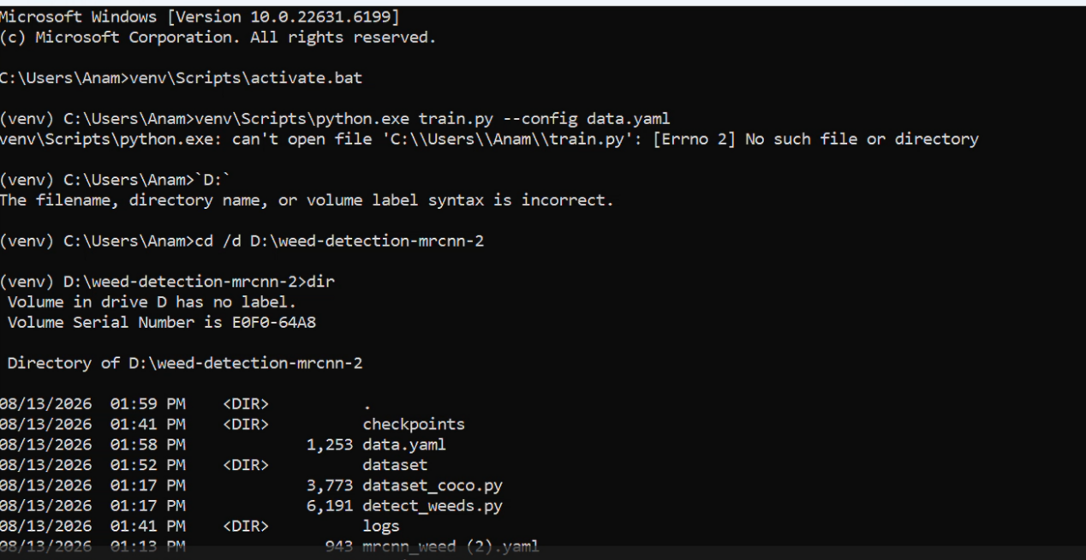
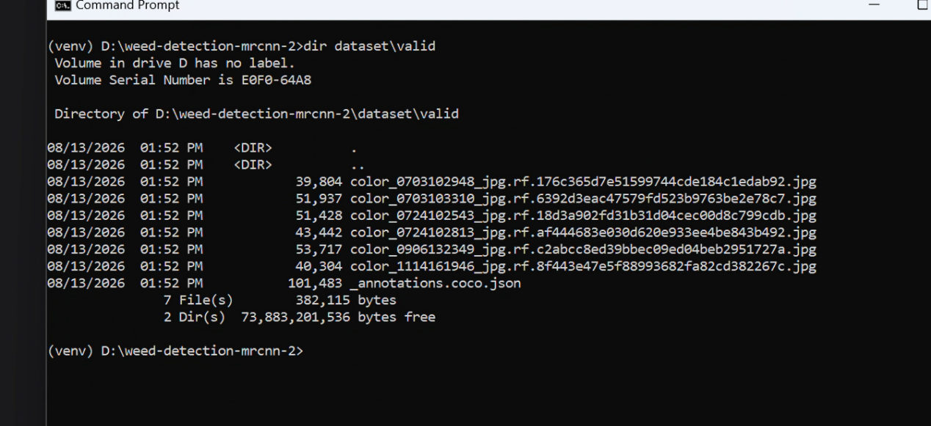

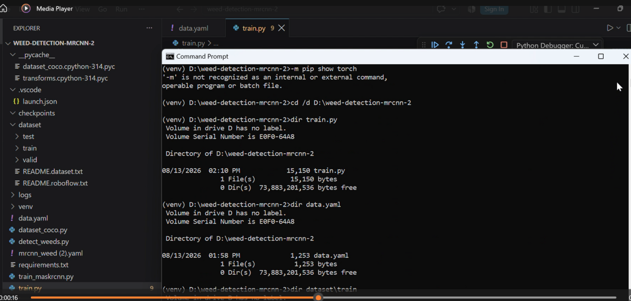

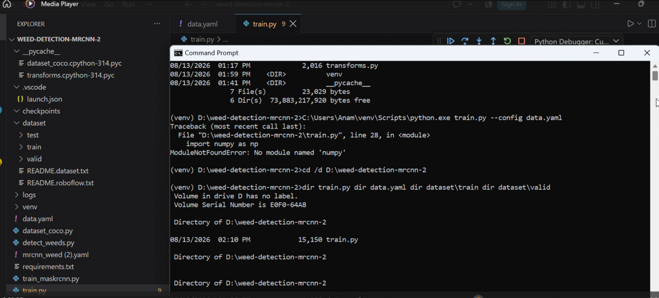

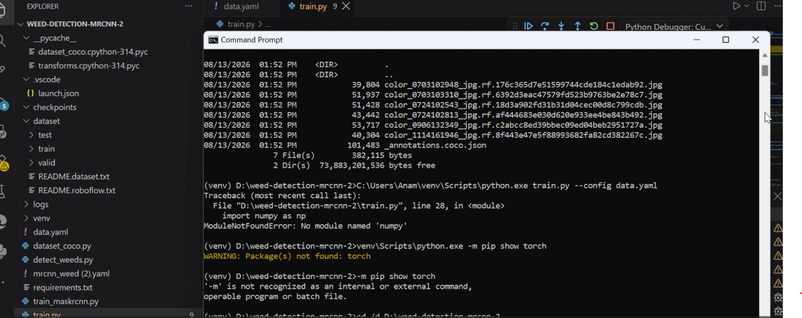

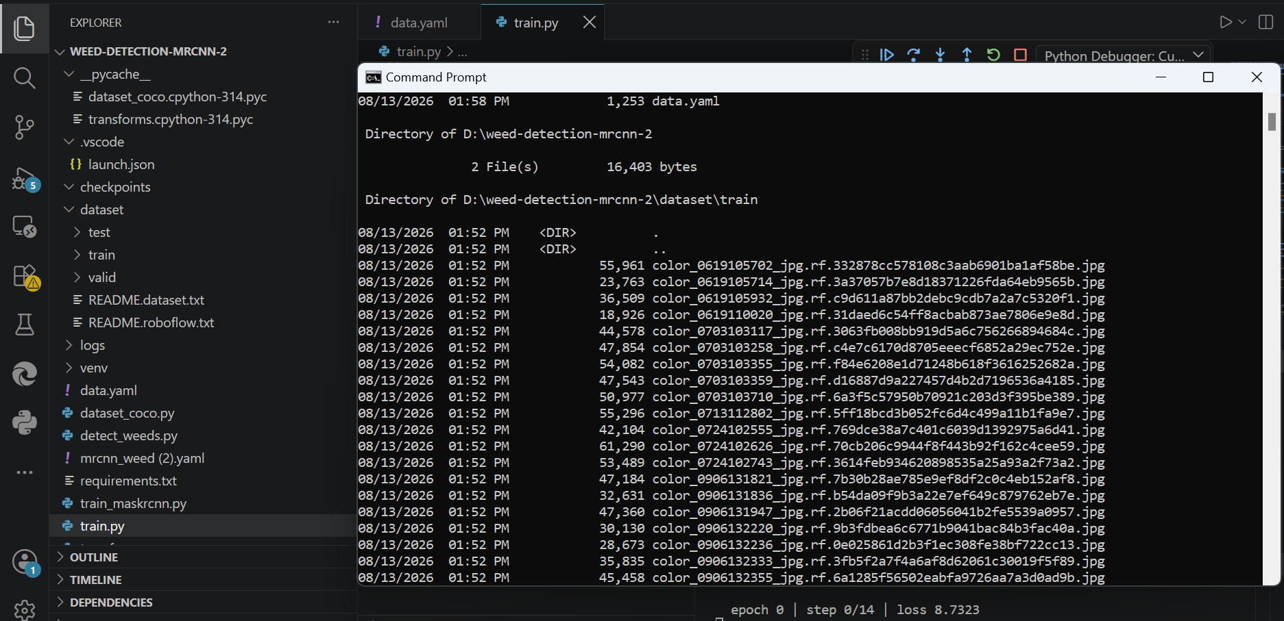

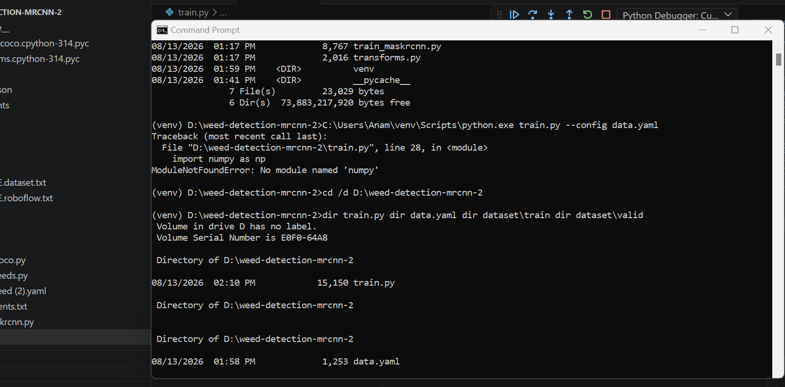
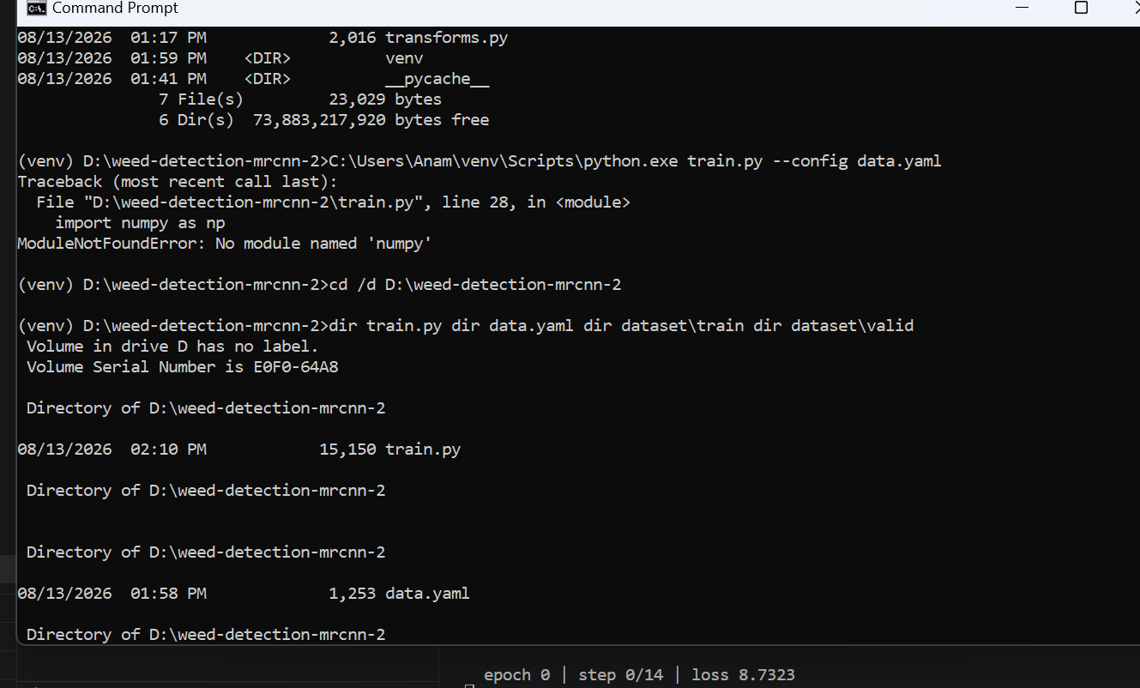

---
title: CropSight
emoji: 🌱
colorFrom: green
colorTo: yellow
sdk: gradio
sdk_version: "4.44.0"
app_file: app.py
pinned: false
---

# CropSight — Precision Weed ID for Targeted Spraying & Robotic Weeding

**See exactly which plants are weeds, not just that some might be** — so
spot-spraying or hand-weeding time goes only where it's needed.

## Who this is for
- Small-to-mid-scale specialty crop growers piloting spot-spray equipment
who want to test whether vision-based weed ID is viable before buying
hardware with detection built in.
- Precision-ag integrators / ag-tech startups needing a fast reference
implementation or a demo for a customer or investor.
- Ag-extension programs and agronomy consultants doing weed-pressure
surveys who want to triage field/drone photos faster than manual review.

## Try it
Upload a field photo. CropSight returns an annotated image (instance
masks + boxes + class + confidence) plus a weed vs. crop instance count.

## Deploying this Space yourself
1. Create a new Space on huggingface.co/new-space, SDK = Gradio.
2. Push this repo's `app.py`, `README.md` (this file), `requirements.txt`,
and your trained `checkpoints/best.pth` to the Space.
- If your checkpoint is large, use Git LFS (`git lfs track "*.pth"`)
or the Space's "Files" tab to upload it directly.
3. Set the `CROPSIGHT_WEIGHTS` environment variable in the Space's
Settings if your checkpoint isn't at the default `checkpoints/best.pth`.
4. The Space builds and serves automatically — no server to manage.

## Limitations
This demo's underlying model was trained on a small sample dataset
(see `data.yaml` / `mrcnn_weed.yaml` in this repo). Treat it as a
proof-of-concept for the specific crop/weed species it was trained on,
not a general "works on any field" tool. Retrain on your own field
photos before relying on it for real spraying/weeding decisions.

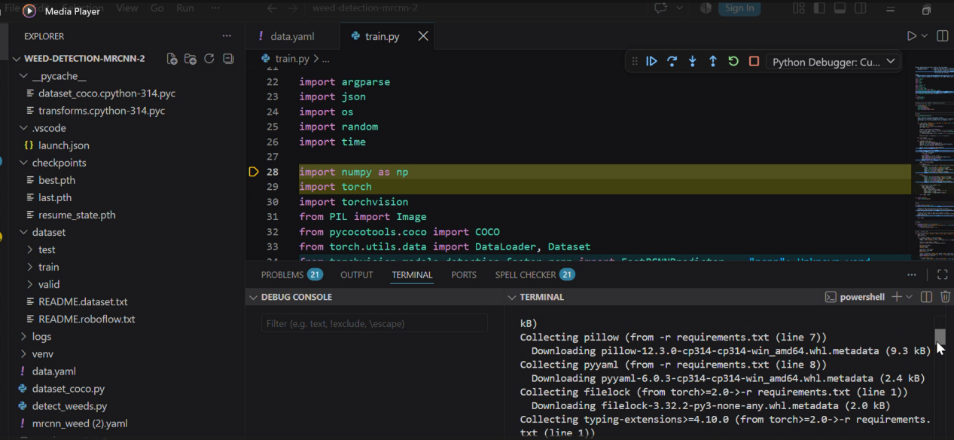

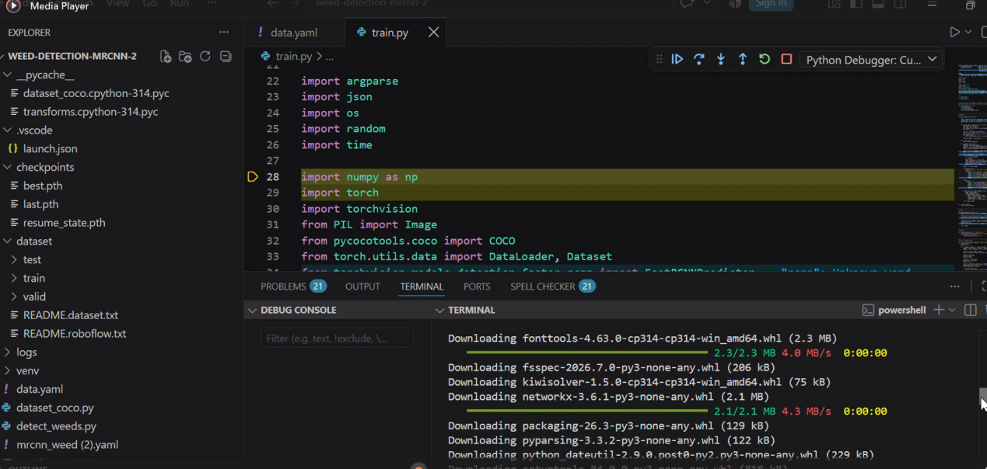

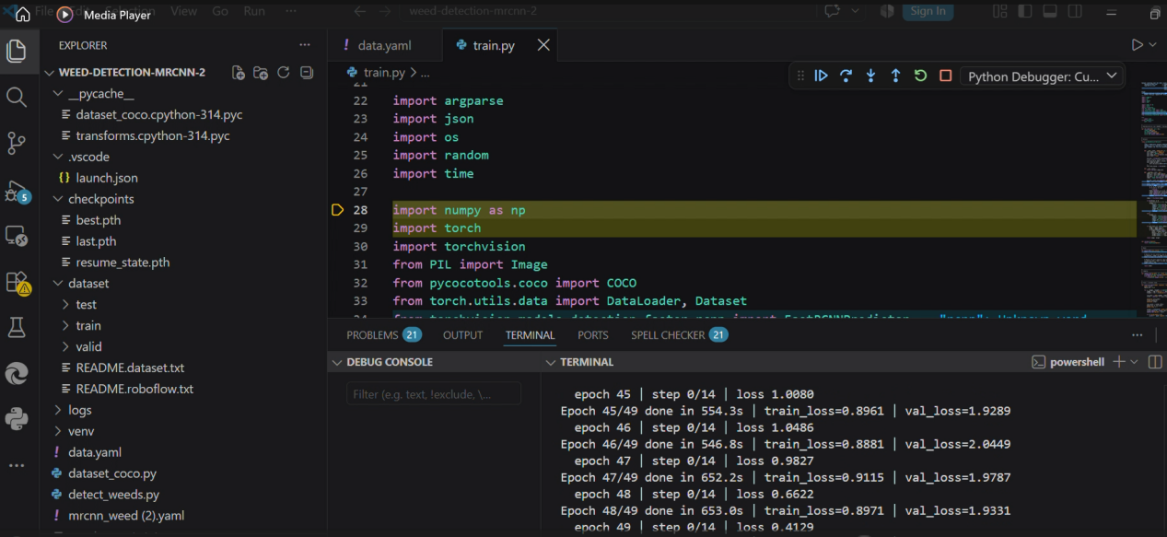

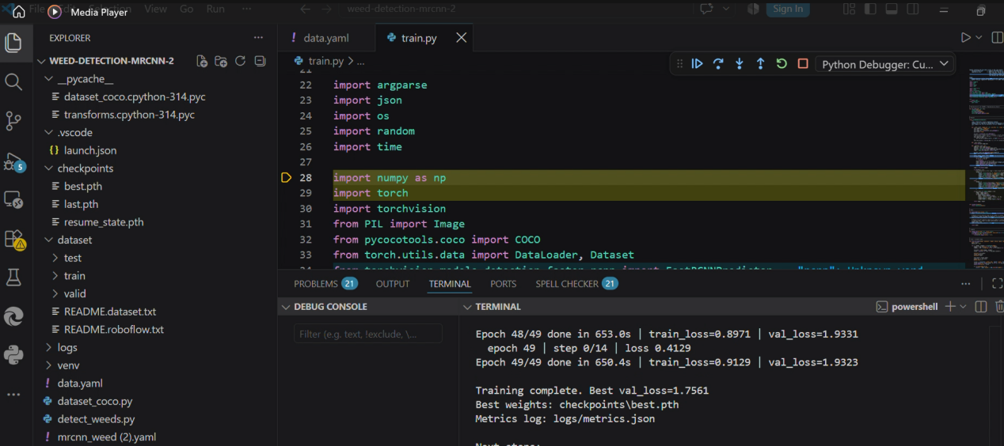

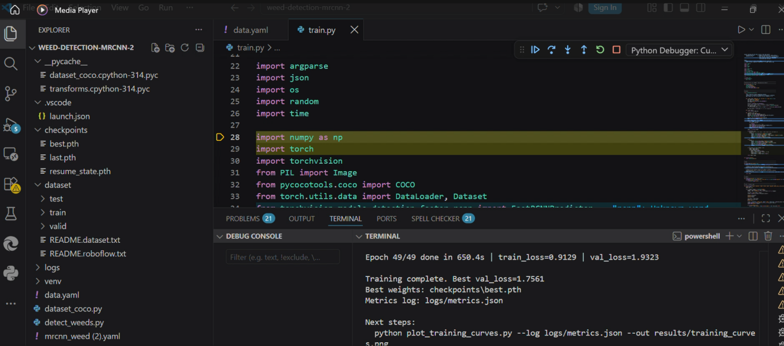

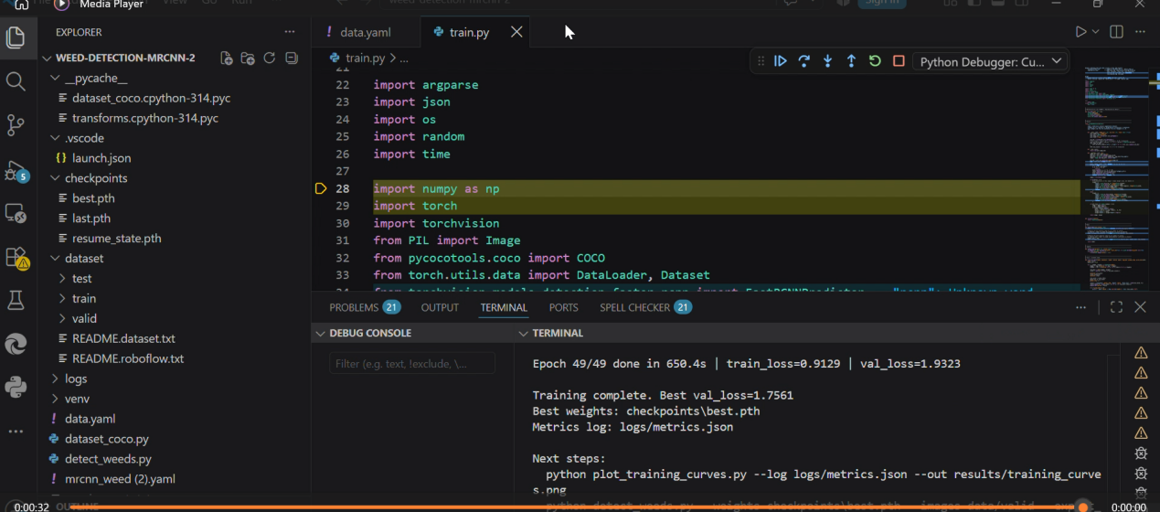

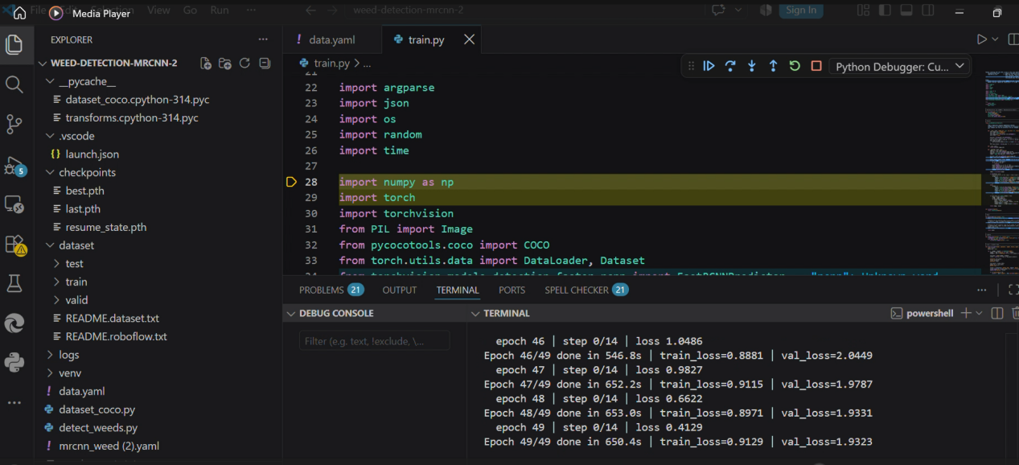

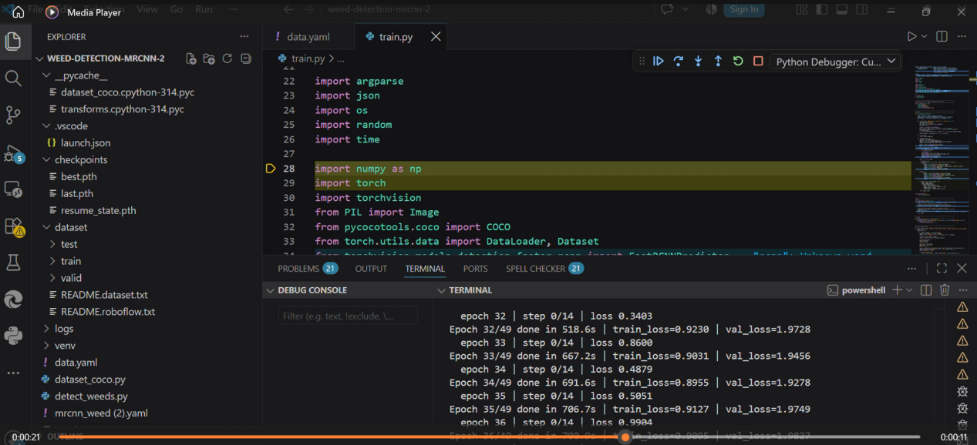

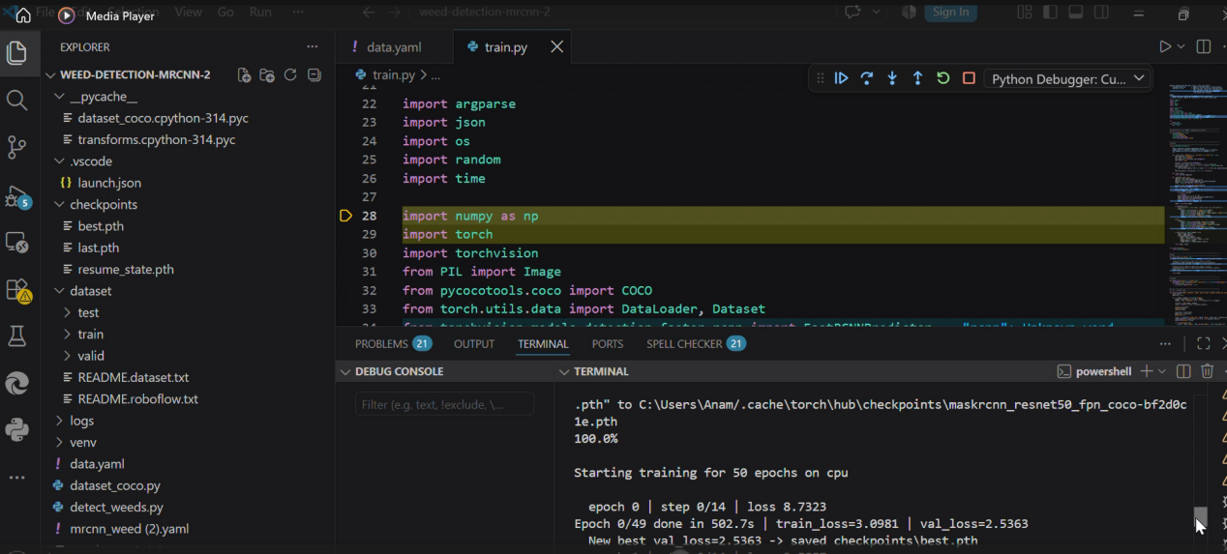

I have used gradio app for weeds detection using Mask-RCNN and when you upload an image you get annotated image.First I trained and tested weeds detection model then I developed a product in which I used gradio app from huggingface to build entire model and tested it too.Some of process images have been attached for understanding .

Instructions to run code:
It is crucial to create environment and install all python packages and modules.
I installed tensorflow and other modules too.
In data.yaml file I set paths of all folders such as train dataset,test dataset and annotations.
Best.pth weights are obtained after training and results are observed.
Dataset in coco.json format downloaded from roboflow

